

PETROLEUM MARKET ANNUAL REPORT 2024

All rights reserved for all information, tables and figures in this report.
They cannot be used without citing reference.

T.R. THE ENERGY MARKET REGULATORY AUTHORITY
Department of Strategy Development

ANKARA, 2025

Important Reminder: Licensee companies can make corrections to the data they previously submitted to the Authority by requesting a correction of the notification within the framework of the relevant provisions of the Energy Market Notification Regulation. For this reason, there may be data differences between the published reports.

This report is published within the scope of the Official Statistics Program.

PRESIDENT'S MESSAGE

As the Energy Market Regulatory Authority (EMRA), at the end of about 24 years in line with the goal of establishing a stable, transparent and competitive energy market, we continued to work with great effort in 2024 in order to fulfill the regulatory duty assigned to our Authority in the best way possible, taking into account both the needs of the companies operating in the market and the rights of consumers.

As the Authority, we strive to fulfill the function of regulating and supervising the petroleum market in accordance with the Petroleum Market Law No. 5015 and to improve it day by day with an innovative approach. In order to ensure the integrity, consistency and reliability of accurate and reliable market information based on the regulation, we carry out our activities in coordination with the market players in order to ensure timely, complete and accurate notifications by license holders. We do not limit the controls regarding data quality only to the controls between the data provided by our Agency; we also cross-check the data received from other relevant public institutions and organizations and subject them to reporting. Taking into account the experience gained from previous years and the opinions and suggestions of relevant stakeholders, we continuously improve sector reports in terms of both scope and data quality.

While underlining that we, as EMRA, are open to all kinds of constructive opinions and suggestions, I wish that the Petroleum Market 2024 Sector Report, which has been prepared with great meticulousness in the form of giving the changes in the petroleum market activities and the market in 2024 in comparison with the previous years, which is eagerly awaited by all relevant segments, will be beneficial to all our stakeholders. In addition, I would like to congratulate all sector stakeholders who constituted a source for the preparation of the report with their sensitivity and participatory approach within the scope of their notification obligations and the staff of our Authority who contributed to the preparation of this report.

Mustafa YILMAZ
The President of EMRA

Executive Summary

- Production in 2024 compared to 2023:
- Total refinery production decreased by 1.01% to 36.167.693,41 tons,
- Diesel production decreased by 4.39% to 15.724.875,71 tons,
- Gasoline production increased by 3.17% to 5.094.213,17 tons,
- Aviation fuels production decreased by 5.90% to 5.515.369,98 tons,
- Marine fuels production increased by 51.68% to 1.358.741,95 tons,
- Other products production decreased by 8.55% to 7.195.004,60 tons

- Imports in 2024 compared to 2023:
- Total imports decreased by 0.53% to 48.741.379,41 tons,
- Crude oil imports decreased by 4.37% to 30.024.609,72 tons,
- Diesel imports increased by 9.70% to 13.671.722,51 tons,
- Aviation fuel imports increased by 17.37% to 788.457,72 tons,
- Marine fuel imports increased by 10.70% to 308.151,38 tons,
- Imports of other products decreased by 0.98% to 3.638.121,06 tons.

- Exports in 2024 compared to 2023:
- Total exports increased by 7.68% to 14.372.858,86 tons,
- Exports of gasoline types decreased by 71.88% to 284.972,41 tons,
- Diesel exports decreased by 6.45% to 2.820.496,96 tons,
- Aviation fuel exports decreased by 4.86% to 5.060.168,80 tons
- Marine fuel exports increased by 33.62% to 1.580.910,50 tons.

- Domestic Sales in 2024 compared to 2023:
- Total domestic sales increased by 2.68% to 32.739.669,21 tons,
- Gasoline sales increased by 20.13% to 4.894.005,37 tons,
- Diesel sales increased by 0.36% to 26.116.681,81 tons.

- Bunker Sales in 2024 compared to 2023:
- Total export sales increased by 8.45% to 4.326.226,71 tons,
- Aviation fuels sales increased by 13.38% to 2.006.668,16 tons,
- Marine fuel sales increased by 2.76% to 1.654.894,53 tons,
- Diesel sales decreased by 1.90% to 510.279,11 tons.

- For deliveries subject to transit regime in 2024:
- Delivery of 677.158,20 tons of oil in diesel types and 85.160,84 tons of exported fuel oil,
- Delivery of 3.985,00 tons of oil and 1.610.383,17 tons of marine fuel,
- 818.217,90 tons of aviation fuel was delivered.
- In fuel oil types, 963,31 tons of exports were delivered.

- Price Movements:
- In 2024, gasoline and diesel prices changed in Türkiye in line with international market prices, and the average tax-free dealer sales price was realized as 24,76 TL/LT for 95 octane unleaded gasoline and 25,44 TL/LT for diesel throughout the year.

- The product types included in this Report are grouped as follows based on the products specified in the Board Decision dated 17/12/2020 and numbered 9822:
- Gasoline Types;
  - 2710.12.45.00.11 - Unleaded Gasoline 95 Octane
  - 2710.12.45.00.13 - Unleaded Gasoline 95 Octane (E10)
  - 2710.12.49.00.11 - Unleaded Gasoline 98 Octane
  - 2710.12.49.00.12 - Unleaded Gasoline 98 Octane (E10)
- Diesel Types;
  - 2710.19.43.00.11 - Diesel
  - 2710.20.11.00.11 - Diesel (Containing biodiesel)
  - 2710.19.43.00.12 - GTL Diesel (Paraffinic diesel produced by synthesizing from gas)
  - 2710.19.43.00.13 - HVO Diesel Oil (Hydroprocessed renewable paraffinic diesel oil)
- Fuel Oil Types;
  - 2710.19.62.00.10 - Heating Fuel (with a sulphur content of < 0,1% by weight)
  - 2710.19.62.00.11 - Fuel Oil (with a sulphur content of < 0,1% by weight)
  - 2710.19.66.00.10 – Heating Fuel (with a sulphur content of > 0,1%, but <= 0,5% by weight)
  - 2710.19.66.00.11 - Fuel Oil (with a sulphur content of > 0,1%, but <= 0,5% by weight)
  - 2710.19.67.00.12 - Fuel Oil (with a sulphur content of > 0,5%, but <= 1% by weight)
  - 2710.19.67.00.13 – Heating Fuel (with a sulphur content of > 0,5%, but <= 1% by weight)
  - 2710.19.67.00.11 – High Sulphure Fuel Oil (with a sulphur content of > 0,5%, but <= 1% by weight)
  - 2710.19.67.00.41 - High Sulphure Fuel Oil (with a sulphur content of > 1% by weight)
  - 2710.20.32.00.00 - Fuel Oil (with a sulphur content of <0,5% by weight)
  - 2710.20.32.00.00 - Fuel Oil (with a sulphur content of >0,5% by weight)
- Aviation Fuels;
  - 2710.12.31.00.00 – Aviation Spirit
  - 2710.12.70.00.00 - Spirit Type Jet Fuel
  - 2710.19.21.00.00 - Jet Fuel
  - 2710.19.21.00.11 - Sustainable Aviation Fuel (SAF)
- Marine Fuels;
  - 2710.19.43.00.17 - Distillate Marine Fuel (with a sulphur content of < 0,001%),
  - 2710.19.46.00.18 - Distillate Marine Fuel (with a sulphur content of > 0,001%, but <= 0,002% by weight),
  - 2710.19.47.00.18 - Distillate Marine Fuel (with a sulphur content of > 0,002%, but <= 0,1% by weight),
  - 2710.19.48.00.11 - Distillate Marine Fuel (with a sulphur content of > 0,1% by weight)
  - 2710.19.62.00.31 – Residual Marine Fuel (with a sulphur content of < 0,1% by weight)
  - 2710.19.66.00.31 - Residual Marine Fuel (with a sulphur content of > 0,1%, but <= 0,5% by weight)
  - 2710.19.67.00.31 - Residual Marine Fuel (with a sulphur content of > 0,5%, but <= 1% by weight)
  - 2710.19.67.00.42 - Residual Marine Fuel (with a sulphur content of > 1% by weight)
- Kerosene;
  - 2710.19.25.00.11 – Kerosene
- Other Products;
  - 2710.12.15.00.11 - Naptha,
  - 3826.00.10.00.11 - Biodiesel,
  - 3826.00.90.00.00 - Sustainable Maritime Blending Component
  - 2207.20.00.10.13 - Ethanol Blended (Denatured ethyl alcohol),
  - 2207.20.00.10.14 - Ethanol Blended (Packaged ethyl alcohol),
  - 2909.19.90.00.13 - Methyl Tert-Butyl Ether (MTBE)
  - 2710.19.46.00.29 - Others (with a sulphur content of > 0,001%, but <= 0,002% by weight)
  - 2710.19.47.00.19 - Others (with a sulphur content of > 0,002%, but <= 0,1% by weight)
  - 2710.12.11.00.00 - Those subjected to special processing
  - 2710.12.25.00.00 - Others
  - 2710.19.31.00.00 - Those subjected to special processing
  - 2710.19.51.00.00 - Those subjected to special processing
  - 2710.19.66.00.39 - Others
  - 2710.12.90.00.19 - Others
  - 2710.19.67.00.39 – Fuel Oil (with a sulphur content of > 0,5% - others)
  - Other Non-Fuel Products
- In this Report;
- Delivery to the Dealer: Deliveries made to fuel and bunker dealership license holders (including sales made with the Vehicle Identification System),
- Delivery to the Eligible Consumer: Deliveries made to eligible consumer license holders,
- Other Delivery: Deliveries made to unlicensed bodies,
- Free Circulation: The amount of the nationalized product purchased/sold domestically in accordance with the provisions of Article 18 of the Customs Law,
- Export Registered: The amount bought/sold for export within the scope of Article 11 of the VAT Law,
- Subject to Transit Regime: Amount of products bought/sold by license holders under transit regime
refers to.

- Export registered deliveries and deliveries subject to transit regime are included in the Reports of Delivery by Province/Total Deliveries in Türkiye. On the other hand, export registered deliveries and deliveries subject to transit regime are not included in the Domestic Sales Reports. 4) Unless otherwise stated, all data in the report are in "tons". 5) In tables with Share (%) column, ratios lower than "0,01" are shown as 0,00. 6) GTL Diesel and HVO Diesel cannot be sold at fuel stations.
OUTLOOK OF THE PETROLEUM MARKET
Oil Market Outlook for 2021, 2022, 2023 and 2024 (tons)
PRODUCT TYPE | PRODUCTION |  |  |  | IMPORT** |  |  |  | EXPORT |  |  |  | DOMESTIC SALES (CONSUMPTION) |  |  |  | TOTAL DELIVERY***
PRODUCT TYPE | 2021 | 2022 | 2023 | 2024 | 2021 | 2022 | 2023 | 2024 | 2021 | 2022 | 2023 | 2024 | 2021 | 2022 | 2023 | 2024 | 2021 | 2022 | 2023 | 2024
Gasoline Types | 4.611.965 | 5.167.261 | 4.937.915 | 5.094.213 | 4.748 | 0 | 76.258 | 0 | 1.673.445 | 1.970.183 | 1.013.432 | 284.972 | 3.032.725 | 3.296.596 | 4.073.775 | 4.894.005 | 3.032.725 | 3.296.596 | 4.073.775 | 4.894.005
Diesel Types | 17.035.171 | 17.355.530 | 16.446.028 | 15.724.876 | 10.523.523 | 9.763.890 | 12.462.576 | 13.671.723 | 2.564.974 | 2.498.091 | 3.015.031 | 2.820.497 | 26.281.764 | 24.543.117 | 26.023.683 | 26.116.682 | 26.803.769 | 25.546.724 | 26.801.008 | 26.879.011
Fuel Oil Types | 163.460 | 40.634 | 526.795 | 1.277.822 | 350.189 | 557.265 | 442.140 | 310.317 | 290.105 | 243.684 | 578.660 | 1.397.608 | 255.128 | 309.169 | 317.963 | 247.203 | 255.128 | 309.169 | 323.313 | 248.167
Aviation Fuels | 3.306.236 | 4.716.032 | 5.861.168 | 5.515.370 | 208.763 | 448.737 | 671.746 | 788.458 | 2.657.742 | 4.138.918 | 5.318.849 | 5.060.169 | 917.837 | 1.071.265 | 1.219.271 | 1.199.399 | 1.211.249 | 1.515.356 | 1.775.999 | 2.017.617
Marine Fuels | 1.195.220 | 1.789.161 | 895.778 | 1.358.742 | 87.450 | 58.287 | 278.362 | 308.151 | 1.233.631 | 1.840.817 | 1.183.174 | 1.580.911 | 39.787 | 45.668 | 31.350 | 44.511 | 1.964.526 | 1.604.313 | 1.627.784 | 1.658.880
Kerosene | 1.971 | 1.601 | 1.385 | 1.666 | 0 | 0 | 0 | 0 | 0 | 0 | 0 | 0 | 2.034 | 1.723 | 1.478 | 1.218 | 2.034 | 1.723 | 1.478 | 1.218
Other Products* | 9.674.946 | 8.956.622 | 7.867.549 | 7.195.005 | 1.749.355 | 3.103.757 | 3.674.000 | 3.638.121 | 1.892.948 | 1.985.841 | 2.238.152 | 3.228.702 | 187.882 | 253.891 | 218.529 | 236.650 | 187.882 | 253.891 | 218.529 | 236.650
TOTAL | 35.988.969 | 38.026.842 | 36.536.617 | 36.167.693 | 12.924.029 | 13.931.935 | 17.605.082 | 18.716.770 | 10.312.845 | 12.677.534 | 13.347.299 | 14.372.859 | 30.717.158 | 29.521.430 | 31.886.049 | 32.739.669 | 33.457.312 | 32.527.771 | 34.821.887 | 35.935.548
*Includes LPG production data.
**The amount of crude oil imports in 2024 is 30.024.609,72 tons.
***Total Delivery: Total of domestic sales, export registered deliveries and deliveries within the scope of transit regime.

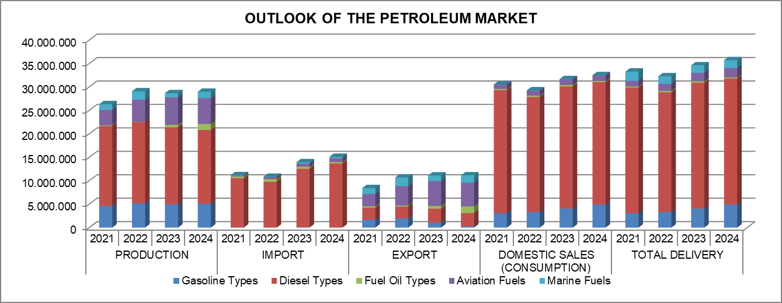

PETROLEUM MARKET OUTLOOK FOR 2024
Detailed Overview by Main Product Groups (tons)
PRODUCT TYPE | PRODUCTION | IMPORT |  | EXPORT |  | DOMESTIC SALES (CONSUMPTION) |  |  | TOTAL SUPPLY (Refinery Production + Import) | TOTAL DEMAND (Domestic Sales + Export)
PRODUCT TYPE | PRODUCTION | Refinery Imports | Distributors and BDLH⁽¹⁾ Imports | Refinery Exports | Distributors and BDLH⁽¹⁾ Exports | Refinery Sales⁽²⁾ | Distributor Fuel Sales⁽³⁾ | Bunker Sales⁽⁴⁾ by the Distributors and BDLH⁽¹⁾ | TOTAL SUPPLY (Refinery Production + Import) | TOTAL DEMAND (Domestic Sales + Export)
Gasoline Types | 5.094.213 | 0 | 0 | 284.972 | 0 | 3.026 | 4.887.203 | 3.776 | 5.094.213 | 5.178.978
Diesel Types | 15.724.876 | 1.450.518 | 12.221.205 | 2.820.440 | 57 | 27 | 25.691.546 | 425.118 | 29.396.599 | 28.937.189
Fuel Oil Types | 1.277.822 | 310.317 | 0 | 1.397.608 | 0 | 44.553 | 202.621 | 0 | 1.588.139 | 1.644.782
Aviation Fuels | 5.515.370 | 27.364 | 761.094 | 334.025 | 4.726.144 | 186.288 | 0 | 1.013.111 | 6.303.828 | 6.259.567
Marine Fuels | 1.358.742 | 0 | 308.151 | 933.514 | 647.397 | 0 | 0 | 44.511 | 1.666.893 | 1.625.422
Total | 28.971.023 | 1.788.198 | 13.290.450 | 5.770.560 | 5.373.597 | 233.895 | 30.781.370 | 1.486.517 | 44.049.672 | 43.645.938
⁽¹⁾ BDLH refers to Bunker Delivery Licence Holders.
⁽²⁾ It refers to the sales made by refinery license holders to end users.
⁽³⁾ Includes sales made by distributor license holders to dealers, free users and sales to end users
⁽⁴⁾ Deliveries under the transit regime are not included.

Supply-Demand Balance in 2024* (ton)
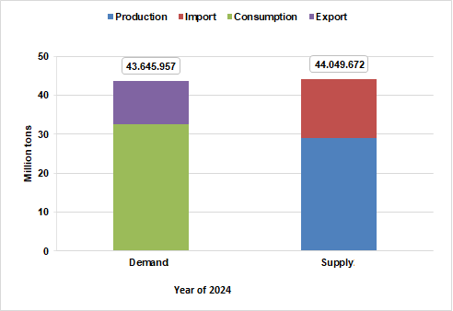

Supply-Demand Balance by Product Types in 2024 (tons)
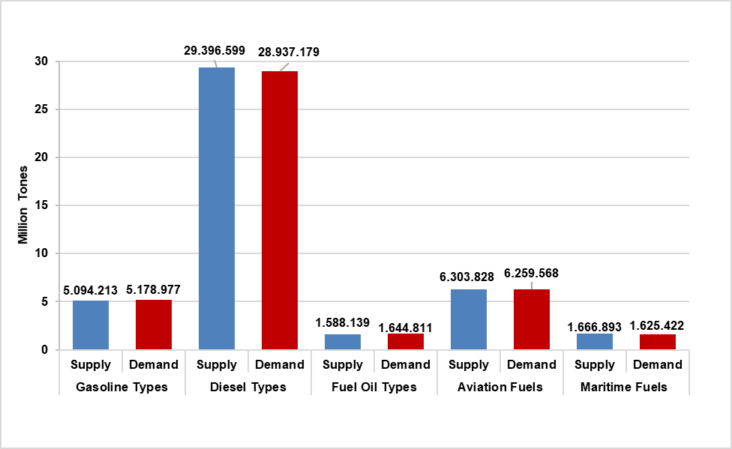
* 5 product types were taken as basis in calculating supply and demand values.

TABLE OF CONTENTS
CHAPTER ONE: PRODUCTION 1
CHAPTER TWO: FOREIGN TRADE 6
2.1. IMPORT 7
2.2. EXPORT 13
CHAPTER THREE: DOMESTIC SALES 22
COMPETITION IN THE OIL MARKET 37
CHAPTER FOUR: WHOLESALE TRADE 51
CHAPTER FIVE: DELIVERIES 56
CHAPTER SIX: DEALER EMPLOYMENT 67
CHAPTER SEVEN: PRICES 70
7.1. TREND OF PRODUCT PRICES IN INTERNATIONAL MARKETS AND IN TÜRKİYE IN 2024 71
7.1.1. INTERNATIONAL MARKETS 71
7.1.2. TÜRKİYE 72
7.2. PRICE FORMATIONS FOR GASOLINE AND DIESEL IN 2023 (ISTANBUL EUROPEAN SIDE) 73
7.2.1. PRICE FORMATION FOR GASOLINE TYPES (ISTANBUL EUROPEAN SIDE – ONE LITER) 73
7.2.2. PRICE FORMATION FOR DIESEL TYPES (ISTANBUL EUROPEAN SIDE – ONE LITER) 74
CHAPTER EIGHT: PETROLEUM PRODUCT DELIVERIES BY PROVINCE (Annex - Excel File) 76

LIST OF TABLES

Table 1.1. Production Amounts by Product and Refinery in 2024* (tons) 2
Table 1.2. Comparison of Refinery Production in 2023 and 2024* 3
Table 2.1.1. Imports by Country (tons) 7
Table 2.1.2. Import Amounts by License Types (tons) 8
Table 2.1.3. Import Amounts by License Holders (tons) 9
Table 2.1.4. Comparison of Total Imports in 2023 and 2024 10
Table 2.2.1. Exports by Country (tons) 13
Table 2.2.2. Export Amounts by License Types (tons) 17
Table 2.2.3. Export Amounts by License Holders (tons) 18
Table 2.2.4. Comparison of Total Exports in 2023 and 2024 19
Table 3.1. Domestic Sales by License Holders (tons) 23
Table 3.2. Domestic Sales by Province (tons) 28
Table 3.3. Comparison of Total Domestic Sales in 2023 and 2024 30
Table 3.4. Domestic Fuel Sales and Market Shares (%) of Distributor License Holders 34
Table 3.5. CR, HHI, EI and REI Values for the Oil Market in 2024 39
Table 3.6. Market Shares of the Top Ten Distributor License Holders in 2015-2024* 42
Table 3.7. Fuel Sales with Vehicle Recognition System (TTS) in 2024* 43
Table 3.8. Comparison of Fuel Sales with Vehicle Identification System (TTS) in 2023 and 2024 44
Table 3.9. Dealer Sales of Distributors in Gasoline Types in 2024 (liters)* 45
Table 3.10. Distributors' Dealer Sales of Gasoline Types by Month in 2024 (liters)* 46
Table 3.11. Dealer Sales of Distributors in Diesel Types in 2024 (liters)* 48
Table 3.12. Distributors' Dealer Sales of Diesel Types by Month in 2024 (liters)* 49
Table 4.1. Wholesale Amounts of Refinery License Holders in 2023 (tons) 52
Table 4.2. Wholesale Amounts of Distributor and Bunker Delivery License Holders in 2023 (tons)* 53
Table 5.1. Distribution of Petroleum Product Deliveries by License Holders and Product Types in 2023 (tons) 57
Table 5.2. Comparison of Total Deliveries in 2022 and 2023 60
Table 5.3. Amount of Bunker Deliveries by License Holders (tons) 61
Table 5.4. Amount of Bunker Deliveries by Type of Delivery (tons) 63
Table 5.5. Comparison of the Amounts of Bunker Deliveries in 2022 and 2023 63
Table 5.6. Distribution of Bunker Deliveries (Including Export) by License Holders and Types of Deliveries in 2023 (tons) 64
Table 5.7. Biofuel Deliveries in 2023 (tons) 66
Table 6.1. Dealer Employment in 2024 68
Table 7.1. Average Price Formation for Gasoline Types in 2024 (TL/lt) 73
Table 7.2. Average Price Formation for Diesel Types in 2024 (TL/lt) 74

LIST OF FIGURES

Figure 1.1. Distribution of Gasoline Production by Month in 2023 and 2024 (tons) 4
Figure 1.2. Distribution of Diesel Production by Month in 2023 and 2024 (tons) 4
Figure 1.3. Distribution of Aviation Fuels Production by Month in 2023 and 2024 (tons) 5
Figure 1.4. Distribution of Marine Fuels Production by Month in 2023 and 2024 (tons) 5
Figure 2.1.1. Distribution of Crude Oil Imports by Months in 2023 and 2024 (tons) 11
Figure 2.1.2. Distribution of Imports of Diesel Types by Month in 2023 and 2024 (tons) 11
Figure 2.1.3. Distribution of Fuel Oil Imports by Month in 2023 and 2024 (tons) 12
Figure 2.1.4. Distribution of Aviation Fuel Imports by Month in 2023 and 2024 (tons) 12
Figure 2.2.1. Distribution of Exports of Gasoline Types by Month in 2023 and 2024 (tons) 20
Figure 2.2.2. Distribution of Exports of Diesel Types by Month in 2023 and 2024 (tons) 20
Figure 2.2.3. Distribution of Exports of Aviation Fuels by Month in 2023 and 2024 (tons) 21
Figure 2.2.4. Distribution of Exports of Marine Fuels by Month in 2023 and 2024 (tons) 21
Figure 3.1. Distribution of Gasoline Sales by Month in 2023 and 2024 (tons) 31
Figure 3.2. Distribution of Diesel Sales by Month in 2023 and 2024 (tons) 31
Figure 3.3. Distribution of Fuel Oil Type Sales by Month in 2023 and 2024 (tons) 32
Figure 3.4. Distribution of Aviation Fuel Sales by Month in 2023 and 2024 (tons) 32
Figure 3.5. Distribution of Marine Fuel Sales by Month in 2023 and 2024 (tons) 33
Figure 3.6. Market Shares of the Top 10 Distributor License Holders by Fuel Sales (%) 36
Figure 3.7. Cumulative Market Shares of the Top 10 Firms in the Petroleum Market by Product Type 38
Figure 3.8. CR₄ Rates for Gasoline and Diesel in 2016-2024 40
Figure 3.9. CR₁₀ Rates for Gasoline and Diesel in 2016-2024 41
Figure 3.10. HHI Values for Gasoline and Diesel for 2016-2024 41
Figure 7.1. Prices of Unleaded Gasoline 95 Octane, Diesel and Brent (Dtd) in 2024 ($/Tons) 71
Figure 7.2. Prices of Unleaded Gasoline 95 Octane, Diesel and Brent (Dtd) in 2024 (TL/lt) 71
Figure 7.3. The Trend of Domestic Unleaded Gasoline 95 Octane Tax-Free Prices in 2024 (TL/lt) 72
Figure 7.4. The Trend of Domestic Diesel Tax-Free Prices in 2024 (TL/lt) 72
Figure 7.5. Average Price Formation for Domestic Gasoline Types in 2023 73
Figure 7.6. Average Price Formation for Domestic Diesel Types in 2024 74

CHAPTER ONE: PRODUCTION

Table 1.1. Production Amounts by Product and Refinery in 2024* (tons)
Product | TÜPRAŞ İzmit Refinery | TÜPRAŞ İzmir Refinery | TÜPRAŞ Kırıkkale Refinery | TÜPRAŞ Batman Refinery | Star Refinery | Total
Unleaded Gasoline 95 Octane | 2.293.528,68 | 1.622.354,70 | 1.168.159,37 | -0,03 |  | 5.084.042,71
Unleaded Gasoline 98 Octane | 10.170,46 |  |  |  |  | 10.170,46
Diesel | 5.016.677,03 | 3.463.367,80 | 2.016.881,49 | 11,04 | 5.160.997,78 | 15.657.935,13
Diesel (Including biodisel) |  |  |  |  | 66.940,58 | 66.940,58
Fuel Oil (with a sulphur content of > 0,5%, but <= 1% by weight) | -91.150,07 | -62.203,07 | -1.402,79 |  |  | -154.755,93
High Sulphure Fuel Oil (with a sulphur content of > 1% by weight) | 491.556,35 | 838.119,26 | 10.999,21 |  |  | 1.340.674,82
Heating Fuel (with a sulphur content of > 0,5%, but <= 1% by weight) | 66.421,73 | 25.481,27 |  |  |  | 91.903,00
Jet Fuel (Kerosene) | 2.807.615,98 | 1.433.842,48 | 407.243,64 |  | 866.667,87 | 5.515.369,98
Marine Fuel (Residual) | 506.714,75 | 624.632,88 |  |  |  | 1.131.347,63
Marine Fuel (Distillate) | 197.894,51 | 29.499,81 |  |  |  | 227.394,32
Kerosene |  |  | 1.666,12 |  |  | 1.666,12
Total of Fuel Products | 11.299.429,42 | 7.975.095,13 | 3.603.547,04 | 11,00 | 6.094.606,23 | 28.972.688,82
Atmosferik Straight Run Fuel Oil | -1.108.064,90 | 526.112,24 | 10.302,49 |  |  | -571.650,17
Base Oil |  | 113.572,34 |  |  |  | 113.572,34
White Spirit & SBP | 4.372,23 |  |  | 20.946,89 |  | 25.319,12
Bitumen | 783.871,45 | 790.187,00 | 610.975,00 | 300.005,98 |  | 2.485.039,43
Other Intermediates | -83.073,84 | 495.872,55 | 172.439,70 | 56.365,09 | 13.745,50 | 655.348,99
Other Gasolines | 84.366,24 |  |  |  |  | 84.366,24
Other Products | 153.076,32 | 105.152,92 | 34.465,32 |  | 1.098.782,56 | 1.391.477,13
Heavy Vacuum Gas Oil | -782.578,12 | -58.771,92 | 44.769,49 |  | 772.874,89 | -23.705,66
LPG** | 469.752,63 | 268.160,69 | 104.284,47 |  | 163.704,73 | 1.005.902,52
Naptha | -61.528,15 | 107.862,32 | 1.148,49 | 49.117,23 | 1.254.247,23 | 1.350.847,12
Petroleum Coke | 650.295,90 |  |  |  | 643.538,53 | 1.293.834,44
Refinery Gas (Non-Liquid) | 485.209,67 | 177.500,37 | 106.443,70 | 931,42 | 347.357,88 | 1.117.443,04
High Sulphure Diesel | -1.071.546,65 | -822.288,71 | -72.016,23 | 134.686,02 | 98.375,63 | -1.732.789,94
Total of Non-Fuel Products | -475.847,23 | 1.703.359,80 | 1.012.812,43 | 562.052,62 | 4.392.626,96 | 7.195.004,59
Total | 10.823.582,19 | 9.678.454,94 | 4.616.359,47 | 562.063,62 | 10.487.233,19 | 36.167.693,41
* A negative production amount in the table indicates that the product in stock or imported product is reused by the refinery and new product or products are produced with this product.
** In the related period, 79,474.52 tons of LPG produced was used as refinery fuel.

Table 1.2. Comparison of Refinery Production in 2023 and 2024*
Product | 2023 | 2024 | Change (%)
Product | Amount (tons) | Amount (tons) | Change (%)
Unleaded Gasoline 95 Octane | 4.923.074,61 | 5.084.042,71 | 3,27
Unleaded Gasoline 98 Octane | 14.840,19 | 10.170,46 | -31,47
Diesel | 16.425.080,66 | 15.657.935,13 | -4,67
Diesel (Including biodisel) | 20.946,84 | 66.940,58 | 219,57
Fuel Oil (with a sulphur content of > 0,5%, but <= 1% by weight) | -281.940,69 | -154.755,93 | -45,11
High Sulphure Fuel Oil (with a sulphur content of > 1% by weight) | 699.422,89 | 1.340.674,82 | 91,68
Heating Fuel (with a sulphur content of > 0,5%, but <= 1% by weight) | 109.312,49 | 91.903,00 | -15,93
Jet Fuel (Kerosene) | 5.861.167,63 | 5.515.369,98 | -5,90
Marine Fuel (Residual) | 748.728,01 | 1.131.347,63 | 51,10
Marine Fuel (Distillate) | 147.050,43 | 227.394,32 | 54,64
Kerosene | 1.385,12 | 1.666,12 | 20,29
Total of Fuel Products | 28.669.068,18 | 28.972.688,82 | 1,06
Atmosferik Straight Run Fuel Oil | -1.339.471,42 | -571.650,17 | -57,32
Base Oil | 94.937,10 | 113.572,34 | 19,63
White Spirit & SBP | 6.080,19 | 25.319,12 | 316,42
Bitumen | 2.572.663,00 | 2.485.039,43 | -3,41
Other Intermediates | 403.574,99 | 655.348,99 | 62,39
Other Gasolines | 0,00 | 84.366,24 | -
Other Products | 1.883.209,34 | 1.391.477,13 | -26,11
Heavy Vacuum Gas Oil | -880.865,20 | -23.705,66 | -97,31
LPG** | 1.055.616,11 | 1.005.902,52 | -4,71
Naptha | 1.916.730,82 | 1.350.847,12 | -29,52
Petroleum Coke | 1.793.082,57 | 1.293.834,44 | -27,84
Refinery Gas (Non-Liquid) | 1.402.244,76 | 1.117.443,04 | -20,31
High Sulphure Diesel | -1.040.253,58 | -1.732.789,94 | 66,57
Total of Non-Fuel Products | 7.867.548,68 | 7.195.004,59 | -8,55
Total | 36.536.616,87 | 36.167.693,41 | -1,01
* A negative production amount in the table indicates that the product in stock or imported product is reused by the refinery and new product or products are produced with this product.
** Of the LPG produced in the relevant periods, 145,265.59 tons and 79,474.52 tons were used as refinery fuel, respectively.
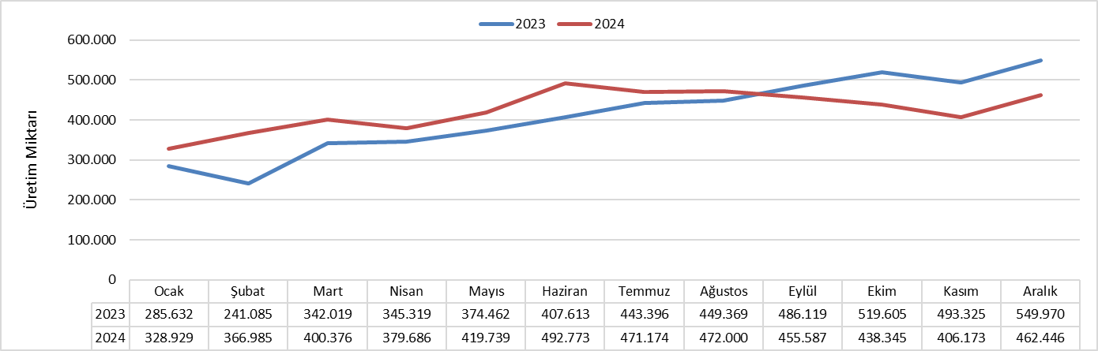

Figure 1.1. Distribution of Gasoline Production by Month in 2023 and 2024 (tons)

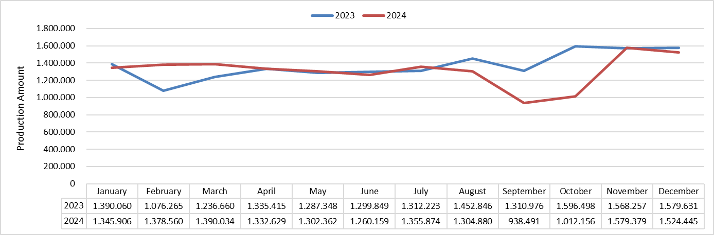

Figure 1.2. Distribution of Diesel Production by Month in 2023 and 2024 (tons)

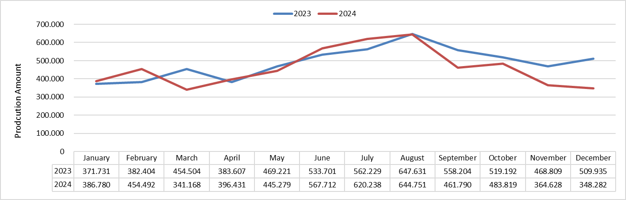

Figure 1.3. Distribution of Aviation Fuels Production by Month in 2023 and 2024 (tons)

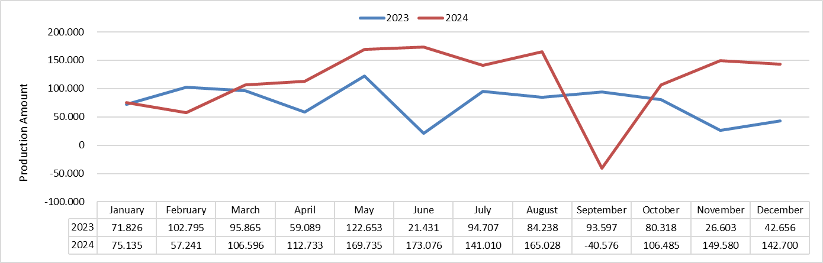

Figure 1.4. Distribution of Marine Fuels Production by Month in 2023 and 2024 (tons)

CHAPTER TWO: FOREIGN TRADE

2.1. IMPORT

Table 2.1.1. Imports by Country (tons)
Country | Crude Oil | Diesel Types | Fuel Oil Types | Aviation Fuels | Marine Fuels | Other Products | Total | Share (%)
Russian Federation | 16.944.443,28 | 11.354.157,18 | 4.850,02 | 705.285,23 | 26.058,59 | 3.170.049,53 | 32.204.843,82 | 66,07
Iraq | 4.736.399,75 | 0,00 | 0,00 | 0,00 | 0,00 | 59.834,06 | 4.796.233,82 | 9,84
Kazakhstan | 2.945.452,11 | 0,00 | 0,00 | 0,00 | 35.067,69 | 0,00 | 2.980.519,80 | 6,11
Saudi Arabia | 1.598.873,64 | 321.973,07 | 0,00 | 0,00 | 0,00 | 0,00 | 1.920.846,71 | 3,94
Nigeria | 925.042,40 | 0,00 | 0,00 | 0,00 | 0,00 | 0,00 | 925.042,40 | 1,90
Italy | 611.797,68 | 193.743,89 | 0,00 | 55,05 | 23.948,85 | 0,00 | 829.545,47 | 1,70
Norway | 672.256,74 | 0,00 | 0,00 | 0,00 | 0,00 | 0,00 | 672.256,74 | 1,38
Egypt | 165.823,61 | 475.247,01 | 0,00 | 0,00 | 1.336,75 | 0,00 | 642.407,37 | 1,32
India |  | 570.599,61 | 0,00 | 28.000,00 | 0,00 | 0,00 | 598.599,61 | 1,23
Libya | 517.445,13 | 0,00 | 0,00 | 5.500,00 | 0,00 | 0,00 | 522.945,13 | 1,07
U.S.A. | 343.898,57 | 0,00 | 151.804,87 | 0,00 | 0,00 | 20.281,99 | 515.985,43 | 1,06
Guyana | 425.822,43 | 0,00 | 0,00 | 0,00 | 0,00 | 0,00 | 425.822,43 | 0,87
Greece | 59.566,42 | 319.080,17 | 0,00 | 38.270,00 | 150,71 | 0,00 | 417.067,30 | 0,86
Netherlands |  | 70,15 | 57.495,35 | 3.751,57 | 3.770,00 | 220.904,34 | 285.991,42 | 0,59
United Arab Emirates |  | 137.317,09 | 0,00 | 0,00 | 0,00 | 18.489,00 | 155.806,10 | 0,32
Azerbaijan |  | 0,00 | 0,00 | 0,00 | 150.126,71 | 0,00 | 150.126,71 | 0,31
Israel |  | 108.834,14 | 0,00 | 0,00 | 13.580,00 | 0,00 | 122.414,14 | 0,25
Algeria |  | 0,00 | 0,00 | 0,00 | 0,00 | 105.263,60 | 105.263,60 | 0,22
Kuwait |  | 96.520,71 | 0,00 | 0,00 | 0,00 | 0,00 | 96.520,71 | 0,20
Malta |  | 94.156,20 | 0,00 | 0,00 | 0,00 | 0,00 | 94.156,20 | 0,19
Tunisia | 77.787,97 | 0,00 | 0,00 | 0,00 | 0,00 | 0,00 | 77.787,97 | 0,16
Turkmenistan |  | 0,00 | 0,00 | 0,00 | 42.953,40 | 0,00 | 42.953,40 | 0,09
France |  | 0,00 | 745,87 | 0,00 | 7.406,26 | 30.359,18 | 38.511,30 | 0,08
England |  | 23,30 | 35.230,34 | 0,00 | 0,00 | 0,50 | 35.254,14 | 0,07
Germany |  | 0,00 | 25.782,35 | 0,00 | 0,00 | 0,00 | 25.782,35 | 0,05
Sweden |  | 0,00 | 24.980,05 | 0,00 | 0,00 | 0,00 | 24.980,05 | 0,05
Portugal |  | 0,00 | 0,00 | 0,00 | 1.100,00 | 12.938,85 | 14.038,85 | 0,03
Estonia |  | 0,00 | 8.880,47 | 0,00 | 0,00 | 0,00 | 8.880,47 | 0,02
Romania |  | 0,00 | 0,00 | 6.591,55 | 0,00 | 0,00 | 6.591,55 | 0,01
Belgium |  | 0,00 | 0,00 | 441,18 | 2.397,91 | 0,00 | 2.839,09 | 0,01
Poland |  | 0,00 | 0,00 | 563,14 | 0,00 | 0,00 | 563,14 | 0,00
Finland |  | 0,00 | 547,71 | 0,00 | 0,00 | 0,00 | 547,71 | 0,00
Kyrgyzstan |  | 0,00 | 0,00 | 0,00 | 254,51 | 0,00 | 254,51 | 0,00
Total | 30.024.609,72 | 13.671.722,51 | 310.317,02 | 788.457,72 | 308.151,38 | 3.638.121,06 | 48.741.379,41 | 100

Table 2.1.2. Import Amounts by License Types (tons)
Licence Type | Crude Oil | Diesel Types | Fuel Oil Types | Aviation Fuels | Marine Fuels | Other Products | Total | Share (%)
Refinery | 30.024.609,72 | 1.450.517,77 | 310.317,02 | 27.363,52 | 0,00 | 3.638.120,56 | 35.450.928,59 | 72,73
Distributor |  | 12.221.204,75 | 0,00 | 37.280,36 | 308.151,38 | 0,50 | 12.566.636,99 | 25,78
Bunker Delivery |  | 0,00 | 0,00 | 723.813,84 | 0,00 | 0,00 | 723.813,84 | 1,49
Total | 30.024.609,72 | 13.671.722,51 | 310.317,02 | 788.457,72 | 308.151,38 | 3.638.121,06 | 48.741.379,41 | 100

Table 2.1.3. Import Amounts by License Holders (tons)
License Holder | Licence Type | Crude Oil | Diesel Types | Fuel Oil Types | Aviation Fuels | Marine Fuels | Other Products | Total | Share (%)
TÜRKİYE PETROL RAFİNERİLERİ A.Ş. | Refinery | 21.441.526,61 | 1.025.894,38 | 310.317,02 | 27.363,52 | 0,00 | 3.571.816,99 | 26.376.918,52 | 54,12
STAR RAFİNERİ A.Ş. | Refinery | 8.583.083,11 | 424.623,39 | 0,00 | 0,00 | 0,00 | 66.303,57 | 9.074.010,08 | 18,62
OPET PETROLCÜLÜK A.Ş. | Distributor |  | 2.750.116,81 | 0,00 | 0,00 | 123.806,83 | 0,50 | 2.873.924,14 | 5,90
PETROL OFİSİ A.Ş. | Distributor |  | 2.246.722,25 | 0,00 | 37.280,36 | 168.638,81 | 0,00 | 2.452.641,42 | 5,03
GÜZEL ENERJİ AKARYAKIT A.Ş. | Distributor |  | 1.847.913,30 | 0,00 | 0,00 | 0,00 | 0,00 | 1.847.913,30 | 3,79
AYTEMİZ AKARYAKIT DAĞITIM A.Ş. | Distributor |  | 1.432.755,30 | 0,00 | 0,00 | 0,00 | 0,00 | 1.432.755,30 | 2,94
SHELL & TURCAS PETROL A.Ş. | Distributor |  | 1.351.628,83 | 0,00 | 0,00 | 0,00 | 0,00 | 1.351.628,83 | 2,77
TP PETROL DAĞITIM A.Ş. | Distributor |  | 1.321.732,89 | 0,00 | 0,00 | 0,00 | 0,00 | 1.321.732,89 | 2,71
TFS AKARYAKIT HİZMETLERİ A.Ş. | Bunker Delivery |  | 0,00 | 0,00 | 716.423,69 | 0,00 | 0,00 | 716.423,69 | 1,47
SOCAR TURKEY PETROL TİC. A.Ş. | Distributor |  | 374.246,71 | 0,00 | 6.591,55 | 15.705,74 | 0,00 | 396.544,00 | 0,81
AKPET AKARYAKIT DAĞITIM A.Ş. | Distributor |  | 234.141,65 | 0,00 | 0,00 | 0,00 | 0,00 | 234.141,65 | 0,48
BP PETROLLERİ A.Ş. | Distributor |  | 173.941,28 | 0,00 | 0,00 | 0,00 | 0,00 | 173.941,28 | 0,36
ALTINBAŞ PETROL VE TİC. A.Ş. | Distributor |  | 172.453,27 | 0,00 | 0,00 | 0,00 | 0,00 | 172.453,27 | 0,35
ENERJİ PETROL ÜRÜNLERİ PAZARLAMA A.Ş. | Distributor |  | 131.231,39 | 0,00 | 0,00 | 0,00 | 0,00 | 131.231,39 | 0,27
KADOOĞLU PETROLCÜLÜK TAŞIMACILIK TİCARET SANAYİ İTHALAT VE İHRACAT A.Ş. | Distributor |  | 100.606,00 | 0,00 | 0,00 | 0,00 | 0,00 | 100.606,00 | 0,21
BALPET PETROL ÜRÜNLERİ TAŞIMACILIK SAN. VE TİC. A.Ş. | Distributor |  | 39.682,83 | 0,00 | 0,00 | 0,00 | 0,00 | 39.682,83 | 0,08
SİYAM PETROLCÜLÜK SAN. VE TİC. A.Ş. | Distributor |  | 21.455,46 | 0,00 | 0,00 | 0,00 | 0,00 | 21.455,46 | 0,04
ES ES AKARYAKIT DAĞITIM A.Ş. | Distributor |  | 20.088,94 | 0,00 | 0,00 | 0,00 | 0,00 | 20.088,94 | 0,04
HYPCO PETROLCÜLÜK A.Ş. | Distributor |  | 1.488,39 | 0,00 | 0,00 | 0,00 | 0,00 | 1.488,39 | 0,00
TERMOPET AKARYAKIT A.Ş. | Distributor |  | 999,47 | 0,00 | 0,00 | 0,00 | 0,00 | 999,47 | 0,00
GOKCEK ELEKTRONİK OTOMOTİV HAVACILIK İNŞAAT TURİZM SANAYİ TİCARET LTD. ŞTİ. | Bunker Delivery |  | 0,00 | 0,00 | 563,14 | 0,00 | 0,00 | 563,14 | 0,00
GÜNEYDOĞU HAVACILIK İŞLETMESİ A.Ş. | Bunker Delivery |  | 0,00 | 0,00 | 235,46 | 0,00 | 0,00 | 235,46 | 0,00
Total |  | 30.024.609,72 | 13.671.722,51 | 310.317,02 | 788.457,72 | 308.151,38 | 3.638.121,06 | 48.741.379,41 | 100

Table 2.1.4. Comparison of Total Imports in 2023 and 2024
PRODUCT TYPE | 2023 |  | 2024 |  | Change (%)
PRODUCT TYPE | Amount (tons) | Share (%) | Amount (tons) | Share (%) | Change (%)
Crude Oil | 31.395.135,95 | 64,07 | 30.024.609,72 | 61,60 | -4,37
Gasoline Types | 76.257,83 | 0,16 | 0,00 | 0,00 | -
Diesel Types | 12.462.575,93 | 25,43 | 13.671.722,51 | 28,05 | 9,70
Fuel Oil Types | 442.140,46 | 0,90 | 310.317,02 | 0,64 | -29,81
Aviation Fuels | 671.745,95 | 1,37 | 788.457,72 | 1,62 | 17,37
Marine Fuels | 278.361,90 | 0,57 | 308.151,38 | 0,63 | 10,70
Other Products | 3.674.000,28 | 7,50 | 3.638.121,06 | 7,46 | -0,98
Total | 49.000.218,30 | 100 | 48.741.379,41 | 100 | -0,53

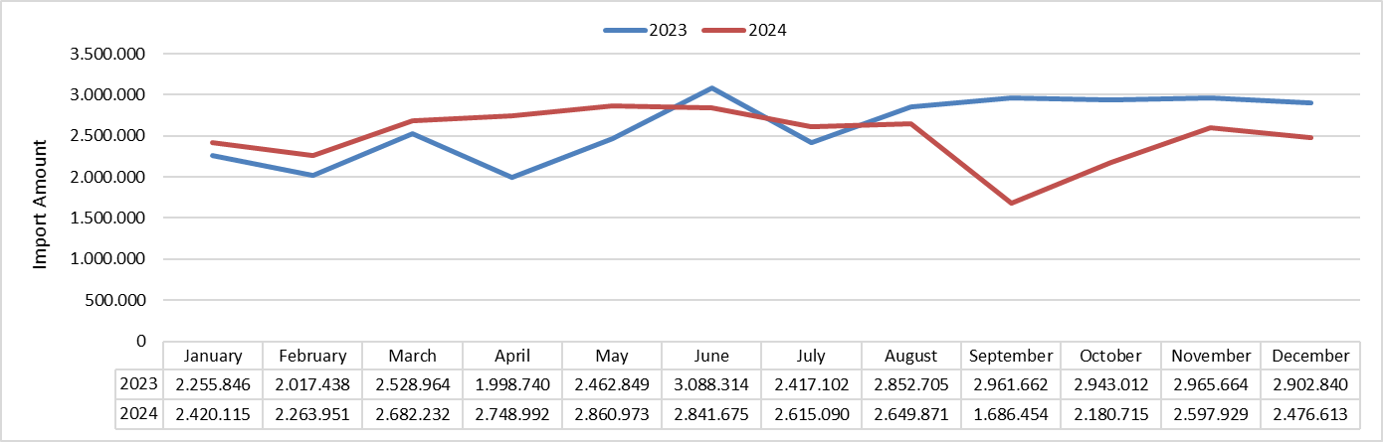

Figure 2.1.1. Distribution of Crude Oil Imports by Months in 2023 and 2024 (tons)

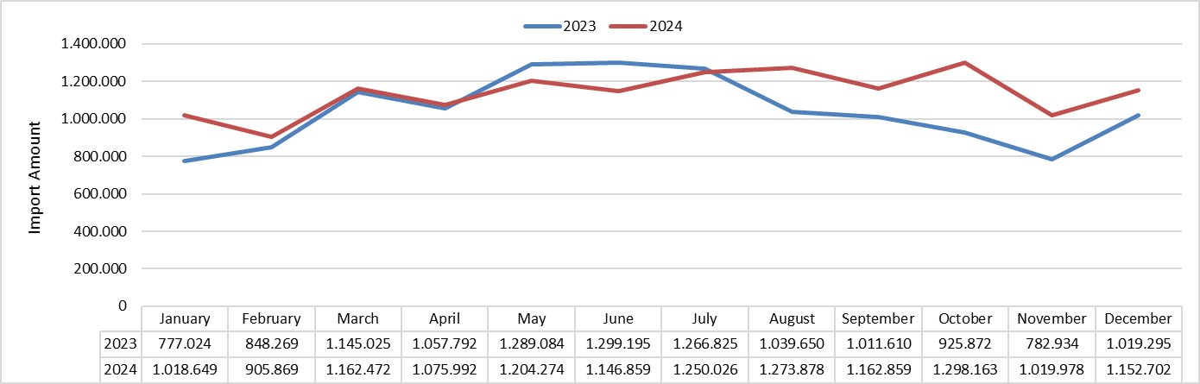

Figure 2.1.2. Distribution of Imports of Diesel Types by Month in 2023 and 2024 (tons)
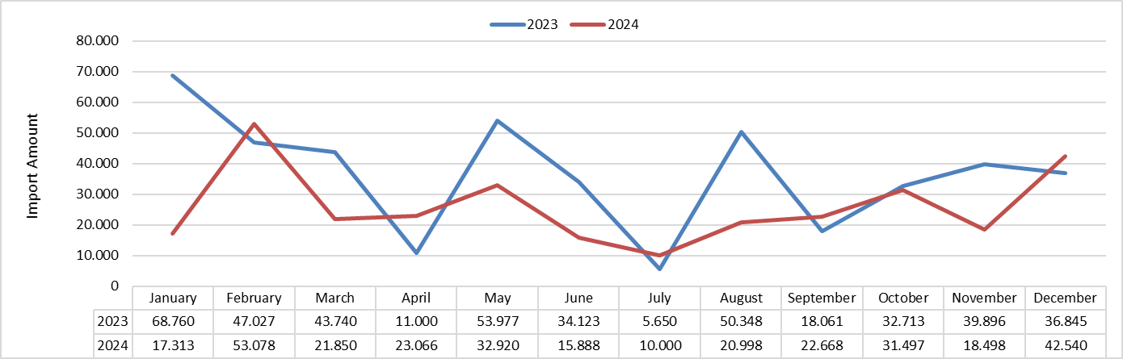

Figure 2.1.3. Distribution of Fuel Oil Imports by Month in 2023 and 2024 (tons)

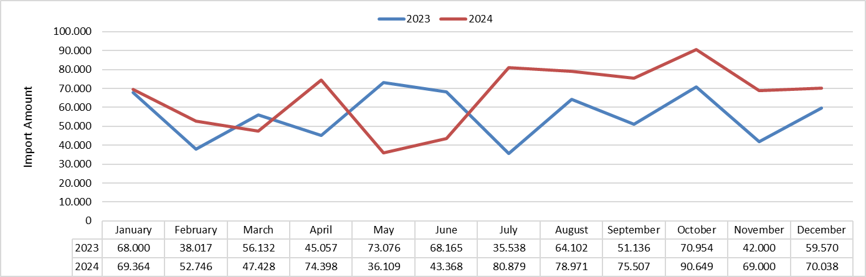

Figure 2.1.4. Distribution of Aviation Fuel Imports by Month in 2023 and 2024 (tons)

2.2. EXPORT

Table 2.2.1. Exports by Country (tons)
Country | Gasoline Types | Diesel Types | Fuel Oil Types | Aviation Fuels | Marine Fuels | Other Products | Total | Share (%)
U.S.A. | 0,00 | 0,00 | 320.120,58 | 2.228.313,31 | 4.104,05 | 522.092,95 | 3.074.630,89 | 21,39
Netherlands | 57.264,72 | 65.945,35 | 394.728,82 | 54.156,74 | 2.561,43 | 1.247.311,71 | 1.821.968,78 | 12,68
Romania | 0,00 | 1.189.552,23 | 0,00 | 71.885,38 | 32.274,27 | 111.865,77 | 1.405.577,65 | 9,78
Italy | 0,00 | 370.764,06 | 85.244,33 | 36.960,20 | 256.609,83 | 36.476,33 | 786.054,76 | 5,47
Egypt | 0,00 | 0,00 | 179.793,08 | 36.236,11 | 390.137,69 | 12.208,19 | 618.375,08 | 4,30
England | 0,00 | 0,00 | 0,00 | 296.850,74 | 3.724,08 | 117.440,51 | 418.015,33 | 2,91
Türkiye* | 0,00 | 0,00 | 0,00 | 338.040,73 | 56.065,91 | 282,98 | 394.389,61 | 2,74
Germany | 0,00 | 0,00 | 0,00 | 385.726,01 | 528,50 | 0,00 | 386.254,51 | 2,69
Spain | 0,00 | 0,00 | 52.099,63 | 13.124,98 | 215.417,93 | 93.564,58 | 374.207,12 | 2,60
Russian Federation | 0,00 | 19,95 | 0,00 | 310.005,51 | 51.440,95 | 0,00 | 361.466,41 | 2,51
Greece | 0,00 | 32.963,62 | 113.069,43 | 32.417,79 | 101.887,07 | 65.800,69 | 346.138,60 | 2,41
Togo | 0,00 | 0,00 | 0,00 | 193,18 | 204,00 | 335.262,64 | 335.659,81 | 2,34
Slovenia | 0,00 | 258.402,65 | 0,00 | 27.705,15 | 956,86 | 0,00 | 287.064,67 | 2,00
T.R.N.C. | 110.432,52 | 130.004,19 | 0,00 | 45.840,27 | 180,00 | 0,00 | 286.456,98 | 1,99
France | 0,00 | 0,00 | 0,00 | 26.327,19 | 30.203,53 | 227.994,22 | 284.524,95 | 1,98
Gibraltar | 0,00 | 0,00 | 45.103,86 | 102.386,69 | 28.815,69 | 107.853,15 | 284.159,38 | 1,98
Malta | 0,00 | 190.282,80 | 0,00 | 17.374,48 | 35.303,56 | 157,80 | 243.118,65 | 1,69
Ukraine | 0,00 | 219.941,23 | 0,00 | 186,56 | 15.647,69 | 0,00 | 235.775,48 | 1,64
Lebanon | 0,00 | 220.842,92 | 0,00 | 2.667,33 | 4.071,69 | 0,00 | 227.581,94 | 1,58
Saudi Arabia | 0,00 | 0,00 | 0,00 | 120.124,83 | 39.369,75 | 40.658,39 | 200.152,97 | 1,39
Singapore | 0,00 | 19,90 | 160.496,27 | 12.473,53 | 3.703,00 | 10,08 | 176.702,78 | 1,23
Free Zone | 0,00 | 0,00 | 0,00 | 0,00 | 169.833,72 | 0,00 | 169.833,72 | 1,18
Georgia | 10.926,90 | 5.957,36 | 0,00 | 94.312,27 | 8.029,39 | 5.878,09 | 125.104,01 | 0,87
Portugal | 0,00 | 0,00 | 0,00 | 886,73 | 841,51 | 116.524,99 | 118.253,23 | 0,82
Morocco | 0,00 | 29.974,18 | 46.952,45 | 65,87 | 35.985,33 | 0,00 | 112.977,82 | 0,79
Poland | 0,00 | 0,00 | 0,00 | 97.623,44 | 361,00 | 0,00 | 97.984,44 | 0,68
United Arab Emirates | 0,00 | 0,00 | 0,00 | 94.230,64 | 741,51 | 831,51 | 95.803,66 | 0,67
Libya | 30.475,98 | 29.963,46 | 0,00 | 29.347,84 | 2.255,63 | 60,00 | 92.102,91 | 0,64
South Africa Republic | 38.769,68 | 0,00 | 0,00 | 15,66 | 50,00 | 52.882,36 | 91.717,70 | 0,64
Albania | 0,00 | 55.923,34 | 0,00 | 22.653,49 | 1.992,95 | 0,00 | 80.569,77 | 0,56
Ireland | 0,00 | 0,00 | 0,00 | 3.136,01 | 636,27 | 70.283,99 | 74.056,28 | 0,52
Austria | 0,00 | 0,00 | 0,00 | 73.993,23 | 0,00 | 0,00 | 73.993,23 | 0,51
Belgium | 37.102,60 | 0,00 | 0,00 | 13.857,25 | 1.279,66 | 21.236,79 | 73.476,30 | 0,51
China | 0,00 | 0,00 | 0,00 | 47.863,80 | 316,80 | 0,00 | 48.180,60 | 0,34
Sweden | 0,00 | 0,00 | 0,00 | 45.906,35 | 100,00 | 0,00 | 46.006,35 | 0,32
Tunisia | 0,00 | 0,00 | 0,00 | 22.100,48 | 22.978,10 | 192,00 | 45.270,58 | 0,31
Kazakhstan | 0,00 | 0,00 | 0,00 | 39.382,02 | 40,00 | 0,00 | 39.422,02 | 0,27
Iraq | 0,00 | 0,00 | 0,00 | 35.136,31 | 470,00 | 0,00 | 35.606,31 | 0,25
Serbia | 0,00 | 0,00 | 0,00 | 28.616,88 | 0,00 | 0,00 | 28.616,88 | 0,20
Various** | 0,00 | 0,00 | 0,00 | 5.410,81 | 22.977,77 | 0,00 | 28.388,58 | 0,20
Brazil | 0,00 | 0,00 | 0,00 | 150,56 | 0,00 | 27.007,12 | 27.157,69 | 0,19
Denmark | 0,00 | 0,00 | 0,00 | 24.581,78 | 815,00 | 37,09 | 25.433,87 | 0,18
Kuwait | 0,00 | 0,00 | 0,00 | 24.388,45 | 0,00 | 0,00 | 24.388,45 | 0,17
Uzbekistan | 0,00 | 0,00 | 0,00 | 24.000,44 | 0,00 | 0,00 | 24.000,44 | 0,17
Azerbaijan | 0,00 | 0,00 | 0,00 | 20.637,52 | 0,00 | 0,00 | 20.637,52 | 0,14
Bulgaria | 0,00 | 5.950,12 | 0,00 | 1.723,40 | 11.497,95 | 42,38 | 19.213,86 | 0,13
Croatia | 0,00 | 13.972,89 | 0,00 | 1.188,13 | 1.003,54 | 0,00 | 16.164,55 | 0,11
Finland | 0,00 | 0,00 | 0,00 | 3.069,09 | 75,98 | 13.001,17 | 16.146,24 | 0,11
Switzerland | 0,00 | 0,00 | 0,00 | 13.440,47 | 0,00 | 0,00 | 13.440,47 | 0,09
Moldova | 0,00 | 0,00 | 0,00 | 12.493,95 | 836,94 | 0,00 | 13.330,88 | 0,09
Jordan | 0,00 | 0,00 | 0,00 | 12.204,61 | 290,39 | 0,00 | 12.495,00 | 0,09
Afghanistan | 0,00 | 0,00 | 0,00 | 11.781,44 | 0,00 | 0,00 | 11.781,44 | 0,08
Qatar | 0,00 | 0,00 | 0,00 | 11.070,47 | 20,00 | 0,00 | 11.090,47 | 0,08
Czechia | 0,00 | 0,00 | 0,00 | 11.030,69 | 0,00 | 0,00 | 11.030,69 | 0,08
Hungary | 0,00 | 0,00 | 0,00 | 8.290,45 | 0,00 | 894,42 | 9.184,87 | 0,06
Australia | 0,00 | 0,00 | 0,00 | 8.903,31 | 0,00 | 0,00 | 8.903,31 | 0,06
India | 0,00 | 0,00 | 0,00 | 4.063,17 | 3.706,49 | 0,00 | 7.769,66 | 0,05
Algeria | 0,00 | 0,00 | 0,00 | 2.872,59 | 4.815,73 | 0,00 | 7.688,31 | 0,05
Norway | 0,00 | 0,00 | 0,00 | 5.820,38 | 324,76 | 0,00 | 6.145,14 | 0,04
Bangladesh | 0,00 | 0,00 | 0,00 | 5.676,63 | 257,00 | 0,00 | 5.933,63 | 0,04
Canada | 0,00 | 0,00 | 0,00 | 4.954,51 | 740,77 | 0,00 | 5.695,28 | 0,04
Ethiopia | 0,00 | 0,00 | 0,00 | 4.809,61 | 0,00 | 0,00 | 4.809,61 | 0,03
Slovakia | 0,00 | 0,00 | 0,00 | 4.181,41 | 0,00 | 0,00 | 4.181,41 | 0,03
Oman | 0,00 | 0,00 | 0,00 | 3.460,74 | 150,00 | 0,00 | 3.610,74 | 0,03
Bahrain | 0,00 | 0,00 | 0,00 | 3.147,49 | 0,00 | 0,00 | 3.147,49 | 0,02
Pakistan | 0,00 | 0,00 | 0,00 | 2.640,10 | 60,00 | 0,00 | 2.700,10 | 0,02
Turkmenistan | 0,00 | 0,00 | 0,00 | 2.319,22 | 0,00 | 0,00 | 2.319,22 | 0,02
South Korea | 0,00 | 0,00 | 0,00 | 467,16 | 1.798,35 | 0,00 | 2.265,51 | 0,02
Montenegro | 0,00 | 0,00 | 0,00 | 1.719,45 | 533,69 | 0,00 | 2.253,14 | 0,02
Thailand | 0,00 | 0,00 | 0,00 | 2.219,48 | 0,00 | 0,00 | 2.219,48 | 0,02
Tajikistan | 0,00 | 0,00 | 0,00 | 1.748,72 | 0,00 | 0,00 | 1.748,72 | 0,01
Malaysia | 0,00 | 0,00 | 0,00 | 1.577,34 | 130,00 | 0,00 | 1.707,34 | 0,01
Israel | 0,00 | 0,00 | 0,00 | 346,33 | 1.302,32 | 0,00 | 1.648,65 | 0,01
Kenya | 0,00 | 0,00 | 0,00 | 57,78 | 1.400,00 | 0,00 | 1.457,78 | 0,01
Estonia | 0,00 | 0,00 | 0,00 | 32,21 | 1.150,00 | 0,00 | 1.182,21 | 0,01
Guinea | 0,00 | 0,00 | 0,00 | 0,00 | 1.115,00 | 0,00 | 1.115,00 | 0,01
Ecuador | 0,00 | 0,00 | 0,00 | 0,00 | 1.110,00 | 0,00 | 1.110,00 | 0,01
Liberia | 0,00 | 0,00 | 0,00 | 170,27 | 260,10 | 631,74 | 1.062,11 | 0,01
Japan | 0,00 | 0,00 | 0,00 | 313,77 | 441,00 | 0,00 | 754,77 | 0,01
Lithuania | 0,00 | 0,00 | 0,00 | 686,37 | 50,00 | 0,00 | 736,37 | 0,01
Mozambique | 0,00 | 0,00 | 0,00 | 0,00 | 710,00 | 0,00 | 710,00 | 0,00
Somalia | 0,00 | 0,00 | 0,00 | 472,27 | 142,19 | 0,00 | 614,45 | 0,00
Iran | 0,00 | 0,00 | 0,00 | 578,27 | 0,00 | 0,00 | 578,27 | 0,00
Yemen | 0,00 | 0,00 | 0,00 | 0,00 | 466,09 | 0,00 | 466,09 | 0,00
Guinea Bissau | 0,00 | 0,00 | 0,00 | 32,64 | 410,55 | 0,00 | 443,19 | 0,00
Kyrgyzstan | 0,00 | 0,00 | 0,00 | 409,15 | 0,00 | 0,00 | 409,15 | 0,00
Latvia | 0,00 | 0,00 | 0,00 | 381,02 | 0,00 | 0,00 | 381,02 | 0,00
Ghana | 0,00 | 0,00 | 0,00 | 0,00 | 380,53 | 0,00 | 380,53 | 0,00
Indonesia | 0,00 | 0,00 | 0,00 | 189,07 | 186,39 | 0,00 | 375,46 | 0,00
Iceland | 0,00 | 0,00 | 0,00 | 88,11 | 266,00 | 0,00 | 354,11 | 0,00
Mongolia | 0,00 | 0,00 | 0,00 | 306,60 | 0,00 | 0,00 | 306,60 | 0,00
Luxembourg | 0,00 | 0,00 | 0,00 | 306,13 | 0,00 | 0,00 | 306,13 | 0,00
Djibouti | 0,00 | 0,00 | 0,00 | 11,91 | 272,29 | 0,00 | 284,20 | 0,00
Senegal | 0,00 | 0,00 | 0,00 | 13,61 | 259,89 | 0,00 | 273,51 | 0,00
North Macedonia | 0,00 | 0,00 | 0,00 | 260,45 | 0,00 | 0,00 | 260,45 | 0,00
Equatorial Guinea | 0,00 | 0,00 | 0,00 | 250,45 | 0,00 | 0,00 | 250,45 | 0,00
Kosovo | 0,00 | 0,00 | 0,00 | 239,20 | 0,00 | 0,00 | 239,20 | 0,00
Philippines | 0,00 | 0,00 | 0,00 | 13,85 | 211,00 | 0,16 | 225,01 | 0,00
Marshall Islands | 0,00 | 0,00 | 0,00 | 0,00 | 0,00 | 208,74 | 208,74 | 0,00
Bahama | 0,00 | 0,00 | 0,00 | 2,85 | 200,00 | 0,00 | 202,85 | 0,00
Gabon | 0,00 | 0,00 | 0,00 | 0,00 | 200,00 | 0,00 | 200,00 | 0,00
Bosnia-Herzegovina | 0,00 | 0,00 | 0,00 | 123,68 | 30,01 | 0,00 | 153,69 | 0,00
Democratic Republic of the Congo | 0,00 | 0,00 | 0,00 | 17,35 | 125,00 | 0,00 | 142,35 | 0,00
Nigeria | 0,00 | 0,00 | 0,00 | 0,00 | 130,00 | 0,00 | 130,00 | 0,00
Sierra Leone | 0,00 | 0,00 | 0,00 | 0,00 | 115,00 | 0,00 | 115,00 | 0,00
Colombia | 0,00 | 0,00 | 0,00 | 11,24 | 90,00 | 0,00 | 101,24 | 0,00
Côte d'Ivoire | 0,00 | 0,00 | 0,00 | 0,00 | 100,00 | 0,00 | 100,00 | 0,00
Brunei | 0,00 | 0,00 | 0,00 | 99,80 | 0,00 | 0,00 | 99,80 | 0,00
Eritrea | 0,00 | 0,00 | 0,00 | 0,00 | 96,95 | 0,00 | 96,95 | 0,00
Barbados | 0,00 | 0,00 | 0,00 | 0,00 | 90,00 | 0,00 | 90,00 | 0,00
Burkina Faso | 0,00 | 0,00 | 0,00 | 84,85 | 0,00 | 0,00 | 84,85 | 0,00
Taiwan | 0,00 | 0,00 | 0,00 | 67,21 | 0,00 | 0,00 | 67,21 | 0,00
Vanuatu | 0,00 | 16,72 | 0,00 | 0,00 | 50,00 | 0,00 | 66,72 | 0,00
Venezuela | 0,00 | 0,00 | 0,00 | 1,62 | 65,00 | 0,00 | 66,62 | 0,00
Tanzania | 0,00 | 0,00 | 0,00 | 66,09 | 0,00 | 0,00 | 66,09 | 0,00
Hong Kong | 0,00 | 0,00 | 0,00 | 65,36 | 0,00 | 0,00 | 65,36 | 0,00
Chile | 0,00 | 0,00 | 0,00 | 0,00 | 60,00 | 0,00 | 60,00 | 0,00
San Marino | 0,00 | 0,00 | 0,00 | 52,20 | 0,00 | 0,00 | 52,20 | 0,00
Syria | 0,00 | 0,00 | 0,00 | 0,00 | 51,50 | 0,00 | 51,50 | 0,00
Honduras | 0,00 | 0,00 | 0,00 | 0,00 | 50,00 | 0,00 | 50,00 | 0,00
Palau | 0,00 | 0,00 | 0,00 | 0,00 | 50,00 | 0,00 | 50,00 | 0,00
Sudan | 0,00 | 0,00 | 0,00 | 0,00 | 50,00 | 0,00 | 50,00 | 0,00
Mauritania | 0,00 | 0,00 | 0,00 | 16,38 | 30,00 | 0,00 | 46,38 | 0,00
Belarus | 0,00 | 0,00 | 0,00 | 43,12 | 0,00 | 0,00 | 43,12 | 0,00
Seychelles | 0,00 | 0,00 | 0,00 | 0,00 | 40,00 | 0,00 | 40,00 | 0,00
South Sudan | 0,00 | 0,00 | 0,00 | 33,21 | 0,00 | 0,00 | 33,21 | 0,00
Bolivia | 0,00 | 0,00 | 0,00 | 28,15 | 0,00 | 0,00 | 28,15 | 0,00
Congo | 0,00 | 0,00 | 0,00 | 22,81 | 0,00 | 0,00 | 22,81 | 0,00
Maldives | 0,00 | 0,00 | 0,00 | 21,55 | 0,00 | 0,00 | 21,55 | 0,00
Gambia | 0,00 | 0,00 | 0,00 | 15,30 | 0,00 | 0,00 | 15,30 | 0,00
Aruba | 0,00 | 0,00 | 0,00 | 14,10 | 0,00 | 0,00 | 14,10 | 0,00
Papua New Guinea | 0,00 | 0,00 | 0,00 | 10,73 | 0,00 | 0,00 | 10,73 | 0,00
Rwanda | 0,00 | 0,00 | 0,00 | 9,89 | 0,00 | 0,00 | 9,89 | 0,00
Cameroon | 0,00 | 0,00 | 0,00 | 8,43 | 0,00 | 0,00 | 8,43 | 0,00
Mali | 0,00 | 0,00 | 0,00 | 7,65 | 0,00 | 0,00 | 7,65 | 0,00
Scotland | 0,00 | 0,00 | 0,00 | 0,00 | 0,00 | 5,45 | 5,45 | 0,00
Mexico | 0,00 | 0,00 | 0,00 | 4,91 | 0,00 | 0,00 | 4,91 | 0,00
Madagascar | 0,00 | 0,00 | 0,00 | 4,81 | 0,00 | 0,00 | 4,81 | 0,00
Fiji | 0,00 | 0,00 | 0,00 | 4,38 | 0,00 | 0,00 | 4,38 | 0,00
Panama | 0,00 | 0,00 | 0,00 | 0,00 | 0,00 | 2,12 | 2,12 | 0,00
Argentina | 0,00 | 0,00 | 0,00 | 2,01 | 0,00 | 0,00 | 2,01 | 0,00
Cook Islands | 0,00 | 0,00 | 0,00 | 0,00 | 0,00 | 1,64 | 1,64 | 0,00
Liechtenstein | 0,00 | 0,00 | 0,00 | 1,07 | 0,00 | 0,00 | 1,07 | 0,00
Total | 284.972,41 | 2.820.496,96 | 1.397.608,44 | 5.060.168,80 | 1.580.910,50 | 3.228.701,75 | 14.372.858,86 | 100
* Indicates exports to free trade zones.
** Indicates exports to more than one country with the same export declaration.

Table 2.2.2. Export Amounts by License Types (tons)
Licence Type | Gasoline Types | Diesel Types | Fuel Oil Types | Aviation Fuels | Marine Fuels | Other Products | Total | Share (%)
Refinery | 284.972,41 | 2.820.440,39 | 1.397.608,44 | 334.024,75 | 933.513,67 | 3.225.913,46 | 8.996.473,12 | 62,59
Bunker Delivery | 0,00 | 19,95 | 0,00 | 3.486.377,39 | 119.282,25 | 1.678,79 | 3.607.358,37 | 25,10
Distributor | 0,00 | 36,62 | 0,00 | 1.239.766,66 | 528.114,59 | 0,00 | 1.767.917,87 | 12,30
Processor | 0,00 | 0,00 | 0,00 | 0,00 | 0,00 | 1.109,50 | 1.109,50 | 0,01
Total | 284.972,41 | 2.820.496,96 | 1.397.608,44 | 5.060.168,80 | 1.580.910,50 | 3.228.701,75 | 14.372.858,86 | 100

Table 2.2.3. Export Amounts by License Holders (tons)
License Holder | License Type | Gasoline Types | Diesel Types | Fuel Oil Types | Aviation Fuels | Marine Fuels | Other Products | Total | Share (%)
TÜRKİYE PETROL RAFİNERİLERİ A.Ş. | Refinery | 284.972,41 | 765.037,27 | 1.397.608,44 | 217.349,78 | 933.513,67 | 1.965.594,97 | 5.564.076,53 | 38,71
STAR RAFİNERİ A.Ş. | Refinery | 0,00 | 2.055.403,12 | 0,00 | 116.674,97 | 0,00 | 1.260.318,49 | 3.432.396,59 | 23,88
TFS AKARYAKIT HİZMETLERİ A.Ş. | Bunker Delivery | 0,00 | 0,00 | 0,00 | 2.235.001,25 | 0,00 | 0,00 | 2.235.001,25 | 15,55
PETROL OFİSİ A.Ş. | Distributor | 0,00 | 0,00 | 0,00 | 1.239.766,66 | 235.826,65 | 0,00 | 1.475.593,31 | 10,27
SOCAR TURKEY PETROL TİCARET A.Ş. | Bunker Delivery | 0,00 | 0,00 | 0,00 | 550.875,25 | 0,00 | 0,00 | 550.875,25 | 3,83
THY OPET HAVACILIK YAKITLARI A.Ş. | Bunker Delivery | 0,00 | 0,00 | 0,00 | 351.723,07 | 0,00 | 0,00 | 351.723,07 | 2,45
SHELL COMPANY OF TÜRKİYE LİMİTED MERKEZİ LONDRA TÜRKİYE ŞUBESİ | Bunker Delivery | 0,00 | 0,00 | 0,00 | 180.135,28 | 0,00 | 0,00 | 180.135,28 | 1,25
OPET PETROLCÜLÜK A.Ş. | Distributor | 0,00 | 0,00 | 0,00 | 0,00 | 171.269,59 | 0,00 | 171.269,59 | 1,19
JET İKMAL HİZMETLERİ A.Ş. | Bunker Delivery | 0,00 | 0,00 | 0,00 | 131.001,07 | 0,00 | 0,00 | 131.001,07 | 0,91
SOCAR TURKEY PETROL TİCARET A.Ş. | Bunker Delivery | 0,00 | 0,00 | 0,00 | 0,00 | 111.788,66 | 0,00 | 111.788,66 | 0,78
UNERCO PETROL ÜRÜNLERİ DENİZCİLİK VE TİCARET A.Ş. | Bunker Delivery | 0,00 | 0,00 | 0,00 | 0,00 | 81.211,93 | 0,00 | 81.211,93 | 0,57
ENERJİ PETROL DENİZCİLİK TİCARET VE SANAYİ A.Ş. | Distributor | 0,00 | 0,00 | 0,00 | 0,00 | 36.450,48 | 0,00 | 36.450,48 | 0,25
İSTANBUL JET HAVACILIK VE YAKIT HİZMETLERİ A.Ş. | Bunker Delivery | 0,00 | 0,00 | 0,00 | 28.999,89 | 0,00 | 0,00 | 28.999,89 | 0,20
TECO PETROLCÜLÜK SAN. VE TİC. A.Ş. | Bunker Delivery | 0,00 | 0,00 | 0,00 | 0,00 | 9.229,69 | 0,00 | 9.229,69 | 0,06
GÖKÇEN AKARYAKIT DAĞITIM İNŞAAT TURİZM LTD. ŞTİ. | Bunker Delivery | 0,00 | 0,00 | 0,00 | 4.526,56 | 0,00 | 0,00 | 4.526,56 | 0,03
ZONAİR İHRAKİYE AKARYAKIT MADENİ YAĞ LPG SAN. VE TİC. LTD. ŞTİ. | Distributor | 0,00 | 0,00 | 0,00 | 2.489,61 | 0,00 | 0,00 | 2.489,61 | 0,02
POTAS AKDENİZ AKARYAKIT DAĞITIM A.Ş. | Bunker Delivery | 0,00 | 0,00 | 0,00 | 1.625,41 | 0,00 | 0,00 | 1.625,41 | 0,01
MUSTAFA OKANOĞULLARI GEMİCİLİK SAN. VE TİC. A.Ş. | Bunker Delivery | 0,00 | 0,00 | 0,00 | 0,00 | 1.619,84 | 0,00 | 1.619,84 | 0,01
ARKAS PETROL ÜRÜNLERİ VE TİCARET A.Ş. | Bunker Delivery | 0,00 | 0,00 | 0,00 | 0,00 | 0,00 | 672,00 | 672,00 | 0,00
DEGAM YAĞ VE KİMYA SAN. TİC. LTD. ŞTİ. | Bunker Delivery | 0,00 | 0,00 | 0,00 | 0,00 | 0,00 | 614,98 | 614,98 | 0,00
TURKUAZ DENİZ HİZMETLERİ TAŞIMACILIK TİCARET A.Ş. | Processing | 0,00 | 0,00 | 0,00 | 0,00 | 0,00 | 521,94 | 521,94 | 0,00
CEON ENERJİ A.Ş. | Bunker Delivery | 0,00 | 0,00 | 0,00 | 0,00 | 0,00 | 469,58 | 469,58 | 0,00
MERT YAĞ ASFALT MADENCİLİK VE LASTİK GERİ DÖNÜŞÜM SAN. TİC. LTD. ŞTİ. | Bunker Delivery | 0,00 | 0,00 | 0,00 | 0,00 | 0,00 | 452,14 | 452,14 | 0,00
DB TARIMSAL ENERJİ SAN. VE TİC. A.Ş. | Processing | 0,00 | 0,00 | 0,00 | 0,00 | 0,00 | 42,38 | 42,38 | 0,00
TERMOPET AKARYAKIT A.Ş. | Distributor | 0,00 | 36,62 | 0,00 | 0,00 | 0,00 | 0,00 | 36,62 | 0,00
WEST BUNKER PETROL DENİZCİLİK TİCARET LTD. ŞTİ. | Bunker Delivery | 0,00 | 19,95 | 0,00 | 0,00 | 0,00 | 0,00 | 19,95 | 0,00
ŞİMŞEKLER GENEL KUMANYACILIK VE DIŞ TİCARET VE SANAYİ A.Ş. | Bunker Delivery | 0,00 | 0,00 | 0,00 | 0,00 | 0,00 | 15,27 | 15,27 | 0,00
Total |  | 284.972,41 | 2.820.496,96 | 1.397.608,44 | 5.060.168,80 | 1.580.910,50 | 3.228.701,75 | 14.372.858,86 | 100

Table 2.2.4. Comparison of Total Exports in 2023 and 2024
Product Type | 2023 |  | 2024 |  | Change (%)
Product Type | Amount (tons) | Share (%) | Amount (tons) | Share (%) | Change (%)
Gasoline Types | 1.013.432,14 | 7,59 | 284.972,41 | 1,98 | -71,88
Diesel Types | 3.015.031,37 | 22,59 | 2.820.496,96 | 19,62 | -6,45
Fuel Oil Types | 578.660,24 | 4,34 | 1.397.608,44 | 9,72 | 141,52
Aviation Fuels | 5.318.849,07 | 39,85 | 5.060.168,80 | 35,21 | -4,86
Marine Fuels | 1.183.173,81 | 8,86 | 1.580.910,50 | 11,00 | 33,62
Other Products | 2.238.152,04 | 16,77 | 3.228.701,75 | 22,46 | 44,26
Total | 13.347.298,66 | 100 | 14.372.858,86 | 100 | 7,68

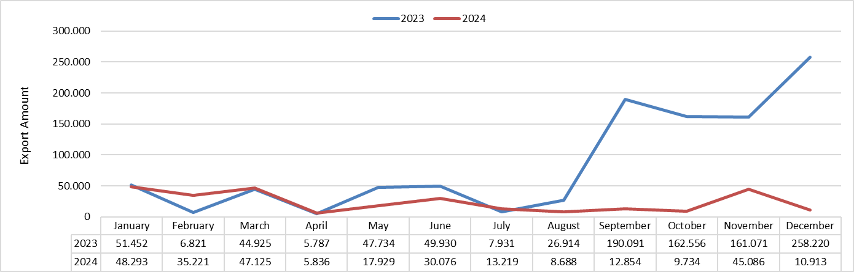

Figure 2.2.1. Distribution of Exports of Gasoline Types by Month in 2023 and 2024 (tons)

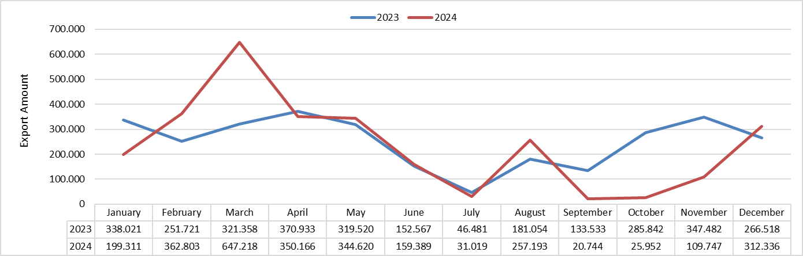

Figure 2.2.2. Distribution of Exports of Diesel Types by Month in 2023 and 2024 (tons)
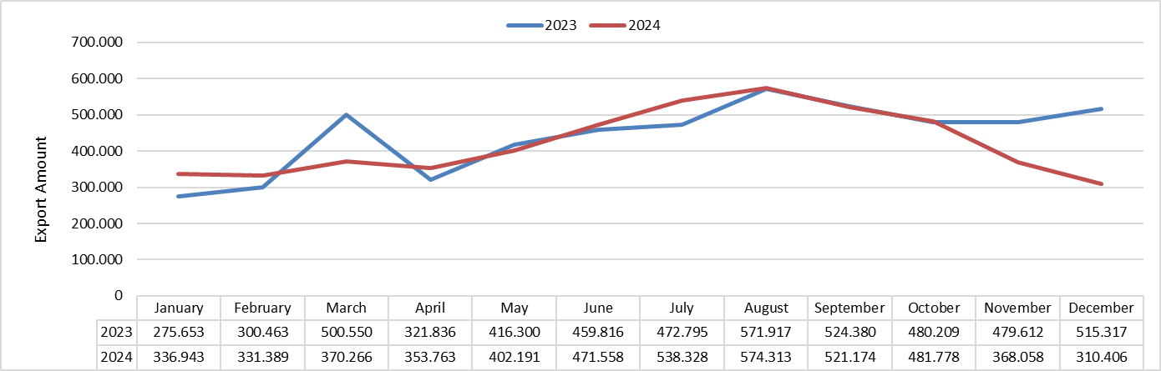

Figure 2.2.3. Distribution of Exports of Aviation Fuels by Month in 2023 and 2024 (tons)

Figure 2.2.4. Distribution of Exports of Marine Fuels by Month in 2023 and 2024 (tons)

CHAPTER THREE: DOMESTIC SALES

Table 3.1. Domestic Sales by License Holders (tons)
License Holder | License Type | Gasoline Types | Diesel Types | Fuel Oil Types | Aviation Fuels | Marine Fuels | Kerosene | Other Products | Total | Share (%)
PETROL OFİSİ A.Ş. | Distributor | 843.190,87 | 5.881.262,16 | 47.279,87 | 230.998,17 | 11.610,16 | 499,55 | 0,00 | 7.014.840,79 | 21,43
SHELL & TURCAS PETROL A.Ş. | Distributor | 1.431.107,02 | 4.373.875,07 | 9.692,25 | 0,00 | 0,00 | 73,09 | 0,00 | 5.814.747,42 | 17,76
OPET PETROLCÜLÜK A.Ş. | Distributor | 1.241.567,54 | 4.456.658,92 | 78.971,04 | 0,00 | 14.572,68 | 281,45 | 0,00 | 5.792.051,63 | 17,69
GÜZEL ENERJİ AKARYAKIT A.Ş. | Distributor | 334.488,83 | 2.121.051,71 | 7.269,72 | 0,00 | 0,00 | 138,09 | 0,00 | 2.462.948,34 | 7,52
BP PETROLLERİ A.Ş. | Distributor | 449.385,07 | 1.637.639,46 | 1.198,17 | 0,00 | 0,00 | 17,13 | 0,00 | 2.088.239,84 | 6,38
TP PETROL DAĞ. A.Ş. | Distributor | 137.063,59 | 1.798.261,88 | 2.248,32 | 0,00 | 239,74 | 0,00 | 0,00 | 1.937.813,53 | 5,92
AYTEMİZ AKARYAKIT DAĞITIM A.Ş. | Distributor | 146.765,53 | 1.445.113,10 | 2.672,92 | 0,00 | 0,00 | 0,00 | 0,00 | 1.594.551,55 | 4,87
SOCAR TURKEY PETROL TİCARET A.Ş. | Distributor | 10.646,61 | 427.445,68 | 19,98 | 0,00 | 18.088,77 | 0,00 | 0,00 | 456.201,04 | 1,39
SOCAR TURKEY PETROL TİCARET A.Ş. | Bunker Delivery | 0,00 | 0,00 | 0,00 | 156.195,44 | 0,00 | 0,00 | 0,00 | 156.195,44 | 0,48
KADOOĞLU PETROLCÜLÜK TAŞIMACILIK TİC. SAN. İTHALAT VE İHRACAT A.Ş. | Distributor | 30.595,90 | 561.361,05 | 3.411,46 | 0,00 | 0,00 | 0,00 | 0,00 | 595.368,41 | 1,82
AKPET AKARYAKIT DAĞITIM A.Ş. | Distributor | 55.450,50 | 481.241,02 | 4.235,49 | 0,00 | 0,00 | 196,93 | 0,00 | 541.123,93 | 1,65
TÜRKİYE PETROL RAFİNERİLERİ A.Ş. | Refinery | 3.026,37 | 27,45 | 44.552,67 | 186.288,07 | 0,00 | 0,00 | 236.650,16 | 470.544,72 | 1,44
ALTINBAŞ PETROL VE TİCARET A.Ş. | Distributor | 23.472,91 | 371.750,65 | 1.511,56 | 0,00 | 0,00 | 0,00 | 0,00 | 396.735,12 | 1,21
THY OPET HAVACILIK YAKITLARI A.Ş. | Bunker Delivery | 0,00 | 0,00 | 0,00 | 374.531,38 | 0,00 | 0,00 | 0,00 | 374.531,38 | 1,14
TERMOPET AKARYAKIT A.Ş. | Distributor | 23.196,15 | 270.180,76 | 7.357,44 | 0,00 | 0,00 | 8,28 | 0,00 | 300.742,63 | 0,92
BALPET PETROL ÜRÜNLERİ TAŞIMACILIK SAN. VE TİC. A.Ş. | Distributor | 16.609,77 | 253.811,37 | 16.337,16 | 0,00 | 0,00 | 0,00 | 0,00 | 286.758,30 | 0,88
TECO PETROLCÜLÜK SAN. VE TİC. A.Ş. | Distributor | 18.443,71 | 215.325,70 | 4.633,68 | 0,00 | 0,00 | 0,00 | 0,00 | 238.403,08 | 0,73
SİYAM PETROLCÜLÜK SAN. VE TİC. A.Ş. | Distributor | 14.205,31 | 221.679,79 | 219,64 | 0,00 | 0,00 | 0,00 | 0,00 | 236.104,74 | 0,72
TFS AKARYAKIT HİZMETLERİ A.Ş. | Bunker Delivery | 0,00 | 0,00 | 0,00 | 221.122,50 | 0,00 | 0,00 | 0,00 | 221.122,50 | 0,68
ENERJİ PETROL ÜRÜNLERİ PAZARLAMA A.Ş. | Distributor | 13.912,36 | 186.518,96 | 918,80 | 0,00 | 0,00 | 0,00 | 0,00 | 201.350,12 | 0,62
İPRA ENERJİ A.Ş. | Distributor | 26.303,86 | 134.507,27 | 727,98 | 0,00 | 0,00 | 0,00 | 0,00 | 161.539,10 | 0,49
KALELİ BEST OİL PETROLCÜLÜK TİC. A.Ş. | Distributor | 10.539,57 | 140.670,85 | 44,74 | 0,00 | 0,00 | 0,00 | 0,00 | 151.255,16 | 0,46
TURKEY AKARYAKIT DAĞITIM A.Ş. | Distributor | 4.224,39 | 146.629,12 | 0,00 | 0,00 | 0,00 | 0,00 | 0,00 | 150.853,50 | 0,46
UZUN GRUBU SAN. VE TİC. A.Ş. | Distributor | 3.249,60 | 110.108,87 | 8.251,98 | 0,00 | 0,00 | 3,90 | 0,00 | 121.614,35 | 0,37
7KITA PETROLCÜLÜK DAĞ. VE PAZARLAMA A.Ş. | Distributor | 6.355,66 | 106.391,16 | 3.113,44 | 0,00 | 0,00 | 0,00 | 0,00 | 115.860,26 | 0,35
HYPCO PETROLCÜLÜK A.Ş. | Distributor | 7.623,22 | 99.809,35 | 37,40 | 0,00 | 0,00 | 0,00 | 0,00 | 107.469,97 | 0,33
BAŞ AKARYAKIT DAĞITIM PAZARLAMA SAN. VE TİC. A.Ş. | Distributor | 2.094,61 | 101.370,98 | 483,30 | 0,00 | 0,00 | 0,00 | 0,00 | 103.948,89 | 0,32
MEMOİL AKARYAKIT DAĞITIM SAN. VE TİC. A.Ş. | Distributor | 4.447,54 | 96.546,00 | 0,00 | 0,00 | 0,00 | 0,00 | 0,00 | 100.993,53 | 0,31
NORM GAZ PETROL ÜRÜNLERİ SAN. TİC. A.Ş. | Distributor | 8.386,00 | 80.520,70 | 0,00 | 0,00 | 0,00 | 0,00 | 0,00 | 88.906,70 | 0,27
ES ES AKARYAKIT DAĞITIM A.Ş. | Distributor | 3.660,77 | 78.827,38 | 24,60 | 0,00 | 0,00 | 0,00 | 0,00 | 82.512,75 | 0,25
VTM AKARYAKIT PETROL ÜRÜNLERİ DAĞ. SAN. VE TİC. A.Ş. | Distributor | 6.938,82 | 59.010,54 | 0,00 | 0,00 | 0,00 | 0,00 | 0,00 | 65.949,36 | 0,20
PETLİNE PETROL ÜRÜNLERİ TİC. A.Ş. | Distributor | 5.442,43 | 50.810,59 | 195,32 | 0,00 | 0,00 | 0,00 | 0,00 | 56.448,34 | 0,17
MFD AKARYAKIT NAKLİYAT TURİZM İNŞAAT TAŞIMACILIK SAN. VE TİC. LTD. ŞTİ. | Distributor | 3.001,14 | 36.873,81 | 0,00 | 0,00 | 0,00 | 0,00 | 0,00 | 39.874,95 | 0,12
EUROİL ENERJİ DAĞITIM A.Ş. | Distributor | 1.948,79 | 30.687,92 | 136,70 | 0,00 | 0,00 | 0,00 | 0,00 | 32.773,41 | 0,10
RPET PETROLCÜLÜK A.Ş. | Distributor | 1.259,75 | 29.424,61 | 212,28 | 0,00 | 0,00 | 0,00 | 0,00 | 30.896,64 | 0,09
LPGAS ENERJİ A.Ş. | Distributor | 2.204,38 | 26.615,26 | 0,00 | 0,00 | 0,00 | 0,00 | 0,00 | 28.819,64 | 0,09
FOX PETROLCÜLÜK A.Ş. | Distributor | 428,01 | 26.647,28 | 338,68 | 0,00 | 0,00 | 0,00 | 0,00 | 27.413,97 | 0,08
ÇLB PETROLCÜLÜK A.Ş. | Distributor | 674,89 | 13.878,44 | 170,50 | 0,00 | 0,00 | 0,00 | 0,00 | 14.723,83 | 0,04
SHELL COMPANY OF TÜRKİYE LİMİTED MERKEZİ LONDRA TÜRKİYE ŞUBESİ | Bunker Delivery | 0,00 | 0,00 | 0,00 | 11.739,61 | 0,00 | 0,00 | 0,00 | 11.739,61 | 0,04
ERGAZ AKARYAKIT LPG LNG CNG DAĞITIM SAN. VE TİC. LTD. ŞTİ. | Distributor | 615,05 | 8.426,10 | 0,00 | 0,00 | 0,00 | 0,00 | 0,00 | 9.041,16 | 0,03
ASTON PETROLLERİ A.Ş. | Distributor | 254,65 | 7.291,40 | 936,32 | 0,00 | 0,00 | 0,00 | 0,00 | 8.482,37 | 0,03
LİMAN PETROLCÜLÜK DAĞITIM A.Ş. | Distributor | 244,52 | 7.103,98 | 0,00 | 0,00 | 0,00 | 0,00 | 0,00 | 7.348,50 | 0,02
GÖZEN HAVACILIK VE TİCARET A.Ş. | Bunker Delivery | 0,00 | 0,00 | 0,00 | 6.465,39 | 0,00 | 0,00 | 0,00 | 6.465,39 | 0,02
AS-MİRA PETROL VE KİMYA ÜRÜNLERİ NAKLİYE SAN. VE TİC. A.Ş. | Bunker Delivery | 0,00 | 6.067,43 | 0,00 | 0,00 | 0,00 | 0,00 | 0,00 | 6.067,43 | 0,02
İSTANBUL JET HAVACILIK VE YAKIT HİZMETLERİ A.Ş. | Bunker Delivery | 0,00 | 0,00 | 0,00 | 4.933,88 | 0,00 | 0,00 | 0,00 | 4.933,88 | 0,02
MODOĞLU İNŞAAT SANAYİ VE PETROL ÜRÜNLERİ LTD. ŞTİ. | Bunker Delivery | 979,70 | 3.369,74 | 0,00 | 0,00 | 0,00 | 0,00 | 0,00 | 4.349,44 | 0,01
A/B PETROL ÜRÜNLERİ PAZARLAMA SAN. VE TİC. LTD. ŞTİ. | Bunker Delivery | 0,00 | 3.810,49 | 0,00 | 0,00 | 0,00 | 0,00 | 0,00 | 3.810,49 | 0,01
AS YAKIT PETROL SAN. VE TİC. A.Ş. | Bunker Delivery | 0,00 | 3.342,16 | 0,00 | 0,00 | 0,00 | 0,00 | 0,00 | 3.342,16 | 0,01
GÖKÇEN HAVACILIK TAŞIMACILIK EĞİTİM VE PETROL ÜRÜNLERİ TİCARET A.Ş. | Bunker Delivery | 0,00 | 0,00 | 0,00 | 2.082,82 | 0,00 | 0,00 | 0,00 | 2.082,82 | 0,01
GRUP GLOBAL PETROL TAŞIMACILIK GIDA SAN. VE TİC. LTD. ŞTİ. | Bunker Delivery | 0,00 | 1.973,62 | 0,00 | 0,00 | 0,00 | 0,00 | 0,00 | 1.973,62 | 0,01
MAGNUS HELICOPTERS HELİKOPTER SAN. TİC. A.Ş. | Bunker Delivery | 0,00 | 0,00 | 0,00 | 1.346,22 | 0,00 | 0,00 | 0,00 | 1.346,22 | 0,00
EAB ULUSLARARASI HAVACILIK SAN. VE TİC. LTD. ŞTİ. | Bunker Delivery | 0,00 | 0,00 | 0,00 | 1.324,36 | 0,00 | 0,00 | 0,00 | 1.324,36 | 0,00
TEMAR DENİZCİLİK VE TİCARET A.Ş. | Bunker Delivery | 0,00 | 1.047,14 | 0,00 | 0,00 | 0,00 | 0,00 | 0,00 | 1.047,14 | 0,00
GÜNEYDOĞU HAVACILIK İŞLETMESİ A.Ş. | Bunker Delivery | 0,00 | 0,00 | 0,00 | 988,06 | 0,00 | 0,00 | 0,00 | 988,06 | 0,00
ERDEM PETROL ÜRÜNLERİ SANAYİ PAZARLAMA LTD. ŞTİ. | Bunker Delivery | 0,00 | 825,93 | 0,00 | 0,00 | 0,00 | 0,00 | 0,00 | 825,93 | 0,00
GOKCEK ELEKTRONİK OTOMOTİV HAVACILIK İNŞAAT TURİZM SAN. TİC. LTD. ŞTİ. | Bunker Delivery | 0,00 | 0,00 | 0,00 | 566,36 | 0,00 | 0,00 | 0,00 | 566,36 | 0,00
KAAN HAVACILIK SAN. VE TİC. A.Ş. | Bunker Delivery | 0,00 | 0,00 | 0,00 | 518,59 | 0,00 | 0,00 | 0,00 | 518,59 | 0,00
SEYMEN PETROL İNŞAAT TURİZM NAKLİYAT VE MADENCİLİK TİC. LTD. ŞTİ. | Bunker Delivery | 0,00 | 235,29 | 0,00 | 0,00 | 0,00 | 0,00 | 0,00 | 235,29 | 0,00
ZONAİR İHRAKİYE AKARYAKIT MADENİ YAĞ LPG SAN. VE TİC. LTD. ŞTİ. | Bunker Delivery | 0,00 | 0,00 | 0,00 | 228,03 | 0,00 | 0,00 | 0,00 | 228,03 | 0,00
SEMERKAN DENİZCİLİK VE NAKLİYAT TİC. LTD. ŞTİ. | Bunker Delivery | 0,00 | 201,38 | 0,00 | 0,00 | 0,00 | 0,00 | 0,00 | 201,38 | 0,00
BROTHER DENİZCİLİK İŞLETMECİLİK SAN. VE TİC. LTD. ŞTİ. | Bunker Delivery | 0,00 | 158,57 | 0,00 | 0,00 | 0,00 | 0,00 | 0,00 | 158,57 | 0,00
WEST BUNKER PETROL DENİZCİLİK TİCARET LTD. ŞTİ. | Bunker Delivery | 0,00 | 111,85 | 0,00 | 0,00 | 0,00 | 0,00 | 0,00 | 111,85 | 0,00
VİMTAŞ TAAHHÜT TURİZM AKARYAKIT TARIM ÜRÜNLERİNİ DEĞERLENDİRME TİCARET VE SANAYİ A.Ş. | Bunker Delivery | 0,00 | 65,98 | 0,00 | 0,00 | 0,00 | 0,00 | 0,00 | 65,98 | 0,00
KALİMAS DENİZCİLİK PETROL TİCARET A.Ş. | Bunker Delivery | 0,00 | 61,98 | 0,00 | 0,00 | 0,00 | 0,00 | 0,00 | 61,98 | 0,00
ACM AIR CHARTER MARKET UÇAK SERVİSİ VE TURİZM HİZMETLERİ LTD. ŞTİ. | Bunker Delivery | 0,00 | 0,00 | 0,00 | 58,90 | 0,00 | 0,00 | 0,00 | 58,90 | 0,00
CK PETROL İNŞAAT TURİZM TİCARET LTD. ŞTİ. | Bunker Delivery | 0,00 | 36,27 | 0,00 | 0,00 | 0,00 | 0,00 | 0,00 | 36,27 | 0,00
KALKAVAN DENİZ NAKLİYAT GIDA BİLGİSAYAR TİC. LTD. ŞTİ. | Bunker Delivery | 0,00 | 17,65 | 0,00 | 0,00 | 0,00 | 0,00 | 0,00 | 17,65 | 0,00
POTAS AKDENİZ AKARYAKIT DAĞITIM A.Ş. | Bunker Delivery | 0,00 | 0,00 | 0,00 | 10,90 | 0,00 | 0,00 | 0,00 | 10,90 | 0,00
Total |  | 4.894.005,37 | 26.116.681,81 | 247.203,41 | 1.199.398,68 | 44.511,36 | 1.218,42 | 236.650,16 | 32.739.669,21 | 100

Table 3.2. Domestic Sales by Province (tons)
Province | Gasoline Types | Diesel Types | Fuel Oil Types | Aviation Fuels | Marine Fuels | Kerosene | Other Products | Total | Share (%)
İSTANBUL | 1.135.677,11 | 3.440.540,42 | 18.831,64 | 405.181,39 | 3.924,74 | 152,81 | 11,81 | 5.004.319,91 | 15,29
ANKARA | 438.883,55 | 1.936.180,44 | 52.871,94 | 277.409,00 | 0,00 | 140,43 | 236.638,32 | 2.942.123,68 | 8,99
İZMİR | 306.612,42 | 1.348.613,37 | 4.358,48 | 75.374,38 | 8.833,96 | 234,75 | 0,00 | 1.744.027,35 | 5,33
BURSA | 231.460,54 | 1.035.912,10 | 5.584,84 | 2.182,70 | 0,00 | 0,00 | 0,00 | 1.275.140,18 | 3,89
ANTALYA | 200.556,42 | 829.611,95 | 8.510,54 | 59.819,79 | 0,00 | 6,79 | 0,00 | 1.098.505,48 | 3,36
KOCAELİ | 154.686,13 | 773.207,76 | 481,84 | 98,85 | 9.988,89 | 56,52 | 0,00 | 938.519,99 | 2,87
MUĞLA | 125.656,42 | 485.665,37 | 294,06 | 45.089,82 | 0,00 | 0,00 | 0,00 | 656.705,67 | 2,01
MERSİN | 108.527,33 | 832.049,72 | 1.840,60 | 303,27 | 0,00 | 62,71 | 0,00 | 942.783,63 | 2,88
ADANA | 105.737,38 | 587.295,69 | 2.019,30 | 34.936,68 | 0,00 | 17,97 | 0,00 | 730.007,02 | 2,23
BALIKESİR | 103.908,83 | 462.363,27 | 1.844,46 | 1.673,79 | 0,00 | 32,73 | 0,00 | 569.823,08 | 1,74
KONYA | 100.458,76 | 931.206,37 | 4.148,94 | 5.137,91 | 0,00 | 163,78 | 0,00 | 1.041.115,76 | 3,18
MANİSA | 92.041,94 | 595.456,22 | 5.677,22 | 114,22 | 0,00 | 0,00 | 0,00 | 693.289,60 | 2,12
GAZİANTEP | 87.255,01 | 701.521,37 | 27.157,84 | 27.834,64 | 0,00 | 0,00 | 0,00 | 843.768,85 | 2,58
TEKİRDAĞ | 81.282,24 | 402.771,92 | 1.890,66 | 845,07 | 3.430,00 | 0,00 | 0,00 | 490.219,89 | 1,50
AYDIN | 79.387,49 | 354.903,30 | 1.802,30 | 779,33 | 0,00 | 0,00 | 0,00 | 436.872,43 | 1,33
SAKARYA | 77.859,52 | 400.520,59 | 442,92 | 16,33 | 0,00 | 0,00 | 0,03 | 478.839,38 | 1,46
HATAY | 71.523,28 | 518.756,07 | 762,56 | 3.794,23 | 532,16 | 11,87 | 0,00 | 595.380,16 | 1,82
KAYSERİ | 70.686,50 | 437.373,06 | 860,72 | 18.807,49 | 0,00 | 54,00 | 0,00 | 527.781,76 | 1,61
SAMSUN | 64.361,39 | 437.341,15 | 874,92 | 12.485,36 | 0,00 | 0,00 | 0,00 | 515.062,81 | 1,57
DENİZLİ | 56.903,90 | 483.377,78 | 1.166,18 | 3.376,33 | 0,00 | 3,90 | 0,00 | 544.828,09 | 1,66
ESKİŞEHİR | 53.075,21 | 290.409,41 | 3.661,89 | 503,86 | 0,00 | 0,00 | 0,00 | 347.650,38 | 1,06
DİYARBAKIR | 49.627,07 | 302.357,47 | 2.137,68 | 21.998,44 | 0,00 | 0,00 | 0,00 | 376.120,65 | 1,15
ÇANAKKALE | 49.226,27 | 220.614,58 | 6.015,15 | 2.277,63 | 2.625,53 | 0,00 | 0,00 | 280.759,16 | 0,86
ŞANLIURFA | 45.233,77 | 372.725,87 | 504,90 | 10.337,33 | 0,00 | 0,00 | 0,00 | 428.801,87 | 1,31
TRABZON | 44.073,61 | 206.972,58 | 1.099,90 | 35.135,53 | 0,00 | 12,35 | 0,00 | 287.293,97 | 0,88
KAHRAMANMARAŞ | 41.738,49 | 332.544,31 | 7.978,60 | 2.805,36 | 0,00 | 0,00 | 0,00 | 385.066,76 | 1,18
EDİRNE | 41.728,06 | 722.584,78 | 1.910,48 | 0,00 | 0,00 | 0,00 | 0,00 | 766.223,31 | 2,34
BOLU | 40.754,34 | 221.418,35 | 100,66 | 15,72 | 0,00 | 0,00 | 0,00 | 262.289,07 | 0,80
AFYONKARAHİSAR | 39.305,12 | 294.805,36 | 517,00 | 57,11 | 0,00 | 0,00 | 0,00 | 334.684,59 | 1,02
MALATYA | 31.470,54 | 196.520,25 | 181,70 | 7.554,35 | 0,00 | 41,63 | 0,00 | 235.768,47 | 0,72
ORDU | 31.101,37 | 175.007,52 | 880,14 | 9.416,41 | 0,00 | 13,13 | 0,00 | 216.418,57 | 0,66
KIRKLARELİ | 30.159,06 | 155.110,01 | 3.639,30 | 13,52 | 0,00 | 53,47 | 0,00 | 188.975,36 | 0,58
ERZURUM | 28.712,61 | 168.420,94 | 521,24 | 13.320,91 | 0,00 | 0,00 | 0,00 | 210.975,70 | 0,64
DÜZCE | 27.495,39 | 182.983,23 | 900,63 | 0,00 | 0,00 | 0,00 | 0,00 | 211.379,25 | 0,65
ZONGULDAK | 27.208,43 | 203.489,78 | 1.025,83 | 264,93 | 15.176,09 | 18,94 | 0,00 | 247.184,00 | 0,75
SİVAS | 26.931,46 | 201.056,41 | 1.720,20 | 3.693,93 | 0,00 | 0,00 | 0,00 | 233.402,00 | 0,71
KÜTAHYA | 26.142,12 | 257.264,28 | 3.056,96 | 431,55 | 0,00 | 0,00 | 0,00 | 286.894,91 | 0,88
ELAZIĞ | 23.934,70 | 164.600,70 | 11.762,86 | 8.870,15 | 0,00 | 0,00 | 0,00 | 209.168,41 | 0,64
YALOVA | 23.558,53 | 105.212,10 | 345,28 | 1,16 | 0,00 | 0,00 | 0,00 | 129.117,07 | 0,39
ÇORUM | 23.546,61 | 193.981,54 | 1.193,02 | 0,00 | 0,00 | 17,13 | 0,00 | 218.738,30 | 0,67
TOKAT | 23.351,35 | 154.180,14 | 204,10 | 1.658,32 | 0,00 | 11,77 | 0,00 | 179.405,68 | 0,55
AKSARAY | 23.285,33 | 177.422,65 | 0,00 | 0,00 | 0,00 | 0,00 | 0,00 | 200.707,98 | 0,61
ISPARTA | 23.021,95 | 146.346,43 | 2.081,02 | 1.178,38 | 0,00 | 5,94 | 0,00 | 172.633,72 | 0,53
OSMANİYE | 21.349,21 | 108.887,27 | 47,22 | 0,00 | 0,00 | 0,00 | 0,00 | 130.283,70 | 0,40
VAN | 20.556,00 | 139.887,90 | 12.209,06 | 19.988,85 | 0,00 | 0,00 | 0,00 | 192.641,80 | 0,59
KASTAMONU | 19.203,04 | 148.283,44 | 297,40 | 656,95 | 0,00 | 46,70 | 0,00 | 168.487,54 | 0,51
MARDİN | 18.544,83 | 146.261,10 | 351,96 | 9.139,99 | 0,00 | 0,00 | 0,00 | 174.297,88 | 0,53
GİRESUN | 18.430,47 | 113.288,67 | 0,00 | 0,00 | 0,00 | 45,32 | 0,00 | 131.764,46 | 0,40
NEVŞEHİR | 18.085,06 | 167.396,02 | 24,60 | 6.187,21 | 0,00 | 0,00 | 0,00 | 191.692,90 | 0,59
UŞAK | 18.019,21 | 119.737,21 | 5.526,40 | 274,70 | 0,00 | 0,00 | 0,00 | 143.557,52 | 0,44
ADIYAMAN | 17.605,48 | 192.142,68 | 0,00 | 4.219,93 | 0,00 | 0,00 | 0,00 | 213.968,09 | 0,65
AMASYA | 16.266,76 | 150.532,69 | 300,82 | 1.151,16 | 0,00 | 5,48 | 0,00 | 168.256,91 | 0,51
RİZE | 15.798,69 | 111.594,81 | 0,00 | 12.917,34 | 0,00 | 0,00 | 0,00 | 140.310,84 | 0,43
BURDUR | 15.654,95 | 152.702,06 | 2.015,22 | 0,00 | 0,00 | 0,00 | 0,00 | 170.372,23 | 0,52
NİĞDE | 15.576,95 | 210.846,51 | 3.581,82 | 0,00 | 0,00 | 0,00 | 0,00 | 230.005,28 | 0,70
BİLECİK | 14.543,68 | 95.440,84 | 35,00 | 0,00 | 0,00 | 0,00 | 0,00 | 110.019,52 | 0,34
YOZGAT | 14.305,79 | 158.764,49 | 50,40 | 0,00 | 0,00 | 8,28 | 0,00 | 173.128,96 | 0,53
KIRIKKALE | 13.399,82 | 209.743,02 | 930,42 | 0,00 | 0,00 | 0,00 | 0,00 | 224.073,26 | 0,68
BATMAN | 13.357,34 | 191.322,79 | 3.306,74 | 7.877,82 | 0,00 | 0,00 | 0,00 | 215.864,68 | 0,66
ERZİNCAN | 11.945,21 | 96.090,84 | 155,72 | 5.378,91 | 0,00 | 0,00 | 0,00 | 113.570,68 | 0,35
KARABÜK | 11.601,80 | 105.702,00 | 367,82 | 0,00 | 0,00 | 0,00 | 0,00 | 117.671,62 | 0,36
ÇANKIRI | 11.275,58 | 112.149,85 | 239,96 | 0,00 | 0,00 | 0,00 | 0,00 | 123.665,39 | 0,38
KIRŞEHİR | 10.239,63 | 57.738,77 | 0,00 | 0,00 | 0,00 | 0,00 | 0,00 | 67.978,40 | 0,21
SİNOP | 10.125,07 | 52.948,05 | 187,72 | 945,37 | 0,00 | 0,00 | 0,00 | 64.206,20 | 0,20
BARTIN | 9.152,15 | 35.917,95 | 138,36 | 0,47 | 0,00 | 0,00 | 0,00 | 45.208,93 | 0,14
KARAMAN | 8.550,43 | 65.362,95 | 0,00 | 0,00 | 0,00 | 0,00 | 0,00 | 73.913,39 | 0,23
AĞRI | 7.759,99 | 102.149,85 | 144,56 | 4.369,83 | 0,00 | 0,00 | 0,00 | 114.424,23 | 0,35
KARS | 7.530,73 | 44.617,49 | 6.425,37 | 7.796,75 | 0,00 | 0,00 | 0,00 | 66.370,33 | 0,20
ŞIRNAK | 7.437,27 | 129.521,77 | 16.342,92 | 6.013,32 | 0,00 | 0,00 | 0,00 | 159.315,28 | 0,49
ARTVİN | 7.099,92 | 45.169,47 | 0,00 | 0,00 | 0,00 | 0,00 | 0,00 | 52.269,39 | 0,16
BİNGÖL | 7.097,53 | 44.797,96 | 0,00 | 2.576,94 | 0,00 | 0,00 | 0,00 | 54.472,43 | 0,17
KİLİS | 6.597,16 | 23.053,22 | 0,00 | 0,00 | 0,00 | 0,00 | 0,00 | 29.650,38 | 0,09
MUŞ | 6.329,70 | 54.711,51 | 25,24 | 6.428,53 | 0,00 | 0,00 | 0,00 | 67.494,99 | 0,21
BİTLİS | 6.194,12 | 74.994,30 | 74,62 | 2,43 | 0,00 | 0,00 | 0,00 | 81.265,48 | 0,25
SİİRT | 4.791,17 | 65.565,45 | 1.176,38 | 1.255,45 | 0,00 | 0,00 | 0,00 | 72.788,45 | 0,22
IĞDIR | 4.672,65 | 24.803,06 | 0,00 | 5.156,01 | 0,00 | 0,00 | 0,00 | 34.631,72 | 0,11
GÜMÜŞHANE | 4.436,70 | 32.276,84 | 263,40 | 0,00 | 0,00 | 0,00 | 0,00 | 36.976,95 | 0,11
HAKKARİ | 3.330,78 | 30.708,03 | 25,10 | 2.254,59 | 0,00 | 0,00 | 0,00 | 36.318,51 | 0,11
ARDAHAN | 3.097,12 | 25.820,27 | 0,00 | 0,00 | 0,00 | 0,00 | 0,00 | 28.917,39 | 0,09
BAYBURT | 2.970,36 | 19.493,87 | 0,00 | 0,00 | 0,00 | 0,00 | 0,00 | 22.464,23 | 0,07
TUNCELİ | 2.925,47 | 15.560,24 | 98,68 | 10,97 | 0,00 | 0,00 | 0,00 | 18.595,36 | 0,06
Total | 4.894.005,37 | 26.116.681,81 | 247.203,41 | 1.199.398,68 | 44.511,36 | 1.218,42 | 236.650,16 | 32.739.669,21 | 100

Table 3.3. Comparison of Total Domestic Sales in 2023 and 2024
Product Type | 2023 |  | 2024 |  | Change (%)
Product Type | Amount (tons) | Share (%) | Amount (tons) | Share (%) | Change (%)
Gasoline Types | 4.073.775,36 | 12,78 | 4.894.005,37 | 14,95 | 20,13
Diesel Types | 26.023.682,96 | 81,61 | 26.116.681,81 | 79,77 | 0,36
Fuel Oil Types | 317.963,27 | 1,00 | 247.203,41 | 0,76 | -22,25
Aviation Fuels | 1.219.271,00 | 3,82 | 1.199.398,68 | 3,66 | -1,63
Marine Fuels | 31.349,64 | 0,10 | 44.511,36 | 0,14 | 41,98
Kerosene | 1.477,94 | 0,00 | 1.218,42 | 0,00 | -17,56
Other Products | 218.529,08 | 0,69 | 236.650,16 | 0,72 | 8,29
Total | 31.886.049,26 | 100 | 32.739.669,21 | 100 | 2,68

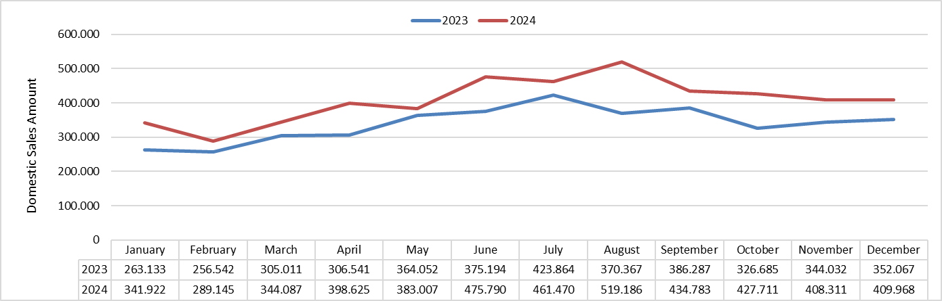

Figure 3.1. Distribution of Gasoline Sales by Month in 2023 and 2024 (tons)

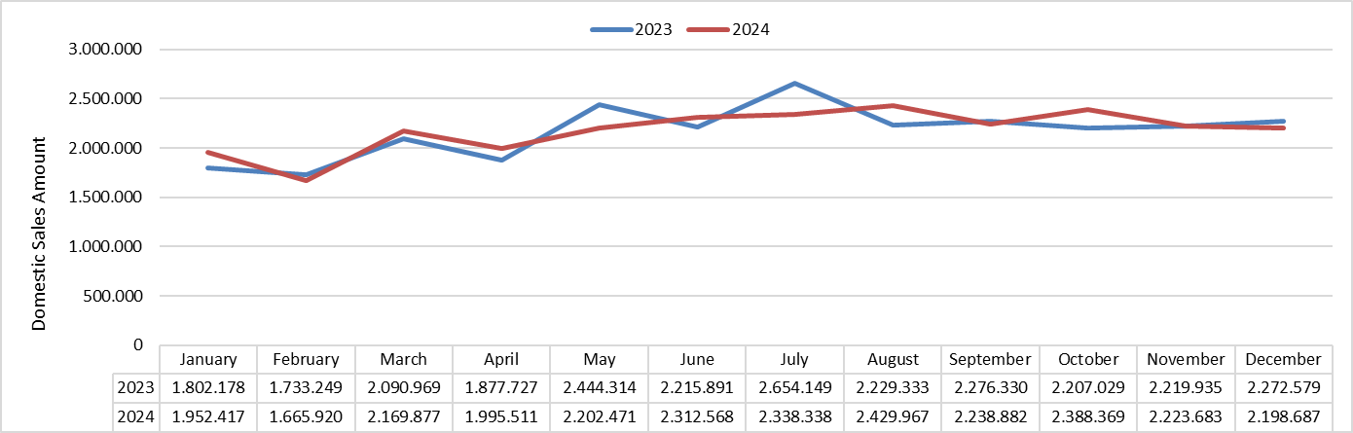

Figure 3.2. Distribution of Diesel Sales by Month in 2023 and 2024 (tons)
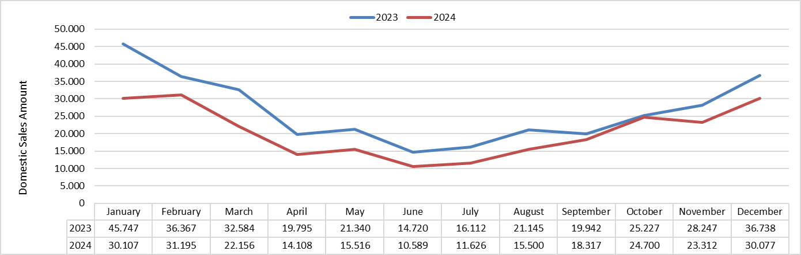

Figure 3.3. Distribution of Fuel Oil Type Sales by Month in 2023 and 2024 (tons)

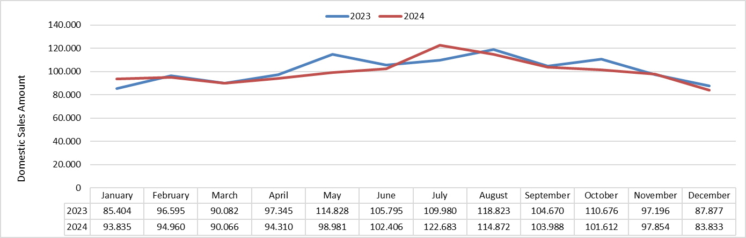

Figure 3.4. Distribution of Aviation Fuel Sales by Month in 2023 and 2024 (tons)
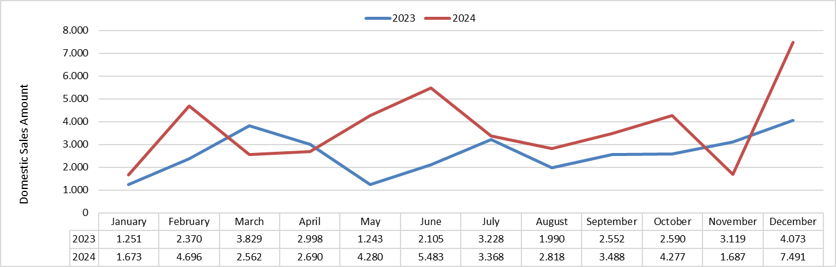

Figure 3.5. Distribution of Marine Fuel Sales by Month in 2023 and 2024 (tons)

Table 3.4. Domestic Fuel Sales and Market Shares (%) of Distributor License Holders
Licence Holder | Gasoline Types | Diesel Types | Fuel Oil Types | Kerosene | Total | Share (%)
PETROL OFİSİ A.Ş. | 841.790,02 | 5.676.539,60 | 47.279,87 | 499,55 | 6.566.109,04 | 21,33
SHELL & TURCAS PETROL A.Ş. | 1.431.107,02 | 4.360.182,05 | 9.692,25 | 73,09 | 5.801.054,40 | 18,85
OPET PETROLCÜLÜK A.Ş. | 1.240.286,82 | 4.420.734,77 | 78.971,04 | 281,45 | 5.740.274,08 | 18,65
GÜZEL ENERJİ AKARYAKIT A.Ş. | 334.488,83 | 2.105.447,42 | 7.269,72 | 138,09 | 2.447.344,06 | 7,95
BP PETROLLERİ A.Ş. | 449.385,07 | 1.637.639,46 | 1.198,17 | 17,13 | 2.088.239,84 | 6,78
TP PETROL DAĞITIM A.Ş. | 136.948,54 | 1.783.469,80 | 2.248,32 | 0,00 | 1.922.666,66 | 6,25
AYTEMİZ AKARYAKIT DAĞITIM A.Ş. | 146.765,53 | 1.445.113,10 | 2.672,92 | 0,00 | 1.594.551,55 | 5,18
KADOOĞLU PETROLCÜLÜK TAŞIMACILIK TİCARET SANAYİ İTHALAT VE İHRACAT A.Ş. | 30.595,90 | 561.361,05 | 3.411,46 | 0,00 | 595.368,41 | 1,93
AKPET AKARYAKIT DAĞITIM A.Ş. | 55.450,50 | 473.865,60 | 4.205,73 | 196,93 | 533.718,75 | 1,73
ALTINBAŞ PETROL VE TİCARET A.Ş. | 23.472,91 | 367.227,13 | 1.511,56 | 0,00 | 392.211,60 | 1,27
SOCAR TURKEY PETROL TİCARET A.Ş. | 10.646,61 | 359.047,68 | 19,98 | 0,00 | 369.714,28 | 1,20
BALPET PETROL ÜRÜNLERİ TAŞIMACILIK SAN. VE TİC. A.Ş. | 16.609,77 | 250.539,12 | 16.337,16 | 0,00 | 283.486,05 | 0,92
TERMOPET AKARYAKIT A.Ş. | 23.196,15 | 248.068,90 | 7.357,44 | 8,28 | 278.630,76 | 0,91
TECO PETROLCÜLÜK SAN. VE TİC. A.Ş. | 18.443,71 | 214.637,44 | 4.633,68 | 0,00 | 237.714,82 | 0,77
SİYAM PETROLCÜLÜK SAN. VE TİC. A.Ş. | 14.205,31 | 209.002,41 | 219,64 | 0,00 | 223.427,36 | 0,73
ENERJİ PETROL ÜRÜNLERİ PAZARLAMA A.Ş. | 13.912,36 | 186.518,96 | 918,80 | 0,00 | 201.350,12 | 0,65
İPRA ENERJİ A.Ş. | 26.303,86 | 134.507,27 | 727,98 | 0,00 | 161.539,10 | 0,52
KALELİ BEST OİL PETROLCÜLÜK TİCARET A.Ş. | 10.539,57 | 140.670,85 | 44,74 | 0,00 | 151.255,16 | 0,49
TURKEY AKARYAKIT DAĞITIM A.Ş. | 4.224,39 | 146.629,12 | 0,00 | 0,00 | 150.853,50 | 0,49
UZUN GRUBU SAN. VE TİC. A.Ş. | 3.249,60 | 110.108,87 | 8.251,98 | 3,90 | 121.614,35 | 0,40
7KITA PETROLCÜLÜK DAĞITIM VE PAZARLAMA A.Ş. | 6.355,66 | 106.391,16 | 3.113,44 | 0,00 | 115.860,26 | 0,38
HYPCO PETROLCÜLÜK A.Ş. | 7.623,22 | 99.809,35 | 37,40 | 0,00 | 107.469,97 | 0,35
BAŞ AKARYAKIT DAĞITIM PAZARLAMA SAN. VE TİC. A.Ş. | 2.094,61 | 101.370,98 | 483,30 | 0,00 | 103.948,89 | 0,34
MEMOİL AKARYAKIT DAĞITIM SAN. VE TİC. A.Ş. | 4.447,54 | 96.546,00 | 0,00 | 0,00 | 100.993,53 | 0,33
NORM GAZ PETROL ÜRÜNLERİ SAN. TİC. A.Ş. | 8.386,00 | 80.520,70 | 0,00 | 0,00 | 88.906,70 | 0,29
ES ES AKARYAKIT DAĞITIM A.Ş. | 3.660,77 | 78.827,38 | 24,60 | 0,00 | 82.512,75 | 0,27
VTM AKARYAKIT PETROL ÜRÜNLERİ DAĞITIM SAN. VE TİC. A.Ş. | 6.938,82 | 59.010,54 | 0,00 | 0,00 | 65.949,36 | 0,21
PETLİNE PETROL ÜRÜNLERİ TİCARET A.Ş. | 5.442,43 | 50.810,59 | 195,32 | 0,00 | 56.448,34 | 0,18
MFD AKARYAKIT NAKLİYAT TURİZM İNŞAAT TAŞIMACILIK SAN. VE TİC. LTD. ŞTİ. | 3.001,14 | 36.873,81 | 0,00 | 0,00 | 39.874,95 | 0,13
EUROİL ENERJİ DAĞITIM A.Ş. | 1.948,79 | 30.687,92 | 136,70 | 0,00 | 32.773,41 | 0,11
RPET PETROLCÜLÜK A.Ş. | 1.259,75 | 29.424,61 | 212,28 | 0,00 | 30.896,64 | 0,10
LPGAS ENERJİ A.Ş. | 2.204,38 | 26.615,26 | 0,00 | 0,00 | 28.819,64 | 0,09
FOX PETROLCÜLÜK A.Ş. | 428,01 | 26.647,28 | 338,68 | 0,00 | 27.413,97 | 0,09
ÇLB PETROLCÜLÜK A.Ş. | 674,89 | 13.878,44 | 170,50 | 0,00 | 14.723,83 | 0,05
ERGAZ AKARYAKIT LPG LNG CNG DAĞITIM SAN. VE TİC. LTD. ŞTİ. | 615,05 | 8.426,10 | 0,00 | 0,00 | 9.041,16 | 0,03
ASTON PETROLLERİ A.Ş. | 254,65 | 7.291,40 | 936,32 | 0,00 | 8.482,37 | 0,03
LİMAN PETROLCÜLÜK DAĞITIM A.Ş. | 244,52 | 7.103,98 | 0,00 | 0,00 | 7.348,50 | 0,02
Total | 4.887.202,67 | 25.691.546,10 | 202.620,98 | 1.218,42 | 30.782.588,18 | 100

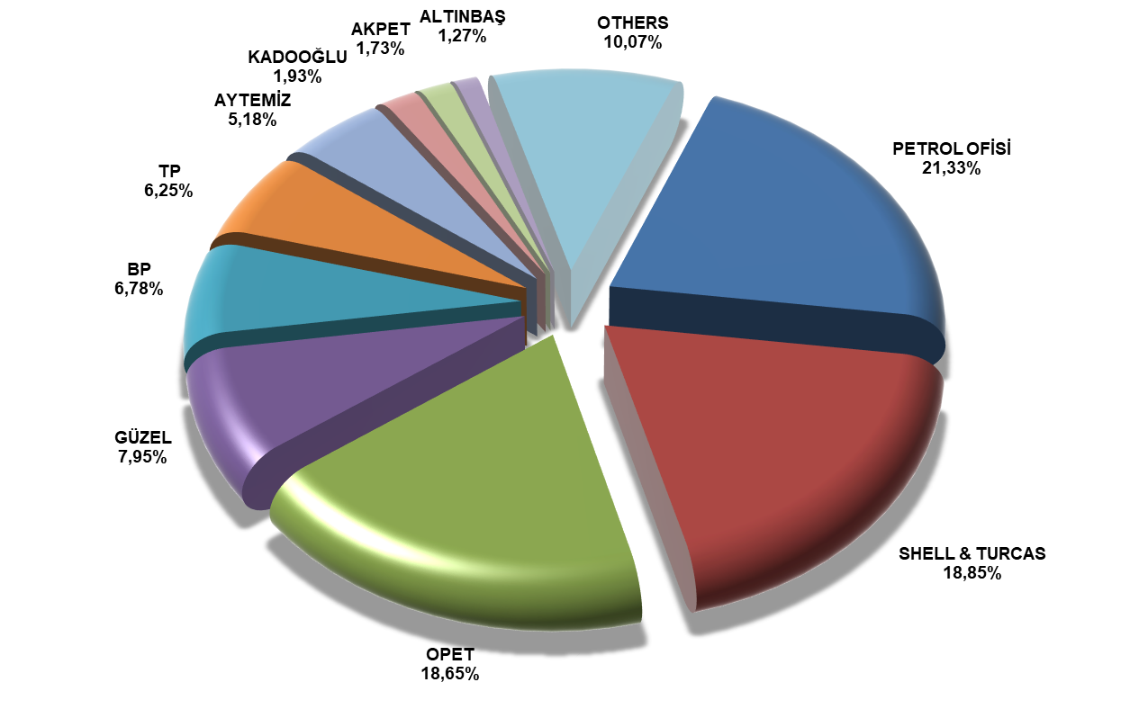

Figure 3.6. Market Shares of the Top 10 Distributor License Holders by Fuel Sales (%)

COMPETITION IN THE OIL MARKET

The petroleum market is generally recognized as a competitive market by sector players. In this sector, the sales volumes of distribution companies in terms of breakdowns (gasoline, diesel and total) and their corresponding market shares are known (see Table 3.4). Based on these sales shares, a number of indices commonly used in energy markets are calculated and interpreted in this section to see how companies shape this competitive market and to measure the level of concentration.

Concentration, in its most general definition, refers to the situation in which sales in the market are controlled by a small number of firms; how close a market is to monopoly or perfect competition can be analyzed basically by the Concentration Ratio (${CR}_{n}$). ${CR}_{n}$, denotes the total market shares of a certain number of firms ($n)$. In this case, ${CR}_{4}$and ${CR}_{10}$correspond to the sum of the market shares of the top 4 and 10 firms with the largest market share in the oil market, respectively. Although there are different interpretations as a result of the calculations, in general, ${CR}_{n} <30$ indicates a low degree of concentration, $30 ≤{CR}_{n}<50$ indicates a moderate degree of concentration, $50 ≤{CR}_{n}<70$ indicates a high degree of concentration, and ${CR}_{n}≥70$ indicates a very high degree of concentration.

Since the Herfindahl Hirschman Index (HHI) is calculated based on the market shares of all firms operating in the market, it is considered more reliable than the Concentration Ratio. The HHI value obtained by summing the squares of the shares of each firm in the market indicates no concentration if it is below 1.500, moderate concentration if it is between 1.500 and 2.500, and high concentration if it is above 2.500. This index is higher both as the number of firms in the market decreases and as the difference between market players in terms of firm size increases.

The Entropy Index (EI), another index used to measure concentration, takes into account all market players like the HHI and is calculated based on logarithmic values. While firms with a market share of less than 1% have little effect on the HHI calculation, the Entropy Index is considered to be one of the most effective concentration measurement methods since it includes all large and small firms on the logarithmic axis. This index, which is calculated with the formula $EI=-\sum_{i=1}^{n}{P_{i}*\log{P_{i}}}$, takes values between 0 and log(n), where $P_{i}$ is the market share of each firm out of n firms in the oil market. The closeness of the EI value to 0 indicates the magnitude of concentration. In other words, this value decreases as the inequality in the market shares of the firms operating in the oil market increases.

Since the maximum value of the Entropy Index depends on log(n), i.e. the number of firms operating in the market in question, this index does not allow for a comparison of the degree of concentration in markets and the number of different units. To overcome this drawback, the Relative Entropy Index (REI) was developed. Therefore, with the REI value to be obtained for two different product types in the petroleum market - since the number of firms in each sub-market is different - these two sub-markets can be compared relatively to each other. This value is the EI divided by logn and takes a value between 0 and 1. As with the EI, the closer the REI value is to 0, the more concentrated the market is, and the closer it is to 1, the less concentrated the market is. In other words, if REI=0, it will be interpreted as a pure monopoly, while REI=1 will be interpreted as a perfectly competitive market where firms have equal market shares.

Figure 3.7 shows the radar graph of the cumulative sum of the market shares of the top 10 firms $F_{i}, i=1,…,10)$ in the gasoline and diesel sub-markets, following the ranking of their market shares based on the total sales amounts of distributor license holders operating in the petroleum market in 2024. Accordingly, when ranked in terms of total market shares in the petroleum market as of 2024, it is understood that all of the top 10 firms are also active in the gasoline sub-market and these firms account for approximately 96% of this market; similarly, these firms ranked in the top 10 in terms of market share in the petroleum market in terms of total sales are also present in the diesel market and these firms dominate approximately 89% of the diesel market. Considering that the total number of firms operating in the gasoline and diesel submarkets in 2024 was 37, it can be concluded that the diesel market is more competitive than the gasoline market, while the gasoline market has a monopolistic structure.

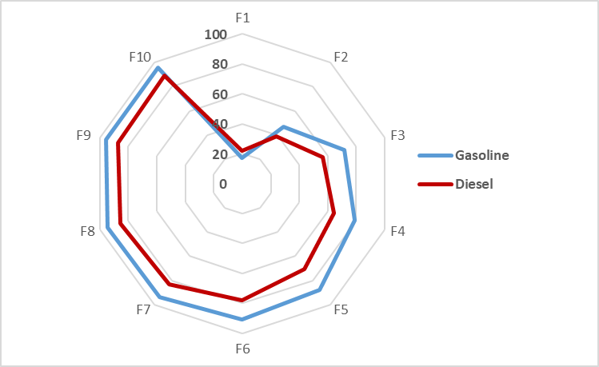

Figure 3.7. Cumulative Market Shares of the Top 10 Firms in the Petroleum Market by Product Type

In this context, the index values shown in Table 3.5 were obtained as a result of the calculations based on the market shares of the companies in the oil market over the data for 2024.

Table 3.5. CR, HHI, EI and REI Values for the Oil Market in 2024
Product Type | # of Companies | CR₄ | CR₁₀ | HHI | EI | REI
Gasoline | 37 | 78,73 | 95,97 | 1.950 | 0,86  (0<EI_{Gas.}<1,57) | 0,55  (0<REI_{Gas.}<1)
Diesel | 37 | 64,47 | 88,87 | 1.278 | 1,07  (0<E_{Die.}<1,57) | 0,68  (0<REI_{Die.}<1
Total* | 37 | 66,77 | 89,93 | 1.348 | 1,04  (0<EI_{Tot.}<1,57) | 0,66  (0<REI_{Tot.}<1)

* Includes fuel oil types and kerosene.

The table above shows that the gasoline market has a much narrower market structure compared to diesel. It can be said that the first 4 out of 37 market players operating in this segment constitute the majority of the market with a market share of 78% in total and that an oligopoly structure is dominant rather than a competitive market. The index values obtained indicate that there is a moderate level of concentration in this sub-sector. The HHI value for gasoline is 1.950, which is above 1.500, which is the lower limit of medium level concentration. Likewise, both the EI and REI index values for gasoline are obtained as values corresponding to the mid-point of the value ranges of the said indices, which again leads to the conclusion that the concentration in this sub-division is moderate. On the other hand, the competitiveness of the diesel market is much more acceptable than that of gasoline. The Entropy Index value (EI_{gasoline}=1.07) moves away from 0 and approaches 1,57, which is the maximum threshold value to be obtained in this calculation for diesel, thus, it is understood that concentration decreases and there is a relative diffusion in this sub-market. Similarly, the REI value obtained for diesel fuel is calculated as 0,68, which is closer to 1. Therefore, it can be concluded that there is less concentration in this sub-market. The REI values for gasoline and diesel are 0,55 and 0,68, respectively. When these two sub-markets are compared with each other based on these index values, it is observed that the concentration in the gasoline market is more intense than in the diesel market. In 2023, the total number of distributor license holders operating in diesel fuel was 37. The top 4 companies in the sale of this petroleum product constitute a relative majority of the market (total market share: 64,47%), but when taken together with the HHI value of 1.278, it can be interpreted that there is no clear market dominance, in other words, no concentration as in gasoline. When the overall petroleum market is analyzed, i.e. the sum of gasoline, diesel, fuel oil and kerosene sales, it is observed that the top 4 of the 37 players in the market constitute 66,77% of the entire market. When we evaluate this result together with the other index values obtained, it can be said that similar interpretations can be made for the distributor license holders operating in diesel types, and that the market currently has a competitive outlook in terms of total sales of petroleum products, that there is no significant concentration, but that it tends to move towards an oligopoly market structure.

According to Figure 3.8, which shows the change in the ${CR}_{4}$ concentration ratio, which is calculated by summing the market shares of the 4 largest firms in the petroleum market, it is understood that the gasoline market was a highly concentrated market in 2016-2024 and the concentration values remained almost constant, whereas the diesel market was moderately concentrated for all years and the concentration ratio showed constant values in recent years.

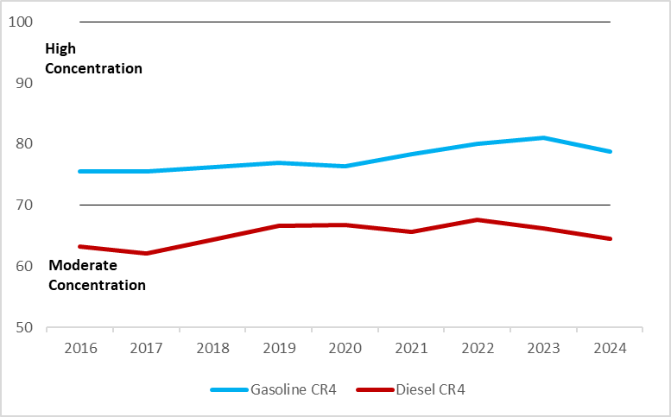

Figure 3.8. CR₄ Rates for Gasoline and Diesel in 2016-2024

Figure 3.9 shows that all sub-markets (Gasoline and Diesel) were highly concentrated markets in 2016-2024, while the concentration ratio of ${CR}_{10}$, which is calculated by summing the shares of the 10 largest firms in the petroleum market, remained stable in recent years (average=86,38). It also shows that all sub-markets (Gasoline and Diesel) were highly concentrated markets in 2016-2024, of which the concentration in the diesel market remained stable in recent years (average=86.38), while the average ${CR}_{10}$ value for gasoline was 93,26 in the 9-year period covering the review period.

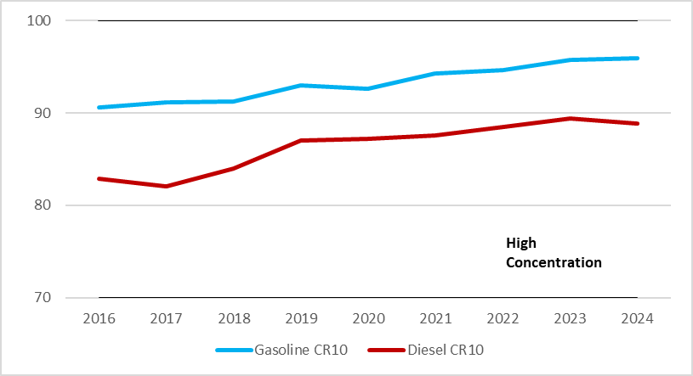

Figure 3.9. CR₁₀ Rates for Gasoline and Diesel in 2016-2024
According to the HHI values, which are considered to be more reliable in terms of taking into account all players in the oil market in the relevant periods, the concentration ratios in gasoline are in the range of 1.590-1.950 between 2016 and 2024. This leads to the conclusion that the abovementioned market is a moderately concentrated market. On the other hand, there is no concentration in the diesel market in terms of HHI values, but the HHI value shows an upward trend from 2017 to 2020.

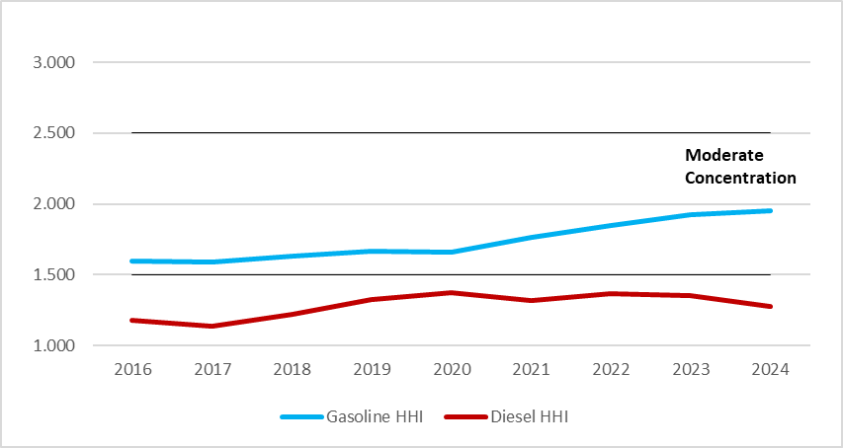

Figure 3.10. HHI Values for Gasoline and Diesel for 2016-2024

Table 3.6. Market Shares of the Top Ten Distributor License Holders in 2015-2024*
Year | 1th Company | 2nd Company | 3rd Company | 4th Company | 5th Company | 6th Company | 7th Company | 8th  Company | 9th  Company | 10th Company | Total Market Shares of Companies (%)
2015 | POAŞ | OPET | SHELL | BP | GÜZEL | TP | AKPET | AYTEMİZ | ALTINBAŞ | KADOOĞLU | 84,10
2015 | 24,42 | 17,16 | 15,85 | 8,37 | 5,46 | 4,34 | 2,52 | 2,14 | 2,10 | 1,74 | 84,10
2016 | POAŞ | OPET | SHELL | BP | GÜZEL | TP | AYTEMİZ | AKPET | ALTINBAŞ | KADOOĞLU | 83,50
2016 | 21,71 | 17,39 | 16,10 | 8,80 | 5,49 | 4,33 | 3,28 | 2,42 | 2,19 | 1,79 | 83,50
2017 | POAŞ | OPET | SHELL | BP | GÜZEL | AYTEMİZ | TP | LUKOİL | ALTINBAŞ | KADOOĞLU | 82,77
2017 | 21,18 | 17,59 | 15,20 | 9,20 | 5,62 | 3,91 | 3,85 | 2,63 | 1,92 | 1,68 | 82,77
2018 | POAŞ | OPET | SHELL | BP | GÜZEL | AYTEMİZ | TP | KADOOĞLU | MİLAN | ALTINBAŞ | 84,60
2018 | 21,78 | 18,67 | 15,99 | 9,14 | 5,56 | 4,55 | 4,02 | 1,72 | 1,59 | 1,58 | 84,60
2019 | POAŞ | OPET | SHELL | BP | GÜZEL | AYTEMİZ | TP | AKPET | KADOOĞLU | MİLAN | 87,58
2019 | 22,36 | 20,68 | 16,11 | 8,67 | 5,51 | 4,40 | 4,27 | 2,34 | 1,69 | 1,55 | 87,58
2020 | POAŞ | OPET | SHELL | BP | GÜZEL | TP | AYTEMİZ | AKPET | KADOOĞLU | TERMOPET | 87,65
2020 | 23,46 | 21,34 | 15,15 | 7,69 | 5,88 | 4,61 | 4,26 | 2,21 | 1,67 | 1,38 | 87,65
2021 | POAŞ | OPET | SHELL | BP | GÜZEL | TP | AYTEMİZ | AKPET | KADOOĞLU | TERMOPET | 88,28
2021 | 22,91 | 18,47 | 17,69 | 8,03 | 6,75 | 5,05 | 4,29 | 2,06 | 1,67 | 1,36 | 88,28
2022 | POAŞ | SHELL | OPET | BP | GÜZEL | TP | AYTEMİZ | AKPET | KADOOĞLU | SOCAR | 89,18
2022 | 22,34 | 19,72 | 18,82 | 8,23 | 6,79 | 5,05 | 3,68 | 1,83 | 1,62 | 1,11 | 89,18
2023 | POAŞ | SHELL | OPET | BP | GÜZEL | TP | AYTEMİZ | KADOOĞLU | AKPET | TERMOPET | 90,21
2023 | 21,90 | 19,71 | 18,93 | 7,59 | 7,19 | 5,88 | 4,22 | 1,93 | 1,86 | 0,99 | 90,21
2024 | POAŞ | SHELL | OPET | GÜZEL | BP | TP | AYTEMİZ | KADOOĞLU | AKPET | ALTINBAŞ | 89,93
2024 | 21,33 | 18,85 | 18,65 | 7,95 | 6,78 | 6,25 | 5,18 | 1,93 | 1,73 | 1,27 | 89,93
* Distributor titles are given with their current trade names at the time the report was prepared.

Table 3.7. Fuel Sales with Vehicle Recognition System (TTS) in 2024*
Licence Holder | Product Type | Sales Amount with SCT (tons) | Sales Amount without SCT (tons) | Total
PETROL OFİSİ ANONİM ŞİRKETİ | Unleaded Gasoline 95 Octane | 158.012,69 | 18.403,03 | 176.415,73
PETROL OFİSİ ANONİM ŞİRKETİ | Diesel | 1.109.821,19 | 122.426,40 | 1.232.247,59
PETROL OFİSİ ANONİM ŞİRKETİ | Firm Total | 1.267.833,88 | 140.829,44 | 1.408.663,32
SHELL & TURCAS PETROL ANONİM ŞİRKETİ | Unleaded Gasoline 95 Octane | 281.012,39 | 84,19 | 281.096,58
SHELL & TURCAS PETROL ANONİM ŞİRKETİ | Diesel | 993.289,56 | 162,25 | 993.451,81
SHELL & TURCAS PETROL ANONİM ŞİRKETİ | Firm Total | 1.274.301,95 | 246,44 | 1.274.548,39
OPET PETROLCÜLÜK ANONİM ŞİRKETİ | Unleaded Gasoline 95 Octane | 148.603,73 | 195,79 | 148.799,51
OPET PETROLCÜLÜK ANONİM ŞİRKETİ | Diesel | 791.496,98 | 2.488,86 | 793.985,84
OPET PETROLCÜLÜK ANONİM ŞİRKETİ | Firm Total | 940.100,71 | 2.684,64 | 942.785,35
BP PETROLLERİ ANONİM ŞİRKETİ | Unleaded Gasoline 95 Octane | 44.518,21 | 6,11 | 44.524,32
BP PETROLLERİ ANONİM ŞİRKETİ | Diesel | 344.399,69 | 11,31 | 344.410,99
BP PETROLLERİ ANONİM ŞİRKETİ | Firm Total | 388.917,90 | 17,42 | 388.935,32
GÜZEL ENERJİ AKARYAKIT ANONİM ŞİRKETİ | Unleaded Gasoline 95 Octane | 17.027,72 |  | 17.027,72
GÜZEL ENERJİ AKARYAKIT ANONİM ŞİRKETİ | Diesel | 183.459,44 |  | 183.459,44
GÜZEL ENERJİ AKARYAKIT ANONİM ŞİRKETİ | Firm Total | 200.487,16 |  | 200.487,16
AYTEMİZ AKARYAKIT DAĞITIM ANONİM ŞİRKETİ | Unleaded Gasoline 95 Octane | 2.376,91 |  | 2.376,91
AYTEMİZ AKARYAKIT DAĞITIM ANONİM ŞİRKETİ | Diesel | 54.966,67 |  | 54.966,67
AYTEMİZ AKARYAKIT DAĞITIM ANONİM ŞİRKETİ | Firm Total | 57.343,58 |  | 57.343,58
AKPET AKARYAKIT DAĞITIM ANONİM ŞİRKETİ | Unleaded Gasoline 95 Octane | 2.327,34 |  | 2.327,34
AKPET AKARYAKIT DAĞITIM ANONİM ŞİRKETİ | Diesel | 37.778,97 |  | 37.778,97
AKPET AKARYAKIT DAĞITIM ANONİM ŞİRKETİ | Firm Total | 40.106,31 |  | 40.106,31
TP PETROL DAĞITIM ANONİM ŞİRKETİ | Unleaded Gasoline 95 Octane | 1.245,23 |  | 1.245,23
TP PETROL DAĞITIM ANONİM ŞİRKETİ | Diesel | 37.420,13 |  | 37.420,13
TP PETROL DAĞITIM ANONİM ŞİRKETİ | Firm Total | 38.665,36 |  | 38.665,36
SOCAR TURKEY PETROL TİCARET ANONİM ŞİRKETİ | Unleaded Gasoline 95 Octane | 614,57 |  | 614,57
SOCAR TURKEY PETROL TİCARET ANONİM ŞİRKETİ | Diesel | 13.439,15 |  | 13.439,15
SOCAR TURKEY PETROL TİCARET ANONİM ŞİRKETİ | Firm Total | 14.053,73 |  | 14.053,73
İPRA ENERJİ ANONİM ŞİRKETİ | Unleaded Gasoline 95 Octane | 80,11 |  | 80,11
İPRA ENERJİ ANONİM ŞİRKETİ | Diesel | 1.618,42 |  | 1.618,42
İPRA ENERJİ ANONİM ŞİRKETİ | Firm Total | 1.698,53 |  | 1.698,53
KADOOĞLU PETROLCÜLÜK TAŞIMACILIK TİCARET SANAYİ İTHALAT VE İHRACAT ANONİM ŞİRKETİ | Unleaded Gasoline 95 Octane | 65,68 |  | 65,68
 | Diesel | 1.417,26 |  | 1.417,26
 | Firm Total | 1.482,94 |  | 1.482,94
ALTINBAŞ PETROL VE TİCARET ANONİM ŞİRKETİ | Unleaded Gasoline 95 Octane | 167,45 |  | 167,45
ALTINBAŞ PETROL VE TİCARET ANONİM ŞİRKETİ | Diesel | 1.139,68 |  | 1.139,68
ALTINBAŞ PETROL VE TİCARET ANONİM ŞİRKETİ | Firm Total | 1.307,13 |  | 1.307,13
UZUN GRUBU SANAYİ VE TİCARET ANONİM ŞİRKETİ | Unleaded Gasoline 95 Octane | 0,28 |  | 0,28
UZUN GRUBU SANAYİ VE TİCARET ANONİM ŞİRKETİ | Diesel | 120,07 |  | 120,07
UZUN GRUBU SANAYİ VE TİCARET ANONİM ŞİRKETİ | Firm Total | 120,36 |  | 120,36
ENERJİ PETROL ÜRÜNLERİ PAZARLAMA ANONİM ŞİRKETİ | Unleaded Gasoline 95 Octane | 27,51 |  | 27,51
ENERJİ PETROL ÜRÜNLERİ PAZARLAMA ANONİM ŞİRKETİ | Diesel | 77,47 |  | 77,47
ENERJİ PETROL ÜRÜNLERİ PAZARLAMA ANONİM ŞİRKETİ | Firm Total | 104,98 |  | 104,98
Total General |  | 4.226.524,50 | 143.777,94 | 4.370.302,44
* The data in this table are the sales made by the distributor license holders to the end user using electronic systems and are included in the domestic sales amounts shown above.

Table 3.8. Comparison of Fuel Sales with Vehicle Identification System (TTS) in 2023 and 2024
Sales Type | Product | 2023 | 2024 | Change (%)
Sales Amount with SCT (tons) | Unleaded Gasoline 95 Octane | 541.922,67 | 656.079,82 | 21,07
Sales Amount with SCT (tons) | Diesel | 3.720.893,55 | 3.570.444,68 | -4,04
Sales Amount with SCT (tons) | Total | 4.262.816,22 | 4.226.524,50 | -0,85
Sales Amount without SCT (tons) | Unleaded Gasoline 95 Octane | 3.176,46 | 18.689,13 | 488,36
Sales Amount without SCT (tons) | Diesel | 24.183,51 | 125.088,81 | 417,25
Sales Amount without SCT (tons) | Total | 27.359,97 | 143.777,94 | 425,50
Total | Unleaded Gasoline 95 Octane | 545.099,13 | 674.768,94 | 23,79
Total | Diesel | 3.745.077,06 | 3.695.533,49 | -1,32
Total | Total | 4.290.176,19 | 4.370.302,44 | 1,87

Table 3.9. Dealer Sales of Distributors in Gasoline Types in 2024 (liters)*
Licence Holder | Station Sales | Sales by Village Pumps | External Sales | Total Sales | Share (%)
SHELL & TURCAS PETROL A.Ş. | 1.921.306.399 |  | 855.599 | 1.922.161.998 | 29,28
OPET PETROLCÜLÜK A.Ş. | 1.662.568.849 |  | 1.088.757 | 1.663.657.605 | 25,34
PETROL OFİSİ A.Ş. | 1.134.537.204 |  | 4.126.310 | 1.138.663.514 | 17,34
BP PETROLLERİ A.Ş. | 603.315.439 |  | 423.930 | 603.739.369 | 9,20
GÜZEL ENERJİ AKARYAKIT A.Ş. | 444.689.546 |  | 3.631.148 | 448.320.694 | 6,83
AYTEMİZ AKARYAKIT DAĞITIM A.Ş. | 196.017.152 | 12.571 | 290.973 | 196.320.697 | 2,99
TP PETROL DAĞITIM A.Ş. | 182.782.998 |  | 337.492 | 183.120.490 | 2,79
AKPET AKARYAKIT DAĞITIM A.Ş. | 73.769.629 | 20.893 | 102.371 | 73.892.893 | 1,13
KADOOĞLU PETROLCÜLÜK TAŞIMACILIK TİCARET SANAYİ İTHALAT VE İHRACAT A.Ş. | 40.727.865 |  | 240.215 | 40.968.080 | 0,62
İPRA ENERJİ A.Ş. | 35.253.072 |  | 27.163 | 35.280.235 | 0,54
ALTINBAŞ PETROL VE TİCARET A.Ş. | 30.853.900 | 53.977 | 133.659 | 31.041.536 | 0,47
TERMOPET AKARYAKIT A.Ş. | 30.855.062 | 10.965 | 109.454 | 30.975.481 | 0,47
TECO PETROLCÜLÜK SAN. VE TİC. A.Ş. | 24.648.310 | 160.782 | 10.634 | 24.819.726 | 0,38
BALPET PETROL ÜRÜNLERİ TAŞIMACILIK SAN. VE TİC. A.Ş. | 22.018.944 |  | 10.391 | 22.029.335 | 0,34
SİYAM PETROLCÜLÜK SAN. VE TİC. A.Ş. | 18.748.121 |  | 136.748 | 18.884.869 | 0,29
ENERJİ PETROL ÜRÜNLERİ PAZARLAMA A.Ş. | 18.435.406 |  | 16.116 | 18.451.522 | 0,28
SOCAR TURKEY PETROL TİCARET A.Ş. | 14.286.103 | 16.838 | 19.535 | 14.322.476 | 0,22
KALELİ BEST OİL PETROLCÜLÜK TİCARET A.Ş. | 13.878.997 |  | 163.833 | 14.042.830 | 0,21
NORM GAZ PETROL ÜRÜNLERİ SANAYİ TİCARET A.Ş. | 11.252.571 |  |  | 11.252.571 | 0,17
HYPCO PETROLCÜLÜK A.Ş. | 10.232.139 |  | 2.889 | 10.235.028 | 0,16
VTM AKARYAKIT PETROL ÜRÜNLERİ DAĞITIM SAN. VE TİC. A.Ş. | 9.211.943 |  | 4.719 | 9.216.662 | 0,14
7KITA PETROLCÜLÜK DAĞITIM VE PAZARLAMA A.Ş. | 8.487.656 |  | 5.194 | 8.492.850 | 0,13
PETLİNE PETROL ÜRÜNLERİ TİCARET A.Ş. | 7.287.798 |  | 43.334 | 7.331.132 | 0,11
MEMOİL AKARYAKIT DAĞITIM SAN. VE TİC. A.Ş. | 5.972.967 |  |  | 5.972.967 | 0,09
TURKEY AKARYAKIT DAĞITIM A.Ş. | 5.588.464 |  | 16.560 | 5.605.024 | 0,09
ES ES AKARYAKIT DAĞITIM A.Ş. | 4.911.757 |  | 18.203 | 4.929.960 | 0,08
UZUN GRUBU SAN. VE TİC. A.Ş. | 4.089.121 |  | 178.801 | 4.267.922 | 0,07
MFD AKARYAKIT NAKLİYAT TURİZM İNŞAAT TAŞIMACILIK SAN. VE TİC. LTD. ŞTİ. | 3.970.367 |  | 16.257 | 3.986.624 | 0,06
LPGAS ENERJİ A.Ş. | 2.865.146 |  |  | 2.865.146 | 0,04
BAŞ AKARYAKIT DAĞITIM PAZARLAMA SAN. VE TİC. A.Ş. | 2.764.004 |  |  | 2.764.004 | 0,04
EUROİL ENERJİ DAĞITIM A.Ş. | 2.533.365 |  | 14.851 | 2.548.216 | 0,04
RPET PETROLCÜLÜK A.Ş. | 1.642.461 |  |  | 1.642.461 | 0,03
ÇLB PETROLCÜLÜK A.Ş. | 1.075.251 |  |  | 1.075.251 | 0,02
ERGAZ AKARYAKIT LPG LNG CNG DAĞITIM SAN. VE TİC. LTD. ŞTİ. | 834.120 |  |  | 834.120 | 0,01
FOX PETROLCÜLÜK A.Ş. | 552.147 |  | 1.500 | 553.647 | 0,01
LİMAN PETROLCÜLÜK DAĞITIM A.Ş. | 352.382 |  |  | 352.382 | 0,01
ASTON PETROLLERİ A.Ş. | 316.103 |  | 12.199 | 328.302 | 0,01
Total | 6.552.632.754 | 276.027 | 12.038.835 | 6.564.947.615 | 100
* The data in this table are sent from the dealer automation systems of the distribution companies to the Authority’s database via web service.

Table 3.10. Distributors' Dealer Sales of Gasoline Types by Month in 2024 (liters)*
Abbreviation for License Holder Title | January | February | March | April | May | June | July | August | September | October | November | December
SHELL | 129.148.775 | 124.009.348 | 135.425.029 | 151.111.454 | 151.071.979 | 182.788.319 | 186.039.237 | 199.216.987 | 175.773.821 | 168.095.173 | 159.469.249 | 160.012.627
OPET | 109.898.228 | 105.062.728 | 115.753.744 | 131.581.875 | 129.346.295 | 162.795.331 | 162.790.971 | 174.030.168 | 151.940.155 | 144.438.909 | 137.356.073 | 138.663.128
PETROL OFİSİ | 75.846.731 | 73.434.340 | 81.423.332 | 89.564.021 | 91.302.882 | 109.959.956 | 112.624.679 | 118.138.391 | 102.762.933 | 98.586.353 | 92.437.086 | 92.582.809
BP | 44.112.451 | 41.172.075 | 44.495.945 | 47.959.869 | 48.966.064 | 57.082.178 | 57.477.968 | 61.409.010 | 54.905.139 | 51.334.749 | 47.282.641 | 47.544.127
GÜZEL | 29.440.179 | 28.399.868 | 31.447.509 | 34.137.859 | 34.575.196 | 42.261.179 | 43.841.500 | 46.832.555 | 41.435.090 | 39.626.520 | 37.998.043 | 38.325.196
AYTEMİZ | 13.089.507 | 12.496.369 | 13.990.334 | 15.240.224 | 15.649.265 | 19.321.885 | 18.929.482 | 19.855.141 | 17.778.277 | 17.027.465 | 16.440.026 | 16.502.721
TP | 12.503.878 | 11.831.939 | 13.140.523 | 14.802.780 | 14.217.555 | 18.073.381 | 17.192.417 | 18.483.110 | 16.500.104 | 15.833.437 | 15.319.475 | 15.221.890
AKPET | 4.695.861 | 4.463.321 | 5.023.855 | 5.854.068 | 5.894.103 | 7.668.754 | 7.964.592 | 8.450.208 | 6.994.290 | 6.307.103 | 5.467.853 | 5.108.883
KADOOĞLU | 2.685.107 | 2.584.293 | 2.859.842 | 3.226.571 | 3.269.915 | 3.964.986 | 4.003.105 | 4.242.282 | 3.821.591 | 3.642.306 | 3.397.125 | 3.270.959
İPRA | 2.592.802 | 2.408.132 | 2.645.928 | 2.903.971 | 2.876.541 | 3.501.895 | 3.390.285 | 3.509.425 | 3.123.076 | 2.915.509 | 2.751.190 | 2.661.482
TERMOPET | 1.720.171 | 1.776.828 | 2.074.598 | 2.594.322 | 2.638.756 | 3.402.725 | 3.415.280 | 3.502.720 | 2.865.261 | 2.612.535 | 2.293.065 | 2.079.221
ALTINBAŞ | 1.654.855 | 1.625.578 | 1.843.201 | 2.157.278 | 2.291.035 | 3.120.952 | 3.381.654 | 3.598.449 | 3.101.089 | 2.953.444 | 2.718.148 | 2.595.854
TECO | 1.458.223 | 1.482.963 | 1.729.388 | 2.051.878 | 2.151.273 | 2.684.962 | 2.674.979 | 2.720.843 | 2.264.387 | 2.118.371 | 1.845.865 | 1.636.594
BALPET | 1.297.466 | 1.280.693 | 1.470.811 | 1.840.140 | 1.785.081 | 2.316.370 | 2.269.814 | 2.331.592 | 2.074.005 | 1.973.125 | 1.756.575 | 1.633.664
SİYAM | 1.105.231 | 1.089.891 | 1.259.426 | 1.515.706 | 1.531.717 | 1.972.200 | 1.884.430 | 1.990.165 | 1.830.938 | 1.718.672 | 1.535.353 | 1.451.140
ENERJİ | 1.100.480 | 1.120.046 | 1.282.910 | 1.426.744 | 1.450.763 | 1.851.106 | 1.854.595 | 1.931.848 | 1.760.748 | 1.662.368 | 1.512.549 | 1.497.363
KALELİ | 920.300 | 889.524 | 1.035.767 | 1.206.154 | 1.170.179 | 1.490.656 | 1.465.477 | 1.546.909 | 1.261.134 | 1.113.416 | 1.008.001 | 935.313
SOCAR | 890.912 | 883.066 | 951.338 | 1.130.501 | 1.146.965 | 1.397.916 | 1.451.118 | 1.509.274 | 1.340.800 | 1.266.079 | 1.190.612 | 1.163.896
NORM GAZ | 831.187 | 810.512 | 864.725 | 878.308 | 912.685 | 1.008.424 | 1.032.686 | 1.084.086 | 1.046.115 | 970.309 | 899.006 | 914.529
HYPCO | 729.512 | 703.187 | 793.690 | 906.827 | 900.494 | 1.051.998 | 1.009.431 | 1.010.622 | 899.299 | 808.957 | 737.458 | 683.552
VTM | 612.746 | 553.403 | 626.735 | 702.860 | 726.074 | 937.003 | 879.945 | 944.795 | 854.396 | 818.262 | 796.091 | 764.353
7KITA | 526.361 | 529.473 | 570.039 | 667.485 | 657.689 | 872.588 | 869.450 | 931.800 | 816.262 | 724.841 | 685.261 | 641.600
MEMOİL | 445.497 | 419.204 | 384.899 | 439.840 | 462.584 | 586.858 | 575.381 | 614.633 | 580.239 | 510.644 | 480.476 | 472.712
PETLINE | 424.019 | 425.476 | 491.945 | 593.437 | 615.124 | 796.875 | 787.713 | 833.992 | 680.926 | 613.931 | 551.805 | 515.887
TURKEY | 322.174 | 369.541 | 387.736 | 421.155 | 428.944 | 524.821 | 535.854 | 569.796 | 534.210 | 497.978 | 486.435 | 526.378
ES ES | 303.787 | 308.756 | 356.698 | 410.528 | 407.006 | 529.307 | 521.425 | 524.520 | 458.167 | 403.642 | 366.955 | 339.167
MFD | 257.377 | 266.173 | 306.706 | 327.716 | 335.023 | 410.572 | 373.769 | 412.264 | 366.922 | 333.031 | 304.178 | 292.895
UZUN | 235.819 | 238.385 | 261.619 | 295.224 | 334.340 | 413.225 | 431.605 | 490.499 | 422.535 | 409.556 | 369.864 | 365.252
BAŞ | 164.118 | 153.717 | 174.145 | 201.667 | 208.161 | 290.886 | 286.178 | 279.824 | 262.582 | 266.311 | 245.869 | 230.545
EUROİL | 131.618 | 156.257 | 180.376 | 223.436 | 210.654 | 257.140 | 239.135 | 263.338 | 239.671 | 244.040 | 211.384 | 191.168
LİMAN | 130.229 | 85.060 | 69.094 | 61.726 | 6.272
ÇLB | 101.859 | 126.672 | 130.118 | 129.149 | 124.591 | 135.512 | 125.895 | 126.275 | 75.011 | 169
RPET | 89.733 | 83.938 | 97.359 | 111.330 | 87.581 | 123.240 | 142.089 | 162.160 | 147.662 | 195.304 | 201.930 | 200.135
ERGAZ | 80.091 | 42.061 | 54.906 | 67.615 | 72.147 | 92.781 | 86.880 | 97.118 | 77.934 | 63.001 | 54.730 | 44.858
ASTON | 35.734 | 36.827 | 41.768 | 59.114 | 56.610 | 62.758 | 35.490
FOX | 16.634 | 21.253 | 22.046 | 32.038 | 47.189 | 76.544 | 80.761 | 83.687 | 52.808 | 50.631 | 35.791 | 34.265
LPGAS |  |  |  | 28.348 | 141.060 | 362.872 | 376.009 | 406.331 | 406.253 | 394.472 | 370.097 | 379.703
Total | 439.599.653 | 421.340.894 | 463.668.082 | 516.863.217 | 518.069.793 | 634.188.154 | 641.041.280 | 682.134.816 | 599.453.830 | 570.530.614 | 538.576.258 | 539.483.871
* The data in this table are sent from the dealer automation systems of the distribution companies to the Authority’s database via web service.
** Based on the ranking of sales figures for the period January 2024, company title ranking was made.

Table 3.11. Dealer Sales of Distributors in Diesel Types in 2024 (liters)*
Licence Holder | Station Sales | Sales by Village Pumps | Sales by Agricultural Tankers | External Sales | Total Sales | Share (%)
PETROL OFİSİ A.Ş. | 4.445.553.078 | 180.867.687 | 154.275.983 | 1.786.453.183 | 6.567.149.931 | 21,52
SHELL & TURCAS PETROL A.Ş. | 4.478.865.665 |  | 20.525.230 | 760.627.335 | 5.260.018.230 | 17,24
OPET PETROLCÜLÜK A.Ş. | 4.200.381.022 | 4.816.871 | 54.465.978 | 933.942.298 | 5.193.606.169 | 17,02
GÜZEL ENERJİ AKARYAKIT A.Ş. | 1.558.463.748 | 1.100.667 | 13.619.629 | 971.856.124 | 2.545.040.167 | 8,34
TP PETROL DAĞITIM A.Ş. | 1.278.303.677 | 348.287 | 9.632.541 | 772.070.217 | 2.060.354.723 | 6,75
BP PETROLLERİ A.Ş. | 1.754.105.741 | 169.014 | 4.571.753 | 222.610.973 | 1.981.457.481 | 6,49
AYTEMİZ AKARYAKIT DAĞITIM A.Ş. | 1.231.639.595 | 163.154 | 9.829.258 | 507.100.209 | 1.748.732.216 | 5,73
KADOOĞLU PETROLCÜLÜK TAŞIMACILIK TİCARET SANAYİ İTHALAT VE İHRACAT A.Ş. | 528.108.829 | 64.530 | 10.019.146 | 147.234.479 | 685.426.985 | 2,25
AKPET AKARYAKIT DAĞITIM A.Ş. | 487.626.143 | 334.860 | 8.531.163 | 81.319.182 | 577.811.348 | 1,89
SOCAR TURKEY PETROL TİCARET A.Ş. | 193.560.979 | 81.749 | 383.386 | 239.106.474 | 433.132.588 | 1,42
ALTINBAŞ PETROL VE TİCARET A.Ş. | 297.640.708 | 641.905 | 4.423.181 | 123.932.136 | 426.637.930 | 1,40
TERMOPET AKARYAKIT A.Ş. | 265.694.768 | 1.556.475 | 5.494.910 | 30.326.079 | 303.072.233 | 0,99
BALPET PETROL ÜRÜNLERİ TAŞIMACILIK SAN. VE TİC. A.Ş. | 269.427.585 |  | 794.441 | 32.436.805 | 302.658.831 | 0,99
TECO PETROLCÜLÜK SAN. VE TİC. A.Ş. | 241.411.103 | 1.281.653 | 6.259.598 | 13.048.208 | 262.000.561 | 0,86
SİYAM PETROLCÜLÜK SAN. VE TİC. A.Ş. | 227.727.374 | 356.993 | 26.752 | 23.364.350 | 251.475.469 | 0,82
ENERJİ PETROL ÜRÜNLERİ PAZARLAMA A.Ş. | 203.990.849 |  | 89.205 | 19.946.353 | 224.026.407 | 0,73
TURKEY AKARYAKIT DAĞITIM A.Ş. | 169.117.349 |  | 63.071 | 7.865.259 | 177.045.679 | 0,58
KALELİ BEST OİL PETROLCÜLÜK TİCARET A.Ş. | 148.437.467 | 57.130 | 5.137.813 | 21.106.353 | 174.738.762 | 0,57
İPRA ENERJİ A.Ş. | 147.348.981 |  | 922.518 | 17.279.422 | 165.550.920 | 0,54
UZUN GRUBU SAN. VE TİC. A.Ş. | 63.335.953 | 28.335 | 788.109 | 67.690.471 | 131.842.867 | 0,43
7KITA PETROLCÜLÜK DAĞITIM VE PAZARLAMA A.Ş. | 117.479.922 |  | 63.017 | 12.712.001 | 130.254.940 | 0,43
BAŞ AKARYAKIT DAĞITIM PAZARLAMA SAN. VE TİC. A.Ş. | 112.120.292 |  | 133.019 | 9.854.315 | 122.107.626 | 0,40
HYPCO PETROLCÜLÜK A.Ş. | 112.740.695 | 221.435 | 544.207 | 6.495.446 | 120.001.783 | 0,39
MEMOİL AKARYAKIT DAĞITIM SAN. VE TİC. A.Ş. | 114.380.491 |  |  | 2.850.917 | 117.231.408 | 0,38
NORM GAZ PETROL ÜRÜNLERİ SANAYİ TİCARET A.Ş. | 88.217.645 |  |  | 8.967.977 | 97.185.621 | 0,32
ES ES AKARYAKIT DAĞITIM A.Ş. | 89.794.232 |  | 246.039 | 5.622.875 | 95.663.146 | 0,31
VTM AKARYAKIT PETROL ÜRÜNLERİ DAĞITIM SAN. VE TİC. A.Ş. | 66.656.208 |  | 52.065 | 4.173.284 | 70.881.558 | 0,23
PETLİNE PETROL ÜRÜNLERİ TİCARET A.Ş. | 56.246.984 | 196.858 | 2.163.941 | 5.005.275 | 63.613.058 | 0,21
MFD AKARYAKIT NAKLİYAT TURİZM İNŞAAT TAŞIMACILIK SAN. VE TİC. LTD. ŞTİ. | 40.442.342 |  |  | 3.943.624 | 44.385.966 | 0,15
EUROİL ENERJİ DAĞITIM A.Ş. | 34.770.953 |  | 194.652 | 1.933.720 | 36.899.326 | 0,12
RPET PETROLCÜLÜK A.Ş. | 34.168.637 | 27.747 |  | 997.913 | 35.194.297 | 0,12
FOX PETROLCÜLÜK A.Ş. | 28.436.007 |  |  | 3.474.283 | 31.910.289 | 0,10
LPGAS ENERJİ A.Ş. | 28.799.792 |  |  | 2.186.711 | 30.986.503 | 0,10
ÇLB PETROLCÜLÜK A.Ş. | 19.497.522 |  |  | 1.064.221 | 20.561.743 | 0,07
ERGAZ AKARYAKIT LPG LNG CNG DAĞITIM SAN. VE TİC. LTD. ŞTİ. | 9.760.642 | 169.951 |  | 313.811 | 10.244.404 | 0,03
LİMAN PETROLCÜLÜK DAĞITIM A.Ş. | 8.945.826 |  |  | 119.650 | 9.065.476 | 0,03
ASTON PETROLLERİ A.Ş. | 7.997.596 |  |  | 878.058 | 8.875.654 | 0,03
SOFTOİL AKARYAKIT ÜRÜNLERİ SAN. VE TİC. A.Ş. | 25 |  |  |  | 25 | 0,00
Total | 23.161.196.424 | 192.485.301 | 313.250.604 | 6.849.909.992 | 30.516.842.322 | 100
* The data in this table are sent from the dealer automation systems of the distribution companies to the Authority’s database via web service.

Table 3.12. Distributors' Dealer Sales of Diesel Types by Month in 2024 (liters)*
Abbreviation for License Holder Title | January | February | March | April | May | June | July | August | September | October | November | December
PETROL OFİSİ | 494.681.332 | 476.437.780 | 543.277.440 | 492.367.065 | 526.779.592 | 541.079.327 | 603.775.785 | 609.413.131 | 581.696.217 | 617.646.220 | 557.069.732 | 522.926.310
SHELL | 423.405.099 | 400.195.363 | 430.194.050 | 410.934.911 | 438.642.724 | 450.602.490 | 473.533.036 | 487.846.624 | 443.858.104 | 448.549.342 | 422.416.902 | 429.839.585
OPET | 378.898.178 | 362.200.885 | 417.544.354 | 422.846.968 | 443.686.797 | 452.384.925 | 484.290.698 | 488.266.807 | 449.263.745 | 464.808.451 | 420.300.124 | 409.114.237
GÜZEL | 184.181.187 | 175.410.198 | 202.442.507 | 174.013.427 | 220.020.285 | 212.201.726 | 220.361.854 | 238.848.383 | 230.139.396 | 247.348.625 | 222.574.774 | 217.497.805
BP | 169.650.979 | 155.849.133 | 167.746.902 | 160.109.528 | 179.263.099 | 175.326.553 | 179.763.169 | 176.148.249 | 166.651.796 | 161.980.982 | 145.635.380 | 143.331.711
TP | 139.344.323 | 134.128.713 | 182.231.234 | 152.835.861 | 186.234.078 | 186.388.960 | 200.693.188 | 198.560.611 | 175.998.340 | 179.064.799 | 165.483.283 | 159.391.333
AYTEMİZ | 119.028.910 | 111.847.960 | 138.111.803 | 131.925.682 | 152.511.095 | 149.506.980 | 152.424.902 | 154.883.674 | 156.585.093 | 165.909.820 | 156.198.373 | 159.797.925
KADOOĞLU | 43.476.524 | 42.823.350 | 45.878.365 | 46.223.158 | 57.479.810 | 61.179.107 | 63.940.437 | 66.652.963 | 64.607.765 | 66.485.374 | 63.445.317 | 63.234.815
AKPET | 39.231.823 | 40.551.965 | 47.109.188 | 46.923.723 | 51.379.301 | 52.130.134 | 54.409.340 | 52.900.893 | 49.377.579 | 54.756.257 | 47.094.386 | 41.946.760
TECO | 20.298.489 | 19.989.693 | 21.491.738 | 21.331.671 | 22.338.555 | 23.086.338 | 25.162.307 | 23.322.828 | 22.231.707 | 23.506.463 | 20.745.075 | 18.495.698
BALPET | 20.233.326 | 19.397.337 | 21.488.338 | 22.358.824 | 26.777.678 | 29.133.935 | 28.124.696 | 27.064.575 | 27.647.678 | 30.068.136 | 26.134.307 | 24.230.003
SOCAR | 19.863.227 | 20.603.284 | 28.412.664 | 25.793.534 | 34.371.871 | 35.793.759 | 37.360.609 | 40.756.892 | 40.443.364 | 49.683.536 | 48.314.447 | 51.735.403
TERMOPET | 19.787.660 | 20.652.440 | 23.371.280 | 25.897.798 | 26.773.637 | 27.768.209 | 29.860.471 | 26.450.833 | 26.016.850 | 29.201.999 | 25.006.709 | 22.284.346
SİYAM | 17.971.103 | 17.169.396 | 17.794.175 | 17.545.098 | 19.397.289 | 22.602.551 | 22.978.207 | 21.703.327 | 22.729.090 | 26.528.493 | 23.279.298 | 21.777.444
ALTINBAŞ | 16.452.813 | 16.200.240 | 19.769.684 | 24.331.756 | 38.167.896 | 46.394.465 | 47.911.635 | 48.195.383 | 48.362.253 | 44.455.747 | 38.301.899 | 38.094.159
ENERJİ | 15.033.170 | 15.535.509 | 16.619.482 | 16.940.247 | 18.745.207 | 20.223.258 | 20.831.208 | 20.367.739 | 20.107.256 | 22.361.576 | 19.033.154 | 18.228.601
TURKEY | 13.176.131 | 12.694.049 | 12.963.475 | 11.949.914 | 14.776.749 | 14.256.771 | 15.919.505 | 15.824.704 | 16.015.204 | 17.427.205 | 16.226.443 | 15.815.528
İPRA | 12.615.706 | 11.875.792 | 13.389.405 | 13.358.883 | 14.673.134 | 15.527.661 | 15.531.967 | 15.081.831 | 13.929.146 | 14.991.023 | 13.065.527 | 11.510.846
7KITA | 10.555.707 | 11.002.188 | 10.840.630 | 9.794.026 | 10.559.829 | 10.710.562 | 10.843.490 | 11.023.061 | 10.958.646 | 11.766.093 | 11.507.384 | 10.693.324
KALELİ | 9.900.134 | 10.356.339 | 12.240.523 | 13.489.798 | 13.548.976 | 16.393.438 | 18.794.538 | 16.308.354 | 15.680.792 | 18.716.415 | 15.464.902 | 13.844.555
HYPCO | 9.674.507 | 9.407.850 | 10.079.182 | 9.978.912 | 10.618.344 | 10.800.252 | 11.261.860 | 10.655.194 | 10.397.022 | 10.200.524 | 8.691.000 | 8.237.136
MEMOİL | 8.857.227 | 8.069.407 | 8.451.094 | 8.496.481 | 9.534.546 | 9.937.791 | 11.553.773 | 11.627.788 | 10.774.640 | 11.109.101 | 9.829.177 | 8.990.383
BAŞ | 8.436.185 | 7.678.356 | 8.175.227 | 7.760.632 | 9.731.310 | 10.899.654 | 11.355.028 | 10.798.194 | 11.365.805 | 13.216.144 | 11.696.224 | 10.994.868
NORM GAZ | 7.483.155 | 6.753.706 | 7.044.985 | 7.055.887 | 7.853.900 | 7.729.338 | 9.529.929 | 9.763.114 | 9.119.857 | 9.077.880 | 8.234.534 | 7.539.335
ES ES | 6.354.929 | 6.466.948 | 7.174.405 | 7.688.221 | 8.805.632 | 9.094.112 | 9.136.529 | 8.490.598 | 8.207.129 | 9.301.842 | 7.863.641 | 7.079.159
VTM | 4.517.897 | 4.328.643 | 4.772.467 | 4.924.172 | 5.608.019 | 6.671.492 | 7.103.192 | 7.075.302 | 6.787.574 | 7.187.017 | 6.019.075 | 5.886.708
UZUN GRUBU | 4.496.313 | 6.261.963 | 15.720.444 | 10.932.706 | 15.550.347 | 15.679.439 | 11.325.788 | 8.046.214 | 9.108.061 | 11.529.497 | 10.309.484 | 12.882.612
PETLİNE | 4.326.403 | 4.126.475 | 5.053.173 | 5.583.176 | 5.744.639 | 5.880.110 | 5.972.006 | 5.671.648 | 5.411.372 | 6.018.514 | 5.272.515 | 4.553.028
MFD | 3.412.384 | 3.218.778 | 3.337.097 | 3.493.133 | 3.885.314 | 4.325.250 | 4.176.608 | 4.009.160 | 3.739.666 | 3.949.073 | 3.674.622 | 3.164.881
LİMAN | 2.776.398 | 2.481.644 | 2.245.180 | 1.430.155 | 132.098
ÇLB | 2.409.802 | 2.577.418 | 2.393.090 | 2.233.007 | 2.493.198 | 2.455.389 | 2.350.633 | 2.240.506 | 1.389.327 | 19.374
RPET | 2.246.438 | 2.166.017 | 2.089.636 | 2.138.331 | 2.422.918 | 2.665.322 | 3.289.021 | 3.039.515 | 2.919.266 | 4.295.058 | 4.050.394 | 3.872.381
EUROİL | 1.755.330 | 2.097.598 | 2.571.819 | 2.699.628 | 2.760.234 | 3.242.358 | 3.540.981 | 3.556.258 | 3.329.430 | 4.049.126 | 3.805.982 | 3.490.582
FOX | 1.381.689 | 1.447.293 | 1.397.833 | 1.733.027 | 2.814.292 | 3.106.118 | 3.820.345 | 3.603.135 | 3.180.865 | 3.642.361 | 3.066.534 | 2.716.798
ASTON | 1.352.164 | 1.188.079 | 1.329.596 | 1.565.713 | 1.337.349 | 1.461.723 | 640.092 | 937
ERGAZ | 744.371 | 633.758 | 821.736 | 975.638 | 863.084 | 961.034 | 1.101.367 | 1.122.902 | 912.549 | 843.307 | 672.289 | 592.369
LPGAS |  |  |  | 148.367 | 824.618 | 2.244.996 | 2.868.438 | 4.106.686 | 4.165.150 | 5.025.998 | 5.562.767 | 6.039.483
SOFTOİL |  |  |  | 25
Total | 2.238.011.013 | 2.143.825.547 | 2.455.574.200 | 2.319.809.082 | 2.587.107.443 | 2.639.845.528 | 2.805.536.628 | 2.833.428.015 | 2.673.107.734 | 2.794.721.369 | 2.546.045.654 | 2.479.830.111
* The data in this table are sent from the dealer automation systems of the distribution companies to the Authority’s database via web service.
** Based on the ranking of sales figures for the period January 2024, company title ranking was made.

CHAPTER FOUR: WHOLESALE TRADE

Table 4.1. Wholesale Amounts of Refinery License Holders in 2024 (tons)

Licence Holder | Product Type | Export Registered | Free Circulation | Total | Share in Total Product Type (%)
TÜRKİYE PETROL RAFİNERİLERİ ANONİM ŞİRKETİ | Gasoline Types |  | 4.835.723,90 | 4.835.723,90 | 100,00
TÜRKİYE PETROL RAFİNERİLERİ ANONİM ŞİRKETİ | Diesel Types |  | 13.933.517,39 | 13.933.517,39 | 80,13
TÜRKİYE PETROL RAFİNERİLERİ ANONİM ŞİRKETİ | Fuel Oil Types |  | 201.131,70 | 201.131,70 | 100,00
TÜRKİYE PETROL RAFİNERİLERİ ANONİM ŞİRKETİ | Aviation Fuels | 3.567.898,26 | 1.220.154,44 | 4.788.052,70 | 86,12
TÜRKİYE PETROL RAFİNERİLERİ ANONİM ŞİRKETİ | Marine Fuels | 356.768,38 | 18.325,53 | 375.093,92 | 100,00
TÜRKİYE PETROL RAFİNERİLERİ ANONİM ŞİRKETİ | Kerosene |  | 1.214,54 | 1.214,54 | 100,00
TÜRKİYE PETROL RAFİNERİLERİ ANONİM ŞİRKETİ | Other Types |  | 5.485,94 | 5.485,94 | 26,80
TÜRKİYE PETROL RAFİNERİLERİ ANONİM ŞİRKETİ | Şirket Toplamı | 3.924.666,64 | 20.215.553,44 | 24.140.220,08 | 85,05
STAR RAFİNERİ ANONİM ŞİRKETİ | Diesel Types |  | 3.455.952,42 | 3.455.952,42 | 19,87
STAR RAFİNERİ ANONİM ŞİRKETİ | Aviation Fuels | 478.928,98 | 292.822,81 | 771.751,78 | 13,88
STAR RAFİNERİ ANONİM ŞİRKETİ | Other Types |  | 14.985,14 | 14.985,14 | 73,20
STAR RAFİNERİ ANONİM ŞİRKETİ | Şirket Toplamı | 478.928,98 | 3.763.760,37 | 4.242.689,34 | 14,95
Total of Gasoline Types |  |  | 4.835.723,90 | 4.835.723,90 | 100,00
Total of Diesel Types |  |  | 17.389.469,81 | 17.389.469,81 | 100,00
Total of Fuel Oil Types |  |  | 201.131,70 | 201.131,70 | 100,00
Total of Aviation Fuels |  | 4.046.827,23 | 1.512.977,25 | 5.559.804,48 | 100,00
Total of Marine Fuels |  | 356.768,38 | 18.325,53 | 375.093,92 | 100,00
Total of Kerosene |  |  | 1.214,54 | 1.214,54 | 100,00
Total of Other Types |  |  | 20.471,07 | 20.471,07 | 100,00
Overall Total |  | 4.403.595,61 | 23.979.313,81 | 28.382.909,42 | 100,00

Table 4.2. Wholesale Amounts of Distributor and Bunker Delivery License Holders in 2024 (tons)*
Licence Holder | Product Type | Export Registered | Free Circulation | Subject to Transit Regime | Total | Share in Total Product Type (%)
OPET PETROLCÜLÜK A.Ş. | Gasoline Types |  | 63.200,66 |  | 63.200,66 | 19,47
OPET PETROLCÜLÜK A.Ş. | Diesel Types |  | 1.159.391,49 | 1.286.300,61 | 2.445.692,09 | 30,49
OPET PETROLCÜLÜK A.Ş. | Firm Total |  | 1.222.592,15 | 1.286.300,61 | 2.508.892,75 | 25,95
AYTEMİZ AKARYAKIT DAĞITIM A.Ş. | Gasoline Types |  | 37.321,16 |  | 37.321,16 | 11,50
AYTEMİZ AKARYAKIT DAĞITIM A.Ş. | Diesel Types |  | 403.552,55 | 1.058.114,62 | 1.461.667,17 | 18,22
AYTEMİZ AKARYAKIT DAĞITIM A.Ş. | Firm Total |  | 440.873,71 | 1.058.114,62 | 1.498.988,33 | 15,51
PETROL OFİSİ A.Ş. | Gasoline Types |  | 55.191,18 |  | 55.191,18 | 17,00
PETROL OFİSİ A.Ş. | Diesel Types |  | 578.713,84 | 35.079,23 | 613.793,07 | 7,65
PETROL OFİSİ A.Ş. | Aviation Fuels |  | 193.994,29 |  | 193.994,29 | 16,23
PETROL OFİSİ A.Ş. | Marine Fuels |  |  | 35,00 | 35,00 | 0,03
PETROL OFİSİ A.Ş. | Firm Total |  | 827.899,31 | 35.114,23 | 863.013,54 | 8,93
TP PETROL DAĞITIM A.Ş. | Gasoline Types |  | 66.666,91 |  | 66.666,91 | 20,53
TP PETROL DAĞITIM A.Ş. | Diesel Types |  | 671.762,10 | 108.955,32 | 780.717,42 | 9,73
TP PETROL DAĞITIM A.Ş. | Fuel Oil Types |  | 25,66 |  | 25,66 | 8,73
TP PETROL DAĞITIM A.Ş. | Firm Total |  | 738.454,67 | 108.955,32 | 847.409,99 | 8,77
BP PETROLLERİ A.Ş. | Gasoline Types |  | 18.035,45 |  | 18.035,45 | 5,56
BP PETROLLERİ A.Ş. | Diesel Types |  | 746.284,23 |  | 746.284,23 | 9,30
BP PETROLLERİ A.Ş. | Firm Total |  | 764.319,67 |  | 764.319,67 | 7,91
GÜZEL ENERJİ AKARYAKIT A.Ş. | Gasoline Types |  | 26.715,24 |  | 26.715,24 | 8,23
GÜZEL ENERJİ AKARYAKIT A.Ş. | Diesel Types |  | 671.773,40 | 23.089,26 | 694.862,66 | 8,66
GÜZEL ENERJİ AKARYAKIT A.Ş. | Firm Total |  | 698.488,64 | 23.089,26 | 721.577,89 | 7,46
SOCAR TURKEY PETROL TİCARET A.Ş. | Gasoline Types |  | 25.380,78 |  | 25.380,78 | 7,82
SOCAR TURKEY PETROL TİCARET A.Ş. | Diesel Types |  | 451.490,52 | 34.248,95 | 485.739,47 | 6,06
SOCAR TURKEY PETROL TİCARET A.Ş. | Aviation Fuels |  | 45.778,51 | 6.028,25 | 51.806,76 | 4,33
SOCAR TURKEY PETROL TİCARET A.Ş. | Marine Fuels | 110.059,67 | 2.408,85 | 9.890,57 | 122.359,09 | 97,65
SOCAR TURKEY PETROL TİCARET A.Ş. | Firm Total | 110.059,67 | 525.058,67 | 50.167,76 | 685.286,10 | 7,09
TFS AKARYAKIT HİZMETLERİ A.Ş. | Aviation Fuels |  | 579.132,57 |  | 579.132,57 | 48,44
TFS AKARYAKIT HİZMETLERİ A.Ş. | Firm Total |  | 579.132,57 |  | 579.132,57 | 5,99
SHELL & TURCAS PETROL A.Ş. | Gasoline Types |  | 28.636,09 |  | 28.636,09 | 8,82
SHELL & TURCAS PETROL A.Ş. | Diesel Types |  | 449.643,43 |  | 449.643,43 | 5,61
SHELL & TURCAS PETROL A.Ş. | Firm Total |  | 478.279,52 |  | 478.279,52 | 4,95
AKPET AKARYAKIT DAĞITIM A.Ş. | Gasoline Types |  | 2.973,74 |  | 2.973,74 | 0,92
AKPET AKARYAKIT DAĞITIM A.Ş. | Diesel Types |  | 71.344,18 | 155.186,83 | 226.531,01 | 2,82
AKPET AKARYAKIT DAĞITIM A.Ş. | Fuel Oil Types |  | 268,26 |  | 268,26 | 91,27
AKPET AKARYAKIT DAĞITIM A.Ş. | Firm Total |  | 74.586,18 | 155.186,83 | 229.773,01 | 2,38
POTAS AKDENİZ AKARYAKIT DAĞITIM A.Ş. | Aviation Fuels |  | 175.055,50 |  | 175.055,50 | 14,64
POTAS AKDENİZ AKARYAKIT DAĞITIM A.Ş. | Firm Total |  | 175.055,50 |  | 175.055,50 | 1,81
İSTANBUL JET HAVACILIK VE YAKIT HİZMETLERİ A.Ş. | Aviation Fuels |  | 134.701,04 |  | 134.701,04 | 11,27
İSTANBUL JET HAVACILIK VE YAKIT HİZMETLERİ A.Ş. | Firm Total |  | 134.701,04 |  | 134.701,04 | 1,39
ALTINBAŞ PETROL VE TİCARET A.Ş. | Gasoline Types |  | 501,42 |  | 501,42 | 0,15
ALTINBAŞ PETROL VE TİCARET A.Ş. | Diesel Types |  | 42.508,40 | 45.368,18 | 87.876,58 | 1,10
ALTINBAŞ PETROL VE TİCARET A.Ş. | Firm Total |  | 43.009,83 | 45.368,18 | 88.378,01 | 0,91
THY OPET HAVACILIK YAKITLARI A.Ş. | Aviation Fuels |  | 52.589,99 |  | 52.589,99 | 4,40
THY OPET HAVACILIK YAKITLARI A.Ş. | Firm Total |  | 52.589,99 |  | 52.589,99 | 0,54
SİYAM PETROLCÜLÜK SANAYİ VE TİCARET A.Ş. | Diesel Types |  | 10.558,10 |  | 10.558,10 | 0,13
SİYAM PETROLCÜLÜK SANAYİ VE TİCARET A.Ş. | Firm Total |  | 10.558,10 |  | 10.558,10 | 0,11
KADOOĞLU PETROLCÜLÜK TAŞIMACILIK TİCARET SANAYİ İTHALAT VE İHRACAT A.Ş. | Gasoline Types |  | 46,03 |  | 46,03 | 0,01
 | Diesel Types |  | 5.280,07 | 5.100,00 | 10.380,07 | 0,13
 | Firm Total |  | 5.326,10 | 5.100,00 | 10.426,10 | 0,11
SHELL COMPANY OF TÜRKİYE LİMİTED MERKEZİ LONDRA TÜRKİYE ŞUBESİ | Aviation Fuels |  | 8.082,53 |  | 8.082,53 | 0,68
 | Firm Total |  | 8.082,53 |  | 8.082,53 | 0,08
BALPET PETROL ÜRÜNLERİ TAŞIMACILIK SANAYİ VE TİCARET A.Ş. | Diesel Types |  | 1.594,44 | 3.200,00 | 4.794,44 | 0,06
BALPET PETROL ÜRÜNLERİ TAŞIMACILIK SANAYİ VE TİCARET A.Ş. | Firm Total |  | 1.594,44 | 3.200,00 | 4.794,44 | 0,05
HYPCO PETROLCÜLÜK A.Ş. | Diesel Types |  | 2.988,39 |  | 2.988,39 | 0,04
HYPCO PETROLCÜLÜK A.Ş. | Firm Total |  | 2.988,39 |  | 2.988,39 | 0,03
ARKAS PETROL ÜRÜNLERİ VE TİCARET A.Ş. | Marine Fuels |  |  | 2.610,00 | 2.610,00 | 2,08
ARKAS PETROL ÜRÜNLERİ VE TİCARET A.Ş. | Firm Total |  |  | 2.610,00 | 2.610,00 | 0,03
UNERCO PETROL ÜRÜNLERİ DENİZCİLİK VE TİCARET A.Ş. | Marine Fuels |  |  | 295,00 | 295,00 | 0,24
UNERCO PETROL ÜRÜNLERİ DENİZCİLİK VE TİCARET A.Ş. | Firm Total |  |  | 295,00 | 295,00 | 0,00
ES ES AKARYAKIT DAĞITIM A.Ş. | Diesel Types |  | 274,73 |  | 274,73 | 0,00
ES ES AKARYAKIT DAĞITIM A.Ş. | Firm Total |  | 274,73 |  | 274,73 | 0,00
GÜNEYDOĞU HAVACILIK İŞLETMESİ A.Ş. | Aviation Fuels |  | 87,18 |  | 87,18 | 0,01
GÜNEYDOĞU HAVACILIK İŞLETMESİ A.Ş. | Firm Total |  | 87,18 |  | 87,18 | 0,00
TEMAR DENİZCİLİK VE TİCARET A.Ş. | Diesel Types |  | 70,02 |  | 70,02 | 0,00
TEMAR DENİZCİLİK VE TİCARET A.Ş. | Firm Total |  | 70,02 |  | 70,02 | 0,00
BROTHER DENİZCİLİK İŞLETMECİLİK SANAYİ VE TİCARET LTD. ŞTİ. | Diesel Types |  |  | 52,17 | 52,17 | 0,00
BROTHER DENİZCİLİK İŞLETMECİLİK SANAYİ VE TİCARET LTD. ŞTİ. | Firm Total |  |  | 52,17 | 52,17 | 0,00
GÖKÇEN AKARYAKIT DAĞITIM İNŞAAT TURİZM LTD.ŞTİ. | Aviation Fuels |  | 13,44 |  | 13,44 | 0,00
GÖKÇEN AKARYAKIT DAĞITIM İNŞAAT TURİZM LTD.ŞTİ. | Firm Total |  | 13,44 |  | 13,44 | 0,00
ZONAİR İHRAKİYE AKARYAKIT MADENİ YAĞ LPG SANAYİ VE TİCARET LTD.ŞTİ. | Aviation Fuels |  | 3,59 |  | 3,59 | 0,00
 | Firm Total |  | 3,59 |  | 3,59 | 0,00
Total of Gasoline Types |  |  | 324.668,66 |  | 324.668,66 | 100
Total of Diesel Types |  |  | 5.267.229,90 | 2.754.695,15 | 8.021.925,05 | 100
Total of Fuel Oil Types |  |  | 293,92 |  | 293,92 | 100
Total of Aviation Fuels |  |  | 1.189.438,63 | 6.028,25 | 1.195.466,88 | 100
Total of Marine Fuels |  | 110059,669 | 2.408,85 | 12.830,57 | 125.299,09 | 100
Overall Total |  | 110.059,67 | 6.784.039,96 | 2.773.553,96 | 9.667.653,59 | 100
* Transfers made by the same legal entity during the activities carried out under more than one license are also included.

CHAPTER FIVE: DELIVERIES

Tablo 5.1. 2024 Yılında Petrol Ürünü Teslimlerinin Lisans Sahiplerine ve Ürün Türlerine Göre Dağılımı (ton)
Licence Holder | Gasoline Types |  | Diesel Types |  |  | Fuel Oil Types |  |  | Aviation Fuels |  | Marine Fuels |  | Kerosene |  | Other Products | Total (tons)
Licence Holder | Delivery to Dealer | Other Delivery | Delivery to Dealer | Delivery to Eligible Consumer | Other Delivery | Delivery to Dealer | Delivery to Eligible Consumer | Other Delivery | Delivery to Dealer | Other Delivery | Delivery to Dealer | Other Delivery | Delivery to Dealer | Other Delivery | Delivery to Dealer | Total (tons)
PETROL OFİSİ A.Ş. | 842.857,53 | 333,34 | 5.404.433,47 | 278.979,62 | 216.699,87 | 36.532,87 | 10.747,00 | 0,00 | 0,00 | 230.998,17 | 0,00 | 489.955,93 | 499,55 | 0,00 | 0,00 | 7.512.037,35
OPET PETROLCÜLÜK A.Ş. | 1.241.567,54 | 0,00 | 4.305.461,88 | 124.761,26 | 338.403,50 | 48.668,35 | 30.302,69 | 0,00 | 0,00 | 0,00 | 0,00 | 18.557,68 | 281,45 | 0,00 | 0,00 | 6.108.004,36
SHELL & TURCAS PETROL A.Ş. | 1.428.965,35 | 2.141,67 | 4.346.184,71 | 10.472,82 | 17.217,54 | 9.692,25 | 0,00 | 0,00 | 0,00 | 0,00 | 0,00 | 0,00 | 73,09 | 0,00 | 0,00 | 5.814.747,42
GÜZEL ENERJİ AKARYAKIT A.Ş. | 334.488,83 | 0,00 | 2.098.927,65 | 6.519,78 | 26.904,28 | 7.269,72 | 0,00 | 0,00 | 0,00 | 0,00 | 0,00 | 0,00 | 138,09 | 0,00 | 0,00 | 2.474.248,34
TP PETROL DAĞ. A.Ş. | 136.948,54 | 115,05 | 1.703.482,82 | 79.214,38 | 272.549,66 | 2.248,32 | 0,00 | 0,00 | 0,00 | 0,00 | 0,00 | 239,74 | 0,00 | 0,00 | 0,00 | 2.194.798,51
BP PETROLLERİ A.Ş. | 449.385,07 | 0,00 | 1.637.639,46 | 0,00 | 0,00 | 1.198,17 | 0,00 | 0,00 | 0,00 | 0,00 | 0,00 | 0,00 | 17,13 | 0,00 | 0,00 | 2.088.239,84
AYTEMİZ AKARYAKIT DAĞITIM A.Ş. | 146.765,53 | 0,00 | 1.445.113,10 | 0,00 | 0,00 | 2.672,92 | 0,00 | 0,00 | 0,00 | 0,00 | 0,00 | 0,00 | 0,00 | 0,00 | 0,00 | 1.594.551,55
SOCAR TURKEY PETROL TİCARET A.Ş. | 10.646,61 | 0,00 | 359.047,68 | 0,00 | 68.397,99 | 19,98 | 0,00 | 963,31 | 0,00 | 156.195,44 | 0,00 | 521.970,19 | 0,00 | 0,00 | 0,00 | 1.117.241,21
TFS AKARYAKIT HİZMETLERİ A.Ş. | 0,00 | 0,00 | 0,00 | 0,00 | 0,00 | 0,00 | 0,00 | 0,00 | 0,00 | 1.039.340,40 | 0,00 | 0,00 | 0,00 | 0,00 | 0,00 | 1.039.340,40
KADOOĞLU PETROLCÜLÜK TAŞIMACILIK TİC. SAN. İTHALAT VE İHRACAT A.Ş. | 30.595,90 | 0,00 | 561.361,05 | 0,00 | 0,00 | 3.411,46 | 0,00 | 0,00 | 0,00 | 0,00 | 0,00 | 0,00 | 0,00 | 0,00 | 0,00 | 595.368,41
AKPET AKARYAKIT DAĞITIM A.Ş. | 55.450,50 | 0,00 | 473.830,60 | 0,00 | 7.410,42 | 4.198,98 | 0,00 | 36,51 | 0,00 | 0,00 | 0,00 | 0,00 | 196,93 | 0,00 | 0,00 | 541.123,93
TÜRKİYE PETROL RAFİNERİLERİ A.Ş. | 0,00 | 3.026,37 | 0,00 | 0,00 | 27,45 | 0,00 | 0,00 | 44.552,67 | 0,00 | 186.288,07 | 0,00 | 0,00 | 0,00 | 0,00 | 236.650,16 | 470.544,72
ALTINBAŞ PETROL VE TİCARET A.Ş. | 23.472,91 | 0,00 | 355.078,85 | 539,60 | 45.988,79 | 1.511,56 | 0,00 | 0,00 | 0,00 | 0,00 | 0,00 | 0,00 | 0,00 | 0,00 | 0,00 | 426.591,70
THY OPET HAVACILIK YAKITLARI A.Ş. | 0,00 | 0,00 | 0,00 | 0,00 | 0,00 | 0,00 | 0,00 | 0,00 | 0,00 | 374.531,38 | 0,00 | 0,00 | 0,00 | 0,00 | 0,00 | 374.531,38
BALPET PETROL ÜRÜNLERİ TAŞIMACILIK SANAYİ VE TİCARET A.Ş. | 16.609,77 | 0,00 | 250.539,12 | 0,00 | 50.185,68 | 16.337,16 | 0,00 | 0,00 | 0,00 | 0,00 | 0,00 | 0,00 | 0,00 | 0,00 | 0,00 | 333.671,73
TERMOPET AKARYAKIT A.Ş. | 23.196,15 | 0,00 | 248.068,90 | 0,00 | 22.111,86 | 7.357,44 | 0,00 | 0,00 | 0,00 | 0,00 | 0,00 | 0,00 | 8,28 | 0,00 | 0,00 | 300.742,63
SİYAM PETROLCÜLÜK SANAYİ VE TİC. A.Ş. | 14.205,31 | 0,00 | 209.002,41 | 0,00 | 32.852,38 | 219,64 | 0,00 | 0,00 | 0,00 | 0,00 | 0,00 | 0,00 | 0,00 | 0,00 | 0,00 | 256.279,74
TECO PETROLCÜLÜK SANAYİ VE TİC. A.Ş. | 18.443,71 | 0,00 | 214.637,44 | 0,00 | 688,26 | 4.633,68 | 0,00 | 0,00 | 0,00 | 0,00 | 0,00 | 0,00 | 0,00 | 0,00 | 0,00 | 238.403,08
ENERJİ PETROL DENİZCİLİK TİCARET VE SANAYİ A.Ş. | 0,00 | 0,00 | 0,00 | 0,00 | 0,00 | 0,00 | 0,00 | 0,00 | 0,00 | 0,00 | 0,00 | 217.831,50 | 0,00 | 0,00 | 0,00 | 217.831,50
ARKAS PETROL ÜRÜNLERİ VE TİC. A.Ş. | 0,00 | 0,00 | 0,00 | 0,00 | 0,00 | 0,00 | 0,00 | 0,00 | 0,00 | 0,00 | 0,00 | 213.412,25 | 0,00 | 0,00 | 0,00 | 213.412,25
ENERJİ PETROL ÜRÜNLERİ PAZARLAMA A.Ş. | 13.912,36 | 0,00 | 186.518,96 | 0,00 | 0,00 | 918,80 | 0,00 | 0,00 | 0,00 | 0,00 | 0,00 | 0,00 | 0,00 | 0,00 | 0,00 | 201.350,12
UNERCO PETROL ÜRÜNLERİ DENİZCİLİK VE TİCARET A.Ş. | 0,00 | 0,00 | 0,00 | 0,00 | 0,00 | 0,00 | 0,00 | 0,00 | 0,00 | 0,00 | 0,00 | 179.306,11 | 0,00 | 0,00 | 0,00 | 179.306,11
İPRA ENERJİ A.Ş. | 26.303,86 | 0,00 | 134.507,27 | 0,00 | 0,00 | 727,98 | 0,00 | 0,00 | 0,00 | 0,00 | 0,00 | 0,00 | 0,00 | 0,00 | 0,00 | 161.539,10
KALELİ BEST OİL PETROLCÜLÜK TİCARET A.Ş. | 10.539,57 | 0,00 | 140.670,85 | 0,00 | 0,00 | 44,74 | 0,00 | 0,00 | 0,00 | 0,00 | 0,00 | 0,00 | 0,00 | 0,00 | 0,00 | 151.255,16
TURKEY AKARYAKIT DAĞITIM A.Ş. | 4.224,39 | 0,00 | 146.629,12 | 0,00 | 0,00 | 0,00 | 0,00 | 0,00 | 0,00 | 0,00 | 0,00 | 0,00 | 0,00 | 0,00 | 0,00 | 150.853,50
UZUN GRUBU SANAYİ VE TİCARET A.Ş. | 3.249,60 | 0,00 | 110.108,87 | 0,00 | 0,00 | 8.251,98 | 0,00 | 0,00 | 0,00 | 0,00 | 0,00 | 0,00 | 3,90 | 0,00 | 0,00 | 121.614,35
7KITA PETROLCÜLÜK DAĞITIM VE PAZARLAMA A.Ş. | 6.355,66 | 0,00 | 106.391,16 | 0,00 | 0,00 | 3.113,44 | 0,00 | 0,00 | 0,00 | 0,00 | 0,00 | 0,00 | 0,00 | 0,00 | 0,00 | 115.860,26
HYPCO PETROLCÜLÜK A.Ş. | 7.623,22 | 0,00 | 99.809,35 | 0,00 | 0,00 | 37,40 | 0,00 | 0,00 | 0,00 | 0,00 | 0,00 | 0,00 | 0,00 | 0,00 | 0,00 | 107.469,97
BAŞ AKARYAKIT DAĞITIM PAZARLAMA SANAYİ VE TİC. A.Ş. | 2.094,61 | 0,00 | 101.370,98 | 0,00 | 0,00 | 483,30 | 0,00 | 0,00 | 0,00 | 0,00 | 0,00 | 0,00 | 0,00 | 0,00 | 0,00 | 103.948,89
MEMOİL AKARYAKIT DAĞITIM SANAYİ VE TİCARET A.Ş. | 4.447,54 | 0,00 | 96.546,00 | 0,00 | 0,00 | 0,00 | 0,00 | 0,00 | 0,00 | 0,00 | 0,00 | 0,00 | 0,00 | 0,00 | 0,00 | 100.993,53
NORM GAZ PETROL ÜRÜNLERİ SANAYİ TİCARET A.Ş. | 8.386,00 | 0,00 | 80.520,70 | 0,00 | 0,00 | 0,00 | 0,00 | 0,00 | 0,00 | 0,00 | 0,00 | 0,00 | 0,00 | 0,00 | 0,00 | 88.906,70
ES ES AKARYAKIT DAĞITIM A.Ş. | 3.660,77 | 0,00 | 78.827,38 | 0,00 | 0,00 | 24,60 | 0,00 | 0,00 | 0,00 | 0,00 | 0,00 | 0,00 | 0,00 | 0,00 | 0,00 | 82.512,75
VTM AKARYAKIT PETROL ÜRÜNLERİ DAĞITIM SANAYİ VE TİCARET A.Ş. | 6.938,82 | 0,00 | 59.010,54 | 0,00 | 0,00 | 0,00 | 0,00 | 0,00 | 0,00 | 0,00 | 0,00 | 0,00 | 0,00 | 0,00 | 0,00 | 65.949,36
PETLİNE PETROL ÜRÜNLERİ TİC. A.Ş. | 5.442,43 | 0,00 | 50.810,59 | 0,00 | 0,00 | 195,32 | 0,00 | 0,00 | 0,00 | 0,00 | 0,00 | 0,00 | 0,00 | 0,00 | 0,00 | 56.448,34
A/B PETROL ÜRÜNLERİ PAZARLAMA SANAYİ VE TİCARET LTD. ŞTİ. | 0,00 | 0,00 | 0,00 | 0,00 | 53.572,24 | 0,00 | 0,00 | 0,00 | 0,00 | 0,00 | 0,00 | 0,00 | 0,00 | 0,00 | 0,00 | 53.572,24
MFD AKARYAKIT NAKLİYAT TURİZM İNŞAAT TAŞIMACILIK SAN. VE TİC. LTD. ŞTİ. | 3.001,14 | 0,00 | 36.873,81 | 0,00 | 0,00 | 0,00 | 0,00 | 0,00 | 0,00 | 0,00 | 0,00 | 0,00 | 0,00 | 0,00 | 0,00 | 39.874,95
EUROİL ENERJİ DAĞITIM A.Ş. | 1.948,79 | 0,00 | 30.687,92 | 0,00 | 0,00 | 136,70 | 0,00 | 0,00 | 0,00 | 0,00 | 0,00 | 0,00 | 0,00 | 0,00 | 0,00 | 32.773,41
RPET PETROLCÜLÜK A.Ş. | 1.259,75 | 0,00 | 29.424,61 | 0,00 | 0,00 | 212,28 | 0,00 | 0,00 | 0,00 | 0,00 | 0,00 | 0,00 | 0,00 | 0,00 | 0,00 | 30.896,64
LPGAS ENERJİ A.Ş. | 2.204,38 | 0,00 | 26.615,26 | 0,00 | 0,00 | 0,00 | 0,00 | 0,00 | 0,00 | 0,00 | 0,00 | 0,00 | 0,00 | 0,00 | 0,00 | 28.819,64
FOX PETROLCÜLÜK A.Ş. | 428,01 | 0,00 | 26.647,28 | 0,00 | 0,00 | 338,68 | 0,00 | 0,00 | 0,00 | 0,00 | 0,00 | 0,00 | 0,00 | 0,00 | 0,00 | 27.413,97
ÇLB PETROLCÜLÜK A.Ş. | 674,89 | 0,00 | 13.878,44 | 0,00 | 0,00 | 170,50 | 0,00 | 0,00 | 0,00 | 0,00 | 0,00 | 0,00 | 0,00 | 0,00 | 0,00 | 14.723,83
SEYMEN PETROL İNŞAAT TURİZM NAKLİYAT VE MADENCİLİK TİCARET LTD. ŞTİ. | 0,00 | 0,00 | 0,00 | 0,00 | 13.304,91 | 0,00 | 0,00 | 0,00 | 0,00 | 0,00 | 0,00 | 0,00 | 0,00 | 0,00 | 0,00 | 13.304,91
SHELL COMPANY OF TÜRKİYE LİMİTED MERKEZİ LONDRA TÜRKİYE ŞUBESİ | 0,00 | 0,00 | 0,00 | 0,00 | 0,00 | 0,00 | 0,00 | 0,00 | 0,00 | 11.739,61 | 0,00 | 0,00 | 0,00 | 0,00 | 0,00 | 11.739,61
ERGAZ AKARYAKIT LPG LNG CNG DAĞITIM SANAYİ VE TİCARET LTD. ŞTİ. | 615,05 | 0,00 | 8.426,10 | 0,00 | 0,00 | 0,00 | 0,00 | 0,00 | 0,00 | 0,00 | 0,00 | 0,00 | 0,00 | 0,00 | 0,00 | 9.041,16
ÇANAKKALE LİMAN İŞLETMESİ SANAYİ VE TİCARET A.Ş. | 0,00 | 0,00 | 0,00 | 0,00 | 0,00 | 0,00 | 0,00 | 0,00 | 0,00 | 0,00 | 0,00 | 8.975,55 | 0,00 | 0,00 | 0,00 | 8.975,55
ASTON PETROLLERİ A.Ş. | 254,65 | 0,00 | 7.291,40 | 0,00 | 0,00 | 936,32 | 0,00 | 0,00 | 0,00 | 0,00 | 0,00 | 0,00 | 0,00 | 0,00 | 0,00 | 8.482,37
LİMAN PETROLCÜLÜK DAĞITIM A.Ş. | 244,52 | 0,00 | 7.103,98 | 0,00 | 0,00 | 0,00 | 0,00 | 0,00 | 0,00 | 0,00 | 0,00 | 0,00 | 0,00 | 0,00 | 0,00 | 7.348,50
GÖZEN HAVACILIK VE TİCARET A.Ş. | 0,00 | 0,00 | 0,00 | 0,00 | 0,00 | 0,00 | 0,00 | 0,00 | 0,00 | 6.465,39 | 0,00 | 0,00 | 0,00 | 0,00 | 0,00 | 6.465,39
AS-MİRA PETROL VE KİMYA ÜRÜNLERİ NAKLİYE SANAYİ VE TİCARET A.Ş. | 0,00 | 0,00 | 0,00 | 0,00 | 6.067,43 | 0,00 | 0,00 | 0,00 | 0,00 | 0,00 | 0,00 | 0,00 | 0,00 | 0,00 | 0,00 | 6.067,43
TEMAR DENİZCİLİK VE TİCARET A.Ş. | 0,00 | 0,00 | 0,00 | 0,00 | 1.113,14 | 0,00 | 0,00 | 0,00 | 0,00 | 0,00 | 0,00 | 3.954,36 | 0,00 | 0,00 | 0,00 | 5.067,50
İSTANBUL JET HAVACILIK VE YAKIT HİZMETLERİ A.Ş. | 0,00 | 0,00 | 0,00 | 0,00 | 0,00 | 0,00 | 0,00 | 0,00 | 0,00 | 4.933,88 | 0,00 | 0,00 | 0,00 | 0,00 | 0,00 | 4.933,88
BROTHER DENİZCİLİK İŞLETMECİLİK SANAYİ VE TİCARET LTD. ŞTİ. | 0,00 | 0,00 | 0,00 | 0,00 | 602,46 | 0,00 | 0,00 | 0,00 | 0,00 | 0,00 | 0,00 | 4.288,21 | 0,00 | 0,00 | 0,00 | 4.890,67
MODOĞLU İNŞAAT SANAYİ VE PETROL ÜRÜNLERİ LTD. ŞTİ. | 0,00 | 979,70 | 0,00 | 0,00 | 3.369,74 | 0,00 | 0,00 | 0,00 | 0,00 | 0,00 | 0,00 | 0,00 | 0,00 | 0,00 | 0,00 | 4.349,44
AS YAKIT PETROL SANAYİ VE TİCARET A.Ş. | 0,00 | 0,00 | 0,00 | 0,00 | 3.342,16 | 0,00 | 0,00 | 0,00 | 0,00 | 0,00 | 0,00 | 0,00 | 0,00 | 0,00 | 0,00 | 3.342,16
DOĞAN TURİZM SANAYİ VE TİCARET NAKLİYAT LTD. ŞTİ. | 0,00 | 0,00 | 0,00 | 0,00 | 2.939,28 | 0,00 | 0,00 | 0,00 | 0,00 | 0,00 | 0,00 | 0,00 | 0,00 | 0,00 | 0,00 | 2.939,28
GÖKÇEN HAVACILIK TAŞIMACILIK EĞİTİM VE PETROL ÜRÜNLERİ TİCARET A.Ş. | 0,00 | 0,00 | 0,00 | 0,00 | 0,00 | 0,00 | 0,00 | 0,00 | 0,00 | 2.082,82 | 0,00 | 0,00 | 0,00 | 0,00 | 0,00 | 2.082,82
GRUP GLOBAL PETROL TAŞIMACILIK GIDA SANAYİ VE TİCARET LTD. ŞTİ. | 0,00 | 0,00 | 0,00 | 0,00 | 1.973,62 | 0,00 | 0,00 | 0,00 | 0,00 | 0,00 | 0,00 | 0,00 | 0,00 | 0,00 | 0,00 | 1.973,62
MAGNUS HELICOPTERS HELİKOPTER SANAYİ TİCARET A.Ş. | 0,00 | 0,00 | 0,00 | 0,00 | 0,00 | 0,00 | 0,00 | 0,00 | 0,00 | 1.346,22 | 0,00 | 0,00 | 0,00 | 0,00 | 0,00 | 1.346,22
EAB ULUSLARARASI HAVACILIK SANAYİ VE TİCARET LTD. ŞTİ. | 0,00 | 0,00 | 0,00 | 0,00 | 0,00 | 0,00 | 0,00 | 0,00 | 0,00 | 1.324,36 | 0,00 | 0,00 | 0,00 | 0,00 | 0,00 | 1.324,36
ERDEM PETROL ÜRÜNLERİ SANAYİ PAZARLAMA LTD. ŞTİ. | 0,00 | 0,00 | 0,00 | 0,00 | 825,93 | 0,00 | 0,00 | 0,00 | 0,00 | 0,00 | 0,00 | 338,00 | 0,00 | 0,00 | 0,00 | 1.163,93
GÜNEYDOĞU HAVACILIK İŞLETMESİ A.Ş. | 0,00 | 0,00 | 0,00 | 0,00 | 0,00 | 0,00 | 0,00 | 0,00 | 0,00 | 988,06 | 0,00 | 0,00 | 0,00 | 0,00 | 0,00 | 988,06
GOKCEK ELEKTRONİK OTOMOTİV HAVACILIK İNŞAAT TURİZM SANAYİ TİC. LTD. ŞTİ. | 0,00 | 0,00 | 0,00 | 0,00 | 0,00 | 0,00 | 0,00 | 0,00 | 0,00 | 566,36 | 0,00 | 0,00 | 0,00 | 0,00 | 0,00 | 566,36
KAAN HAVACILIK SANAYİ VE TİC. A.Ş. | 0,00 | 0,00 | 0,00 | 0,00 | 0,00 | 0,00 | 0,00 | 0,00 | 0,00 | 518,59 | 0,00 | 0,00 | 0,00 | 0,00 | 0,00 | 518,59
ZONAİR İHRAKİYE AKARYAKIT MADENİ YAĞ LPG SANAYİ VE TİCARET LTD. ŞTİ. | 0,00 | 0,00 | 0,00 | 0,00 | 0,00 | 0,00 | 0,00 | 0,00 | 0,00 | 228,03 | 0,00 | 0,00 | 0,00 | 0,00 | 0,00 | 228,03
SEMERKAN DENİZCİLİK VE NAKLİYAT TİCARET LTD. ŞTİ. | 0,00 | 0,00 | 0,00 | 0,00 | 201,38 | 0,00 | 0,00 | 0,00 | 0,00 | 0,00 | 0,00 | 0,00 | 0,00 | 0,00 | 0,00 | 201,38
WEST BUNKER PETROL DENİZCİLİK TİCARET LTD. ŞTİ. | 0,00 | 0,00 | 0,00 | 0,00 | 111,85 | 0,00 | 0,00 | 0,00 | 0,00 | 0,00 | 0,00 | 0,00 | 0,00 | 0,00 | 0,00 | 111,85
VİMTAŞ TAAHHÜT TURİZM AKARYAKIT TARIM ÜRÜNLERİNİ DEĞERLENDİRME TİCARET VE SAN. A.Ş. | 0,00 | 0,00 | 0,00 | 0,00 | 65,98 | 0,00 | 0,00 | 0,00 | 0,00 | 0,00 | 0,00 | 0,00 | 0,00 | 0,00 | 0,00 | 65,98
KALİMAS DENİZCİLİK PETROL TİCARET A.Ş. | 0,00 | 0,00 | 0,00 | 0,00 | 61,98 | 0,00 | 0,00 | 0,00 | 0,00 | 0,00 | 0,00 | 0,00 | 0,00 | 0,00 | 0,00 | 61,98
ACM AIR CHARTER MARKET UÇAK SERVİSİ VE TURİZM HİZMETLERİ LTD. ŞTİ. | 0,00 | 0,00 | 0,00 | 0,00 | 0,00 | 0,00 | 0,00 | 0,00 | 0,00 | 58,90 | 0,00 | 0,00 | 0,00 | 0,00 | 0,00 | 58,90
AKINTÜRK PETROL VE PETROL ÜRÜNLERİ NAKLİYAT İNŞAAT TURİZM SANAYİ VE TİCARET LTD. ŞTİ. | 0,00 | 0,00 | 0,00 | 0,00 | 0,00 | 0,00 | 0,00 | 0,00 | 0,00 | 0,00 | 0,00 | 50,00 | 0,00 | 0,00 | 0,00 | 50,00
CK PETROL İNŞAAT TURİZM TİC LTD. ŞTİ. | 0,00 | 0,00 | 0,00 | 0,00 | 36,27 | 0,00 | 0,00 | 0,00 | 0,00 | 0,00 | 0,00 | 0,00 | 0,00 | 0,00 | 0,00 | 36,27
KALKAVAN DENİZ NAKLİYAT GIDA BİLGİSAYAR TİCARET LTD. ŞTİ. | 0,00 | 0,00 | 0,00 | 0,00 | 17,65 | 0,00 | 0,00 | 0,00 | 0,00 | 0,00 | 0,00 | 0,00 | 0,00 | 0,00 | 0,00 | 17,65
POTAS AKDENİZ AKARYAKIT DAĞ. A.Ş. | 0,00 | 0,00 | 0,00 | 0,00 | 0,00 | 0,00 | 0,00 | 0,00 | 0,00 | 10,90 | 0,00 | 0,00 | 0,00 | 0,00 | 0,00 | 10,90
Toplam | 4.887.409,23 | 6.596,13 | 25.191.479,71 | 500.487,45 | 1.187.043,70 | 161.564,54 | 41.049,69 | 45.552,49 | 0,00 | 2.017.616,59 | 0,00 | 1.658.879,53 | 1.218,42 | 0,00 | 236.650,16 | 35.935.547,64

Table 5.2. Comparison of Total Deliveries in 2023 and 2024
Product Type | 2023 |  | 2024 |  | Change (%)
Product Type | Amount (tons) | Share (%) | Amount (tons) | Share (%) | Change (%)
Gasoline Types | 4.073.775,36 | 11,70 | 4.894.005,37 | 13,62 | 20,13
Diesel Types | 26.801.007,54 | 76,97 | 26.879.010,86 | 74,80 | 0,29
Fuel Oil Types | 323.313,27 | 0,93 | 248.166,72 | 0,69 | -23,24
Aviation Fuels | 1.775.999,35 | 5,10 | 2.017.616,59 | 5,61 | 13,60
Marine Fuels | 1.627.784,49 | 4,67 | 1.658.879,53 | 4,62 | 1,91
Kerosene | 1.477,94 | 0,00 | 1.218,42 | 0,00 | -17,56
Other Products | 218.529,08 | 0,63 | 236.650,16 | 0,66 | 8,29
Total | 34.821.887,03 | 100 | 35.935.547,64 | 100 | 3,20

Table 5.3. Amount of Bunker Deliveries by License Holders (tons)
Licence Holder | Gasoline Types | Diesel Types | Fuel Oil Types | Aviation Fuels | Marine Fuels | Other Products | Total | Pay (%)
TFS AKARYAKIT HİZMETLERİ A.Ş. | 0,00 | 0,00 | 0,00 | 1.039.340,40 | 0,00 | 0,00 | 1.039.340,40 | 24,02
PETROL OFİSİ A.Ş. | 1.400,85 | 223.573,36 | 0,00 | 230.998,17 | 489.955,93 | 0,00 | 945.928,31 | 21,86
SOCAR TURKEY PETROL TİCARET A.Ş. | 0,00 | 68.397,99 | 963,31 | 156.195,44 | 521.970,19 | 0,00 | 747.526,94 | 17,28
THY OPET HAVACILIK YAKITLARI A.Ş. | 0,00 | 0,00 | 0,00 | 374.531,38 | 0,00 | 0,00 | 374.531,38 | 8,66
TÜRKİYE PETROL RAFİNERİLERİ A.Ş. | 492,15 | 0,00 | 0,00 | 175.339,65 | 0,00 | 149.153,13 | 324.984,93 | 7,51
ENERJİ PETROL DENİZCİLİK TİC. VE SAN. A.Ş. | 0,00 | 0,00 | 0,00 | 0,00 | 217.831,50 | 0,00 | 217.831,50 | 5,04
ARKAS PETROL ÜRÜNLERİ VE TİCARET A.Ş. | 0,00 | 0,00 | 0,00 | 0,00 | 213.412,25 | 0,00 | 213.412,25 | 4,93
UNERCO PETROL ÜRÜNLERİ DENİZCİLİK VE TİC. A.Ş. | 0,00 | 0,00 | 0,00 | 0,00 | 179.306,11 | 0,00 | 179.306,11 | 4,14
A/B PETROL ÜRÜNLERİ PAZARLAMA SANAYİ VE TİCARET LTD. ŞTİ. | 0,00 | 53.572,24 | 0,00 | 0,00 | 0,00 | 0,00 | 53.572,24 | 1,24
OPET PETROLCÜLÜK A.Ş. | 1.280,72 | 35.963,67 | 0,00 | 0,00 | 14.572,68 | 0,00 | 51.817,07 | 1,20
TERMOPET AKARYAKIT A.Ş. | 0,00 | 22.111,86 | 0,00 | 0,00 | 0,00 | 0,00 | 22.111,86 | 0,51
GÜZEL ENERJİ AKARYAKIT A.Ş. | 0,00 | 15.604,28 | 0,00 | 0,00 | 0,00 | 0,00 | 15.604,28 | 0,36
TP PETROL DAĞITIM A.Ş. | 115,05 | 14.792,07 | 0,00 | 0,00 | 239,74 | 0,00 | 15.146,86 | 0,35
SHELL & TURCAS PETROL A.Ş. | 0,00 | 13.693,02 | 0,00 | 0,00 | 0,00 | 0,00 | 13.693,02 | 0,32
SEYMEN PETROL İNŞAAT TURİZM NAKLİYAT VE MADENCİLİK TİCARET LTD. ŞTİ. | 0,00 | 13.304,91 | 0,00 | 0,00 | 0,00 | 0,00 | 13.304,91 | 0,31
SİYAM PETROLCÜLÜK SANAYİ VE TİCARET A.Ş. | 0,00 | 12.677,38 | 0,00 | 0,00 | 0,00 | 0,00 | 12.677,38 | 0,29
SHELL COMPANY OF TÜRKİYE LİMİTED MERKEZİ LONDRA TÜRKİYE ŞUBESİ | 0,00 | 0,00 | 0,00 | 11.739,61 | 0,00 | 0,00 | 11.739,61 | 0,27
ÇANAKKALE LİMAN İŞLETMESİ SAN. VE TİC. A.Ş. | 0,00 | 0,00 | 0,00 | 0,00 | 8.975,55 | 0,00 | 8.975,55 | 0,21
AKPET AKARYAKIT DAĞITIM A.Ş. | 0,00 | 7.375,42 | 0,00 | 0,00 | 0,00 | 0,00 | 7.375,42 | 0,17
GÖZEN HAVACILIK VE TİCARET A.Ş. | 0,00 | 0,00 | 0,00 | 6.465,39 | 0,00 | 0,00 | 6.465,39 | 0,15
AS-MİRA PETROL VE KİMYA ÜRÜNLERİ NAKLİYE SANAYİ VE TİCARET A.Ş. | 0,00 | 6.067,43 | 0,00 | 0,00 | 0,00 | 0,00 | 6.067,43 | 0,14
TEMAR DENİZCİLİK VE TİCARET A.Ş. | 0,00 | 1.113,14 | 0,00 | 0,00 | 3.954,36 | 0,00 | 5.067,50 | 0,12
İSTANBUL JET HAVACILIK VE YAKIT HİZMETLERİ A.Ş. | 0,00 | 0,00 | 0,00 | 4.933,88 | 0,00 | 0,00 | 4.933,88 | 0,11
BROTHER DENİZCİLİK İŞLETMECİLİK SANAYİ VE TİCARET LTD. ŞTİ. | 0,00 | 602,46 | 0,00 | 0,00 | 4.288,21 | 0,00 | 4.890,67 | 0,11
ALTINBAŞ PETROL VE TİCARET A.Ş. | 0,00 | 4.523,52 | 0,00 | 0,00 | 0,00 | 0,00 | 4.523,52 | 0,10
MODOĞLU İNŞAAT SAN. VE PETROL ÜRÜNLERİ LTD. ŞTİ. | 979,70 | 3.369,74 | 0,00 | 0,00 | 0,00 | 0,00 | 4.349,44 | 0,10
AS YAKIT PETROL SANAYİ VE TİCARET A.Ş. | 0,00 | 3.342,16 | 0,00 | 0,00 | 0,00 | 0,00 | 3.342,16 | 0,08
BALPET PETROL ÜRÜNLERİ TAŞIMACILIK SANAYİ VE TİCARET A.Ş. | 0,00 | 3.272,25 | 0,00 | 0,00 | 0,00 | 0,00 | 3.272,25 | 0,08
DOĞAN TURİZM SAN. VE TİC. NAKLİYAT LTD. ŞTİ. | 0,00 | 2.939,28 | 0,00 | 0,00 | 0,00 | 0,00 | 2.939,28 | 0,07
GÖKÇEN HAVACILIK TAŞIMACILIK EĞİTİM VE PETROL ÜRÜNLERİ TİCARET A.Ş. | 0,00 | 0,00 | 0,00 | 2.082,82 | 0,00 | 0,00 | 2.082,82 | 0,05
GRUP GLOBAL PETROL TAŞIMACILIK GIDA SANAYİ VE TİCARET LTD. ŞTİ. | 0,00 | 1.973,62 | 0,00 | 0,00 | 0,00 | 0,00 | 1.973,62 | 0,05
MAGNUS HELICOPTERS HELİKOPTER SANAYİ TİC. A.Ş. | 0,00 | 0,00 | 0,00 | 1.346,22 | 0,00 | 0,00 | 1.346,22 | 0,03
EAB ULUSLARARASI HAVACILIK SAN. VE TİC. LTD. ŞTİ. | 0,00 | 0,00 | 0,00 | 1.324,36 | 0,00 | 0,00 | 1.324,36 | 0,03
ERDEM PETROL ÜRÜNLERİ SANAYİ PAZARLAMA LTD. ŞTİ. | 0,00 | 825,93 | 0,00 | 0,00 | 338,00 | 0,00 | 1.163,93 | 0,03
GÜNEYDOĞU HAVACILIK İŞLETMESİ A.Ş. | 0,00 | 0,00 | 0,00 | 988,06 | 0,00 | 0,00 | 988,06 | 0,02
TECO PETROLCÜLÜK SANAYİ VE TİCARET A.Ş. | 0,00 | 688,26 | 0,00 | 0,00 | 0,00 | 0,00 | 688,26 | 0,02
GOKCEK ELEKTRONİK OTOMOTİV HAVACILIK İNŞAAT TURİZM SANAYİ TİCARET LTD. ŞTİ. | 0,00 | 0,00 | 0,00 | 566,36 | 0,00 | 0,00 | 566,36 | 0,01
KAAN HAVACILIK SANAYİ VE TİCARET A.Ş. | 0,00 | 0,00 | 0,00 | 518,59 | 0,00 | 0,00 | 518,59 | 0,01
ZONAİR İHRAKİYE AKARYAKIT MADENİ YAĞ LPG SANAYİ VE TİCARET LTD. ŞTİ. | 0,00 | 0,00 | 0,00 | 228,03 | 0,00 | 0,00 | 228,03 | 0,01
SEMERKAN DENİZCİLİK VE NAKLİYAT TİC. LTD. ŞTİ. | 0,00 | 201,38 | 0,00 | 0,00 | 0,00 | 0,00 | 201,38 | 0,00
WEST BUNKER PETROL DENİZCİLİK TİC. LTD. ŞTİ. | 0,00 | 111,85 | 0,00 | 0,00 | 0,00 | 0,00 | 111,85 | 0,00
VİMTAŞ TAAHHÜT TURİZM AKARYAKIT TARIM ÜRÜNLERİNİ DEĞERLENDİRME TİC. VE SANAYİ A.Ş. | 0,00 | 65,98 | 0,00 | 0,00 | 0,00 | 0,00 | 65,98 | 0,00
KALİMAS DENİZCİLİK PETROL TİCARET A.Ş. | 0,00 | 61,98 | 0,00 | 0,00 | 0,00 | 0,00 | 61,98 | 0,00
ACM AIR CHARTER MARKET UÇAK SERVİSİ VE TURİZM HİZMETLERİ LTD. ŞTİ. | 0,00 | 0,00 | 0,00 | 58,90 | 0,00 | 0,00 | 58,90 | 0,00
AKINTÜRK PETROL VE PETROL ÜRÜNLERİ NAKLİYAT İNŞAAT TURİZM SANAYİ VE TİCARET LTD. ŞTİ. | 0,00 | 0,00 | 0,00 | 0,00 | 50,00 | 0,00 | 50,00 | 0,00
CK PETROL İNŞAAT TURİZM TİCARET LTD. ŞTİ. | 0,00 | 36,27 | 0,00 | 0,00 | 0,00 | 0,00 | 36,27 | 0,00
KALKAVAN DENİZ NAKLİYAT GIDA BİLGİSAYAR TİCARET LTD. ŞTİ. | 0,00 | 17,65 | 0,00 | 0,00 | 0,00 | 0,00 | 17,65 | 0,00
POTAS AKDENİZ AKARYAKIT DAĞITIM A.Ş. | 0,00 | 0,00 | 0,00 | 10,90 | 0,00 | 0,00 | 10,90 | 0,00
Toplam | 4.268,47 | 510.279,11 | 963,31 | 2.006.668,16 | 1.654.894,53 | 149.153,13 | 4.326.226,71 | 100

Table 5.4. Amount of Bunker Deliveries by Type of Delivery (tons)
Product Type | Delivery with SCT | Delivery without SCT | Delivery Subject to Transit Regime | Other | Total
Gasoline Types | 3.776,32 | 0,00 | 0,00 | 492,15 | 4.268,47
Diesel Types | 51.615,61 | 373.492,65 | 85.160,84 | 10,01 | 510.279,11
Fuel Oil Types | 0,00 | 0,00 | 963,31 | 0,00 | 963,31
Aviation Fuels | 0,00 | 1.013.110,61 | 818.217,90 | 175.339,65 | 2.006.668,16
Marine Fuels | 3.858,53 | 40.652,82 | 1.610.383,17 | 0,00 | 1.654.894,53
Other Products | 0,00 | 0,00 | 0,00 | 149.153,13 | 149.153,13
Total | 59.250,46 | 1.427.256,09 | 2.514.725,22 | 324.994,94 | 4.326.226,71

Table 5.5. Comparison of the Amounts of Bunker Deliveries in 2023 and 2024
Product Type | 2023 |  | 2024 |  | Change (%)
Product Type | Amount (tons) | Share (%) | Amount (tons) | Share (%) | Change (%)
Gasoline Types | 4.112,70 | 0,10 | 4.268,47 | 0,10 | 3,79
Diesel Types | 520.160,81 | 13,04 | 510.279,11 | 11,80 | -1,90
Fuel Oil Types | 5.350,00 | 0,13 | 963,31 | 0,02 | -81,99
Aviation Fuels | 1.769.866,66 | 44,37 | 2.006.668,16 | 46,38 | 13,38
Marine Fuels | 1.610.421,07 | 40,37 | 1.654.894,53 | 38,25 | 2,76
Other Products | 79.306,18 | 1,99 | 149.153,13 | 3,45 | 88,07
Total | 3.989.217,42 | 100 | 4.326.226,71 | 100 | 8,45

Table 5.6. Biofuel Deliveries in 2024 (tons)
Title of the Firm | Blended Products | Delivery Type |  | Total
Title of the Firm | Blended Products | Delivery to Refinery | Delivery to Distributor | Total
ÖMER BUCAK İNŞAAT TAAHHÜT SANAYİ VE TİCARET LİMİTED ŞİRKETİ | Biodiesel | 0,00 | 400,00 | 400,00
MERT YAĞ ASFALT MADENCİLİK VE LASTİK GERİ DÖNÜŞÜM SANAYİ TİCARET LİMİTED ŞİRKETİ | Biodiesel | 1.877,76 | 0,00 | 1.877,76
DEHA BİTKİSEL ATIK YAĞ TOPLAMA GERİ KAZANIM BİODİZEL ÜRETİMİ SANAYİ VE TİCARET A.Ş. | Biodiesel | 0,00 | 4.511,98 | 4.511,98
DEGAM YAĞ VE KİMYA SANAYİ TİCARET LİMİTED ŞİRKETİ | Biodiesel | 835,50 | 6.887,48 | 7.722,98
KOLZA BİODİZEL YAKIT VE PETROL ÜRÜNLERİ SANAYİ VE TİCARET A.Ş. | Biodiesel | 220,05 | 12.479,28 | 12.699,32
AVES ENERJİ YAĞ VE GIDA SANAYİ A.Ş. | Biodiesel | 1.102,47 | 16.687,46 | 17.789,92
DB TARIMSAL ENERJİ SANAYİ VE TİCARET A.Ş. | Biodiesel | 264,32 | 57.458,60 | 57.722,92
TEZKİM TARIMSAL KİMYA A.Ş. | Ethanol Blended | 0,00 | 20.413,38 | 20.413,38
TARIMSAL KİMYA A.Ş. | Ethanol Blended | 0,00 | 20.517,10 | 20.517,10
KONYA ŞEKER A.Ş. | Ethanol Blended | 7.840,69 | 25.878,53 | 33.719,22
Total |  | 12.140,79 | 165.233,81 | 177.374,58

CHAPTER SIX: DEALER EMPLOYMENT

Table 6.1. Dealer Employment in 2024
Province | Number of Employees
Province | Fuel Deliverer | Diğer | Fuel Deliverer
ADANA | 1.768 | 910 | 2.678
ADIYAMAN | 569 | 280 | 849
AFYONKARAHİSAR | 1.003 | 603 | 1.606
AĞRI | 220 | 100 | 320
AKSARAY | 531 | 390 | 921
AMASYA | 498 | 222 | 720
ANKARA | 3.836 | 2.709 | 6.545
ANTALYA | 2.726 | 1.920 | 4.646
ARDAHAN | 177 | 52 | 229
ARTVİN | 105 | 76 | 181
AYDIN | 1.244 | 853 | 2.097
BALIKESİR | 1.567 | 946 | 2.513
BARTIN | 141 | 98 | 239
BATMAN | 324 | 211 | 535
BAYBURT | 89 | 47 | 136
BİLECİK | 254 | 203 | 457
BİNGÖL | 159 | 117 | 276
BİTLİS | 212 | 124 | 336
BOLU | 559 | 340 | 899
BURDUR | 374 | 258 | 632
BURSA | 2.262 | 1.646 | 3.908
ÇANAKKALE | 638 | 545 | 1.183
ÇANKIRI | 227 | 165 | 392
ÇORUM | 622 | 273 | 895
DENİZLİ | 1.055 | 665 | 1.720
DİYARBAKIR | 913 | 635 | 1.548
DÜZCE | 462 | 297 | 759
EDİRNE | 696 | 533 | 1.229
ELAZIĞ | 465 | 317 | 782
ERZİNCAN | 173 | 78 | 251
ERZURUM | 469 | 243 | 712
ESKİŞEHİR | 678 | 531 | 1.209
GAZİANTEP | 1.481 | 823 | 2.304
GİRESUN | 406 | 236 | 642
GÜMÜŞHANE | 103 | 49 | 152
HAKKARİ | 68 | 49 | 117
HATAY | 1.184 | 726 | 1.910
IĞDIR | 90 | 47 | 137
ISPARTA | 466 | 290 | 756
İSTANBUL | 7.422 | 6.274 | 13.696
İZMİR | 3.156 | 2.060 | 5.216
KAHRAMANMARAŞ | 873 | 464 | 1.337
KARABÜK | 176 | 110 | 286
KARAMAN | 237 | 143 | 380
KARS | 173 | 98 | 271
KASTAMONU | 459 | 281 | 740
KAYSERİ | 1.506 | 965 | 2.471
KIRIKKALE | 329 | 155 | 484
KIRKLARELİ | 442 | 264 | 706
KIRŞEHİR | 215 | 114 | 329
KİLİS | 92 | 49 | 141
KOCAELİ | 1.747 | 1.322 | 3.069
KONYA | 2.315 | 1.473 | 3.788
KÜTAHYA | 731 | 289 | 1.020
MALATYA | 620 | 338 | 958
MANİSA | 1.594 | 920 | 2.514
MARDİN | 458 | 272 | 730
MERSİN | 1.852 | 1.091 | 2.943
MUĞLA | 1.414 | 1.170 | 2.584
MUŞ | 210 | 149 | 359
NEVŞEHİR | 388 | 222 | 610
NİĞDE | 434 | 262 | 696
ORDU | 607 | 378 | 985
OSMANİYE | 547 | 226 | 773
RİZE | 223 | 164 | 387
SAKARYA | 1.220 | 764 | 1.984
SAMSUN | 1.258 | 766 | 2.024
SİİRT | 142 | 72 | 214
SİNOP | 194 | 138 | 332
SİVAS | 695 | 395 | 1.090
ŞANLIURFA | 1.299 | 593 | 1.892
ŞIRNAK | 214 | 196 | 410
TEKİRDAĞ | 1.086 | 758 | 1.844
TOKAT | 534 | 333 | 867
TRABZON | 633 | 440 | 1.073
TUNCELİ | 59 | 44 | 103
UŞAK | 420 | 210 | 630
VAN | 458 | 278 | 736
YALOVA | 255 | 208 | 463
YOZGAT | 451 | 259 | 710
ZONGULDAK | 438 | 276 | 714
Total | 66.390 | 43.590 | 109.980

CHAPTER SEVEN: PRICES

7.1. TREND OF PRODUCT PRICES IN INTERNATIONAL MARKETS AND IN TÜRKİYE IN 2024

7.1.1. INTERNATIONAL MARKETS
Figure 7.1 shows the prices published for gasoline and diesel products and Brent crude oil (FOB) under the CIF MED (Genova/Lavera) heading in Platts European Market Scan, which Türkiye follows.
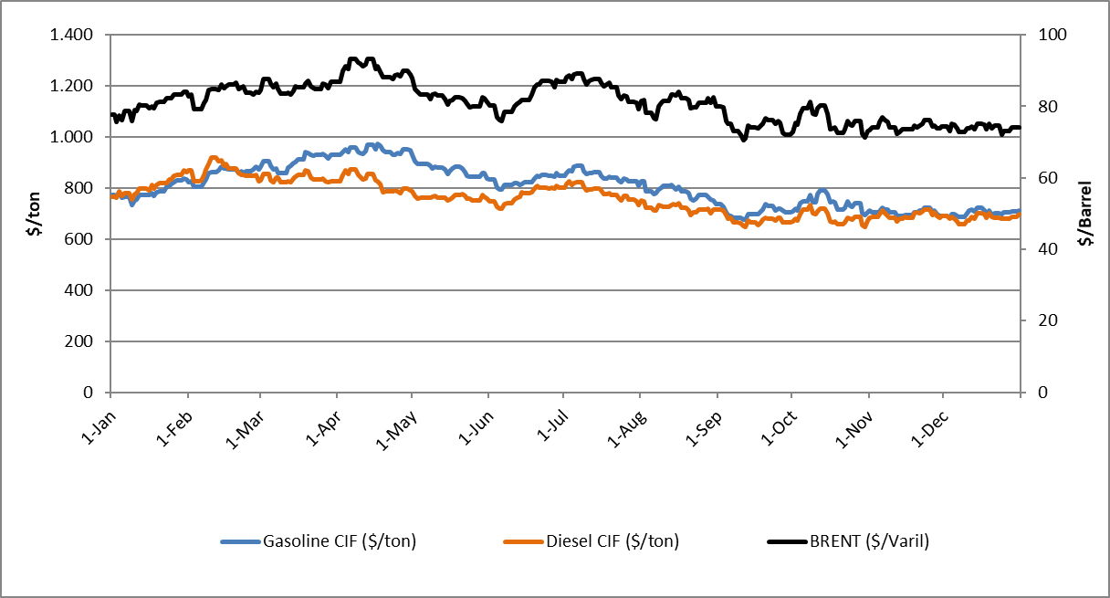

Figure 7.1. Prices of Unleaded Gasoline 95 Octane, Diesel and Brent (Dtd) in 2024 ($/Tons)
These data are converted to TL/lt and presented in Figure 7.2 below.

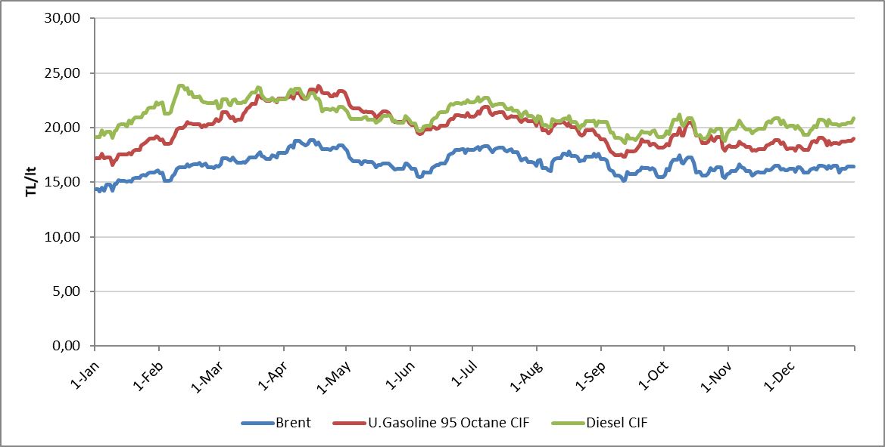

Figure 7.2. Prices of Unleaded Gasoline 95 Octane, Diesel and Brent (Dtd) in 2024 (TL/lt)

As can be seen in Figure 7.1 and Figure 7.2, the prices of all three products followed an upward trend in the first quarter of 2024, a downward trend in the second quarter and a fluctuating course in the third and fourth quarters.

7.1.2. TÜRKİYE
In Platts European Market Scan, which is followed by Türkiye, prices are published on a daily basis, whereas in Türkiye, prices are not changed daily and changes are reflected according to a certain formulation. In this manner, the trends of domestic unleaded gasoline 95 octane and diesel prices without tax in 2024 are presented in Figure 7.3 and Figure 7.4, respectively.
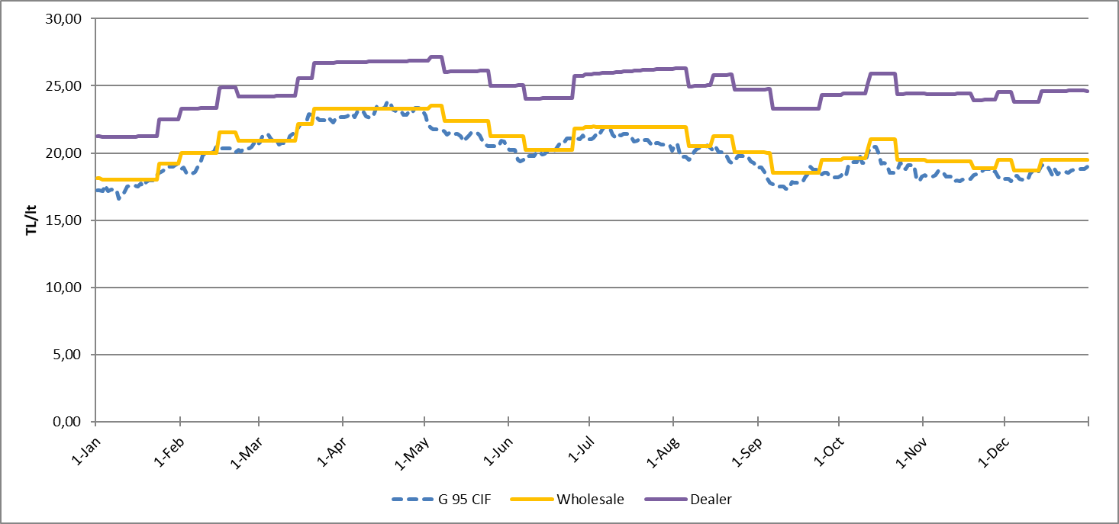

Figure 7.3. The Trend of Domestic Unleaded Gasoline 95 Octane Tax-Free Prices in 2024 (TL/lt)

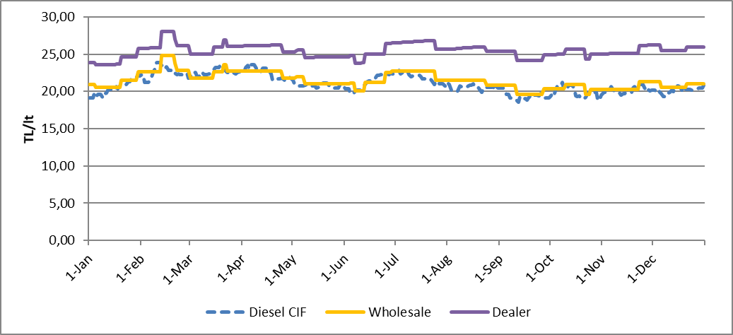

Figure 7.4. The Trend of Domestic Diesel Tax-Free Prices in 2024 (TL/lt)

Throughout 2024, gasoline and diesel prices changed in Turkey in line with international market prices, and the average tax-free dealer sales price was realized as 24,76 TL/LT for 95 octane unleaded gasoline and 25,44 TL/LT for diesel throughout the year.

7.2. PRICE FORMATIONS FOR GASOLINE AND DIESEL IN 2023 (ISTANBUL EUROPEAN SIDE)
In this section, the distribution of the shares of gasoline and diesel in the final taxed price of gasoline and diesel fuel in the European Side of Istanbul is analyzed for indicative purposes.

7.2.1. PRICE FORMATION FOR GASOLINE TYPES (ISTANBUL EUROPEAN SIDE – ONE LITER)
In 2024, there are four officially defined types of gasoline: “Unleaded Gasoline 95 Octane”, “Unleaded Gasoline 95 Octane (E10)”, “Unleaded Gasoline 98 Octane” and “Unleaded Gasoline 98 Octane (E10)”. However, only 95 Octane unleaded gasoline is widely sold at fuel stations. The share distribution of this product is presented in Table 7.1 and Figure 7.5.

Table 7.1. Average Price Formation for Gasoline Types in 2024 (TL/lt)
Year | Product | Product Price | Wholesaler Margin | Portion of Income | Total Margin of Distributor and Dealer | Total Tax | Final Sale Price
2024 | U. Gasoline 95 Octane* | 19,948 | 0,686 | 0,02529 | 4,125 | 17,391 | 42,176
Note: Pursuant to the Board Decision dated 02/05/2024 and numbered 12599, with the amendment made in Article 6 of the Board Decision No. 8730 on Differentiated Fuels; as of 15/05/2024, no price difference will be applied for the same type of fuel, whether differentiated or not, in sales made at fuel stations.
Table 7.1 shows that 41,29% of the final price of TL 42,176/LT is composed of tax and revenue share, 47,30% is composed of product cost and 11,41% is composed of gross profit margin of the companies operating in the market.

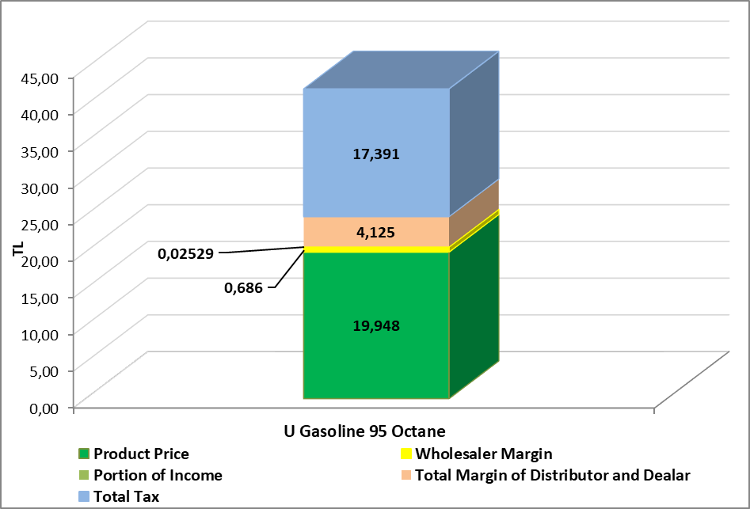

Figure 7.5. Average Price Formation for Domestic Gasoline Types in 2023

7.2.2. PRICE FORMATION FOR DIESEL TYPES (ISTANBUL EUROPEAN SIDE – ONE LITER)
Currently, there is only one officially defined type of diesel fuel. All of the diesel types sold under different trade names at fuel stations are diesel with a sulfur content of 10 ppm, popularly known as “Eurodiesel”. The share distribution of this product is presented in Table 7-2 and Figure 7-6.

Table 7.2. Average Price Formation for Diesel Types in 2024 (TL/lt)
Year | Product | Product Price | Wholesaler Margin | Portion of Income | Total Margin of Distributor and Dealer | Total Tax | Final Sale Price
2024 | Diesel ** | 21,003 | 0,440 | 0,02529 | 3,993 | 16,749 | 42,209
Note: Pursuant to the Board Decision dated 02/05/2024 and numbered 12599, with the amendment made in Article 6 of the Board Decision No. 8730 on Differentiated Fuels; As of 15/05/2024, no price difference will be applied for the same type of fuel, whether differentiated or not, in sales made at fuel stations.
Table 7.2 shows that 39.74% of the final price of TL 42.209/LT is composed of tax and revenue share, 49.76% is composed of product cost and 10.50% is composed of gross profit margin of the companies operating in the market.
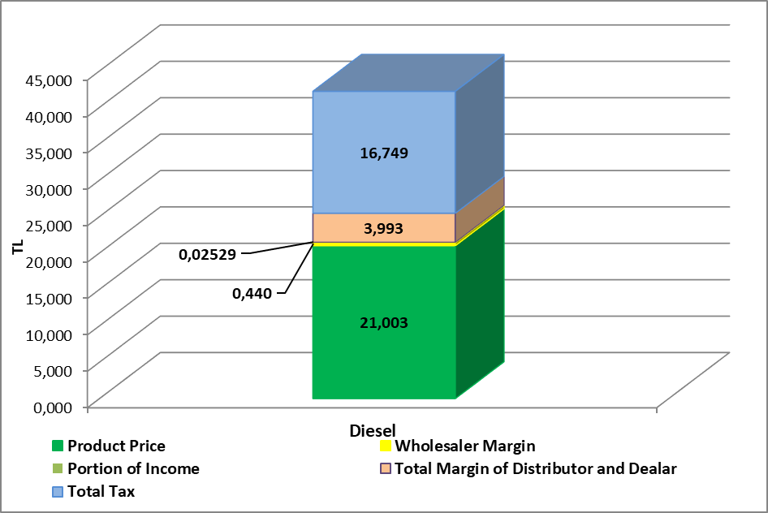

Figure 7.6. Average Price Formation for Domestic Diesel Types in 2024

NOTES:
* The types of gasoline sold at fuel stations are listed under the titles “K. Gasoline 95 Octane” and “K. Gasoline 95 Octane (Other)”, and the products sold under the other title may have different names from company to company. On the other hand, gasoline types supplied to the market as fuel or in circulation in our country must comply with the “TS EN 228 Automotive Fuels - Unleaded Gasoline - Properties and Test Methods” standard prepared by the Turkish Standards Institute. Therefore, there is no difference between K. Gasoline 95 Octane and K. Gasoline 95 Octane (Other) in terms of technical regulations and both can be used safely in all kinds of gasoline vehicles.
** The types of diesel sold at fuel stations are listed under the titles “Diesel” and “Diesel (Other)” and different companies may use different brands for diesel sold in the other product category. All types of diesel sold at fuel stations are products of European standards (eurodiesel) and can be used safely in all types of vehicles. In terms of legislation, there is only one diesel standard in our country and diesel products must comply with the “TS EN 590 Automotive Fuels-Diesel (Diesel) - Requirements and Test Methods” standard prepared by the Turkish Standards Institute. According to the standards, the maximum sulfur content in all types of diesel fuel must be 10 mg/kg. It is stated that diesel sold under different brands under the heading of Diesel (Other) has been given additional properties with some additives; however, there is no control or inspection on whether these products have the stated properties in addition to their compliance with the standards. Therefore, in terms of technical regulations, there is no difference between Diesel Diesel and Diesel (Other) and both can be safely used in diesel vehicles.
*** Pursuant to the Board Decision dated 02/05/2024 and numbered 12599, with the amendment made in Article 6 of the Board Decision No. 8730 on Differentiated Fuels; As of 15/05/2024, no price difference will be applied for the same type of fuels, whether differentiated or not, in sales made at fuel stations.
Definitions:

- Product Price: Product Prices are published in Platts (S&P Global Commodity Insights) European Market Scan as CIF MED (Genova/Lavera) $/TON.
It is the price calculated by multiplying the average of the daily prices published in Platts European Market Scan under the CIF MED (Genova/Lavera) heading for K. Gasoline 95 Octane and diesel by the indicative US dollar exchange rate determined by the CBRT and the density of the product.
Since product prices in international markets may move in a different direction from crude oil prices (e.g. gasoline prices increase while crude oil prices decrease, etc.), it may be misleading to link product prices directly to crude oil prices.

- Wholesaler Marjin: The margin added on the product price by refiners or distributors.

- Portion of Income: These are the amounts added to consumer prices in order to maintain the supplementary part of the national petroleum stock. It is set as 0,02529 TL/lt for gasoline types and diesel types.
- Total Margin of Distributor and Dealer: It is the margin that includes costs from the procurement of products (from refineries, imports or other distributors) to their delivery to the end user.
- Total Tax: The sum of Special Consumption Tax (SCT) and Value Added Tax (VAT) determined by the Ministry of Treasury and Finance.
For Gasoline Types (95 Octane) | SCT 11,9819 TL/LT* | VAT rate %20
For Diesel Types | SCT 11,2327 TL/LT* | VAT rate %20
NOTES: *SCT amounts have been redetermined in accordance with the Presidential Decree dated 30/12/2024 and numbered 9380.
*03/07/2024-30/12/2024 SCT for Gasoline Types (95 Octane) 11,2965 TL/LT - SCT for Diesel Types 10,5902 TL/LT
*03/01/2024-02/07/2024 SCT for Gasoline Types (95 Octane) 9,4540 TL/LT - SCT for Diesel Types 8,8629 TL/LT

CHAPTER EIGHT: PETROLEUM PRODUCT DELIVERIES BY PROVINCE (Annex - Excel File)

It covers the sales of fuel in free circulation to dealers, free users and unlicensed end users.
It covers domestic sales and deliveries to end-users under the transit regime.

